Characterization of Soybean Genotypes Based On Morphological And Molecular Markers

Niharika Saharia¹ and Ramendra Nath Sarma² and C. Author1

¹Student, Department of Plant Breeding and Genetics, Assam Agricultural University, Jorhat-13
²Professor, Department of Plant Breeding and Genetics, Assam Agricultural University, Jorhat-13

E-mail: niharikasaharia10@gmail.com

Abstract

Keywords: Soybean, SSR, Diversity, Morphological markers, D2 statistics
Soybean has attained important status in agriculture and oil economy of the country. It is a distinctive multi-purpose crop with ever increasing popularity due to various health benefits. It is imperative to estimate the nature and extent of variability among soybean genotypes to develop improved varieties suitable for varied agro-ecological situations. Moreover, there is limitation of molecular marker based diversity analysis in a precise way among the genotypes used for varietal breeding programme.

The present investigation was carried out with 38 soybean genotypes during Kharif, 2020. In the field experiment, the data on qualitative traits were taken on plot basis. For molecular analysis, 24 SSR primers were used to asses fingerprint pattern for estimation of genetic relatedness.

. Among the qualitative characters, hilum colour, pubescent density and pubescent type had the maximum distinguishing potential (4 classes) indicating their importance in describing the genotypes.

Euclidean distance based on qualitative characters indicated the genotype DLSb-2 and JS 22-14 to be most divergent.

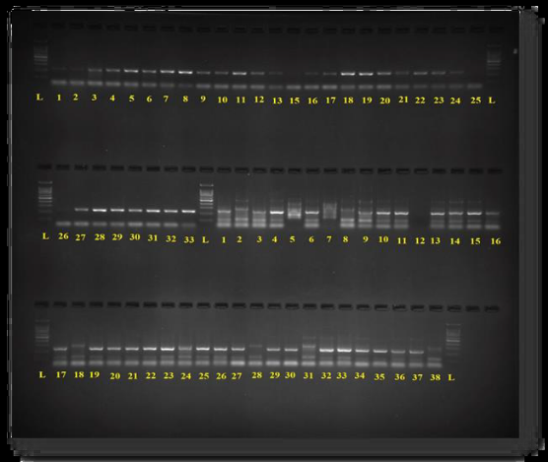
Out of 24soybean specific SSR primers, 19 were found to be polymorphic. The number of SSR allele per locus ranged from one to three with an average of 1.4 alleles per locus. The PIC value ranged from 0.10 (Satt416) to 0.79 (Sat_172) with an average of 0.37.Jaccard’s coefficient of similarity (SSR marker based) ranged from 0.52 to 0.97 with an average value of 0.72. No concordance was found between the distance matrices of morphological and molecular markers.
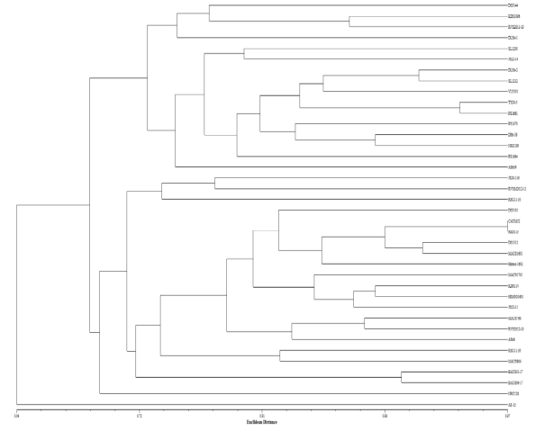

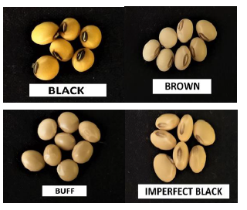
Figure 2 ->Amplification profile of SSR
Figure 1 -> Dendogram based on SSR.
Figure 3 -> A morphological marker.

