Development of a Portable Kit for Visible light Photodynamic inactivation of Microbes on Food Surfaces

Niladri Sekhar Roy 1, Dr. Debayan Sarkar*1

1 Department of Chemistry, Indian Institute of Technology Indore, India

E-mail: Sarkard@iiti.ac.in

Abstract

By the 1980s, pharmaceutical companies were convinced that there were already enough antibiotics. This led to the development of pervasive antimicrobial resistance. S. aureus is a leading cause of human infection due to its ability to survive on both biotic and abiotic surfaces in the biofilm state. In particular, methicillin-resistant Staphylococcus (MRSA) has emerged as a widespread cause of both community- and hospital-acquired infections. As the efficacy of antibiotics decreases and the end of the antibiotic era gets closer, major international research efforts are evolving to discover new ways to eradicate bacteria. A prominent member of this list is the light-based photodynamic therapy (PDT) platform. PDT was accidentally discovered over 100 years ago by Oskar Raab and Hermann von Tappiener when they noticed that Paramecium spp protozoans stained with acridine orange died upon exposure to bright light. Eichner and Koenig’sg groups have already carried out photodynamic inactivation of bacteria to decolonize Methicillin-resistant Staphylococcus aureus.
The project's main goal is to create a portable kit that includes a tiny non-toxic spray solution of Vitamin B2, which serves as a photosensitizer, and a source of flash visible light, which leads to photodynamic inactivation of the DNA/RNA material of coronaviruses found in open food items and packed food components. This would lead to fast inactivation of the microbes and completely eliminate it from the food and other surfaces, thus stopping the propagation.: a) To design an automatic system (KIT) that can provide visible disinfection lighting (sterilization) using environmentally friendly Photosensitisers and visible light (specifically 455nm and 476 nm), improving performance while keeping human health in mind, and making it IOT enabled to provide better performance enhancement. b) To design a visible disinfection lighting system for large-scale industry, warehouses, and large-scale surface purification with a combination of chemical and visible lighting while remaining human-friendly and IOT enabled for the benefit of energy efficiency, decision support, responsive service, enhanced experience, and product personalizations. Based on the principle of photodynamic inactivation (PDI) employing Vitamin Photosensitisers, it is absolutely non-toxic and can be used to disinfect food items too. This kit/ device would employ visible light Photodynamic Inactivation (PDI) as the key energy source, not the harmful UV radiation (Figure 1).
Student Academic Board (SAB), Indian Institute of Technology Guwahati, Guwahati, Assam, India
Keywords: Photodynamic Inactivation, MRSA, IOT

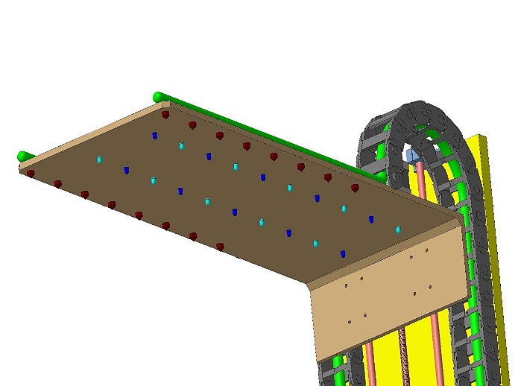
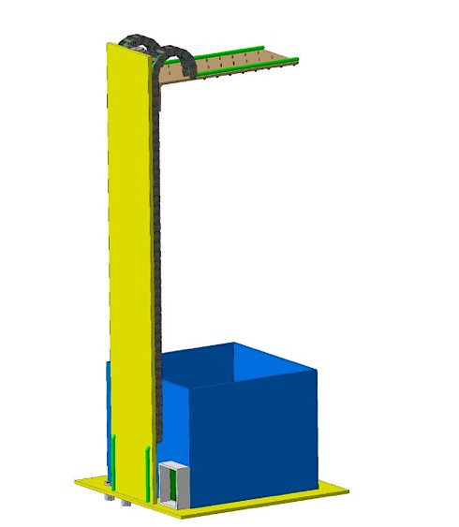

Figure1: Portable Kit for Visible light Photodynamic inactivation of Microbes on Food Surface

References:

- Maisch, T., Eichner, A., Späth, A., Gollmer, A., König, B., Regensburger, J. and Bäumler, W., 2014. Fast and effective photodynamic inactivation of multiresistant bacteria by cationic riboflavin derivatives. PloS one, 9(12), p.e111792.
- Alves, E., Faustino, M.A., Neves, M.G., Cunha, A., Tome, J. and Almeida, A., 2014. An insight on bacterial cellular targets of photodynamic inactivation. Future medicinal chemistry, 6(2), pp.141-164.
- Calin, M.A. and Parasca, S.V., 2009. Light sources for photodynamic inactivation of bacteria. Lasers in medical science, 24(3), pp.453-460.
- Maisch, T., Baier, J., Franz, B., Maier, M., Landthaler, M., Szeimies, R.M. and Bäumler, W., 2007. The role of singlet oxygen and oxygen concentration in photodynamic inactivation of bacteria. Proceedings of the National Academy of Sciences, 104(17), pp.7223-7228.

