Soft Polymer Crosslinked Silk Fibroin Based Hydrogel: Synthesis and Characterization

Pallabi Paul¹, Lal Mohan Kundu^{1,2,*}
¹Department of Chemistry, IIT Guwahati, India
²Centre for the Environment, IIT Guwahati, India
Email: lmkundu@iitg.ac.in

Abstract

Silk is a useful biomaterial used in textile industry, made of two protein chains, e.g., sericin and silk fibroin (SF).¹ SF-based materials are valuable biomaterial, have many applications in medicine and drug delivery.² Based on the thixotropic property of SF, injectable hydrogels can be a potential material for topical drug delivery in cancer therapeutics.³ A few SF-based hydrogels have been reported for drug delivery purposes yet unable to achieve target-specificity and controlled delivery criteria. Herein, we propose a soft hydrogel via crosslinking of SF and a soft polymer. The material has been characterized using FT-IR, FESEM, TGA, powder XRD. SF to hydrogel formation has been shown in figure 1. Synthesized hydrogel can be used as a drug delivery system.

Keywords: Cancer therapy, drug delivery, Schiff’s base, hydrogel, Silk fibroin.
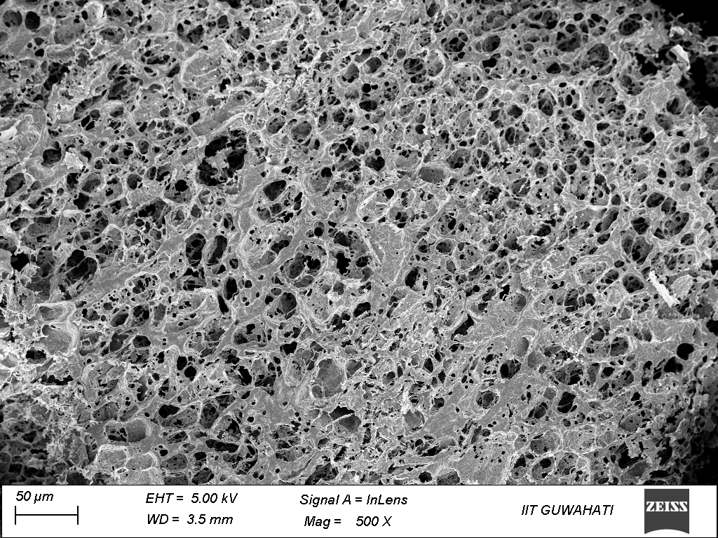
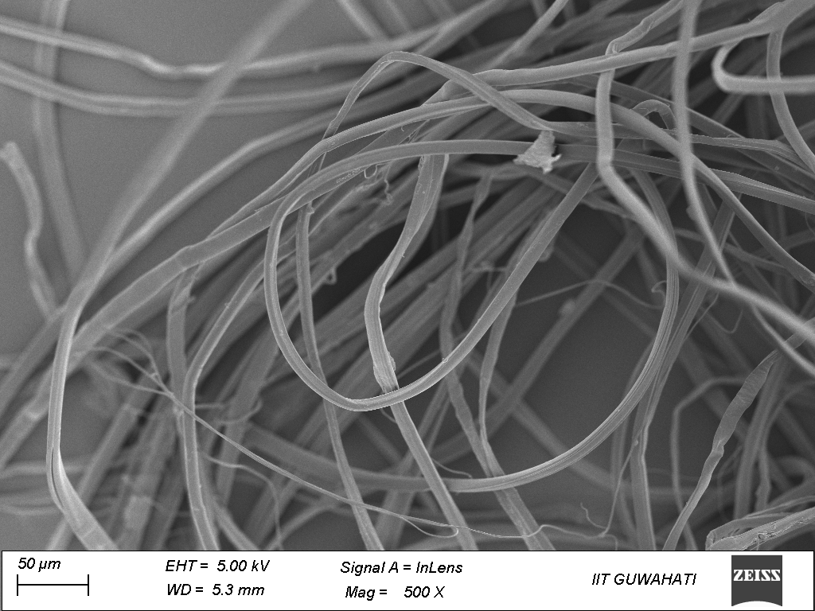

SF
Hydrogel

Figure 1. FESEM images of SF and hydrogel.

References
- Xu, X.; Yeats, R. S.; Yu, G. Seismol. Soc. Am. Bull. 2010, 100, 541-561.
- Lammel, A. S.; Hu, X.; Park, S. H.; Kaplan, D. L.; Scheibel, T. R. Biomaterials 2010, 31, 4583-4591.
- Wu, H.; Liu, S.; Xiao, L.; Dong, X.; Lu, Q.; Kaplan, L. D. ACS Applied Materials & Interfaces 2016, 8, 17118-17126.

