Synthesis of Pyrimido[2,1-a]isoindolone and Isoindolo[2,1-a]quinazolinone via Intramolecular Aza-Prins Type Reaction

Subhamoy Biswas, Bikoshita Porashar, Pallav Jyoti Arandhara and Anil K. Saikia*
Department of Chemistry, IIT Guwahati, India

E-mail: asaikia@iitg.ac.in

Abstract

A novel aza-Prins type cyclization reaction involving N-acyliminium ions and amides is reported for the synthesis of tetrahydropyrimido[2,1-a]isoindole-2,6-dione and 6,6a-dihydroisoindolo[2,1-a]quinazoline-5,11-dione derivatives in excellent yields. The strategy features inexpensive reagents, mild reaction conditions, and metal-free synthesis of N-heterocyclic frameworks. Further, post-synthetic modification results in the unprecedented formation of its triazole, tetracyclic diazacyclopenta[def]phenanthrene-1,4(9a,1H)-dione and carbonyl derivatives.

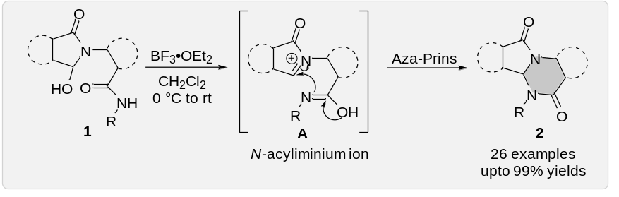

Keywords: aza-Prins cyclization, pyrimidoisoindolone and isoindoloquinazolinone.

References:
- Biswas, S.; Porashar, B.; Arandhara, P. J.; Saikia A. K. Chem. Commun. 2021, 57, 11701.

