Motion Control of the Underactuated Snake Robot in various Environment

Bhavik M. Patel and Santosha K. Dwivedy

Department of Mechanical Engineering, Indian Institute of Technology Guwahati, 781039, India

E-mail: bpatel@iitg.ac.in

Abstract

Snake robots have been developed to explore unknown and irregular environments using the locomotion of biological snakes. The graphical representation of the snake robot is shown in this abstract. The serpentine motion can be generated using the control scheme. In this, Proportional – Derivative (PD) control scheme is used for the motion control of the snake robot. Initially, control scheme is designed using the MATLAB-SIMULINK. The motion of the snake robot is considered in various environment. The effect of different environment such as land based and underwater condition is described in this work. The effect of the environment is studied and control parameters are derived based on the error tracking. The joint tracking error is considered for the snake robot motion. Finally, the environmental effect and motion of the snake robot is concluded in this work.
Student Academic Board (SAB), Indian Institute of Technology Guwahati, Guwahati, Assam, India
Research & Industrial Conclave 2023 "An amalgamation of Academia, Industry & Start-up”
"

Keywords: Snake Robot, Motion Control, PD control, Modelling

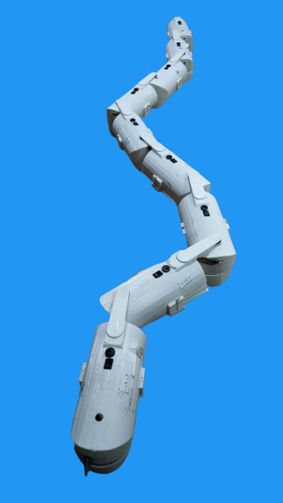
Figure 1 Developed model of the snake robot

