Aggregation Propensity of the Rotavirus Proteome: An In Silico Investigation

Pooja Rani Kuri¹ and Pranab Goswami^{1*}

1 Department of Biosciences and Bioengineering, IIT Guwahati, India

E-mail: pgoswami@iitg.ac.in

Abstract

Rotavirus is a leading cause of severe infantile gastroenteritis worldwide, resulting in approximately 199,000 childhood deaths in 2015, of which 90% occurred in low-income countries. India alone accounts for 22% of global rotavirus-related deaths among children under 5 years of age. While some rotavirus vaccines have been recommended by the World Health Organization (WHO) for implementation, there is currently no specific treatment for rotavirus infection. The maintenance of viral protein homeostasis is crucial for the successful progression of the viral life cycle within the host cell. The rotavirus genome consists of eleven double-stranded RNA segments encoding six structural and six non-structural proteins. Protein aggregation, mediated by aggregation-prone regions (APRs), plays a pivotal role in disrupting protein homeostasis. Synthetic analogs of APRs have the ability to self-assemble into β-sheet-rich aggregates, potentially interfering with protein homeostasis and promoting proteasomal degradation of the original proteins. To explore the possibility of inducing specific protein aggregation in rotavirus, we utilized computational tools to identify potential APRs within the viral proteome, with the goal of selectively inducing toxic protein aggregation in viral proteins while minimizing effects on the host cell.
Student Academic Board (SAB), Indian Institute of Technology Guwahati, Guwahati, Assam, India

Keywords: Rotavirus, aggregation, gastroenteritis

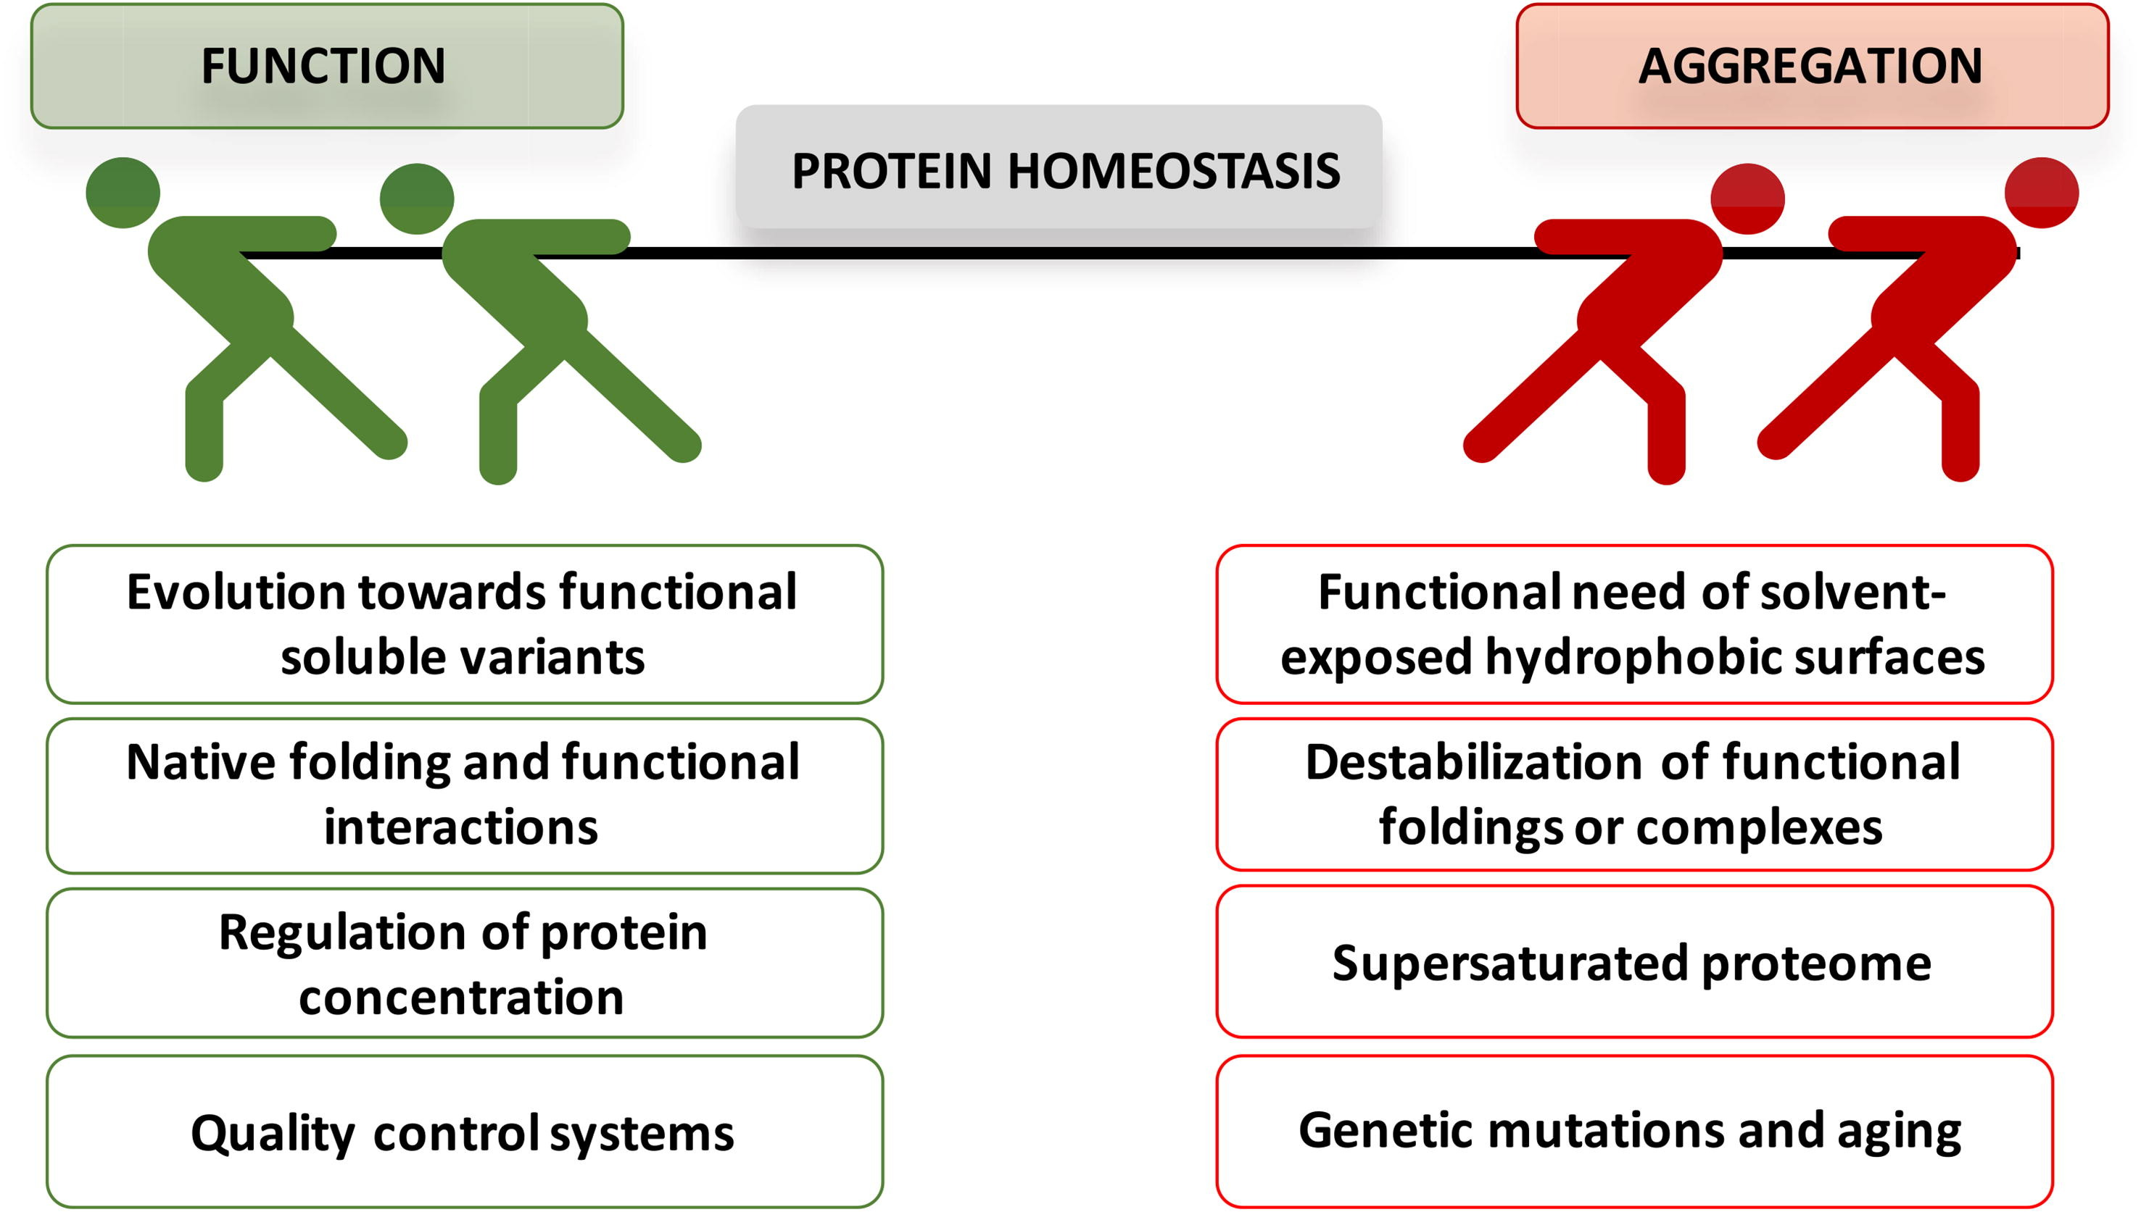
Fig 1. Innate competition between functional interactions and protein non-functional aggregation. Several factors contribute to balancing this subtle equilibrium. (Source: https://doi.org/10.1016/j.csbj.2020.05.026, under creative common license http://creativecommons.org/licenses/by-nc-nd/4.0/)

References
1. GBD 2015 Mortality and Causes of Death Collaborators. Global, regional, and national life expectancy, all-cause and cause-specific mortality for 249 causes of death, 1980–2015: a systematic analysis for the Global Burden of Disease Study 2015. Lancet. 2016. 34
2. GBD Diarrhoeal Disease Collaborators. Estimates of global, regional, and national morbidity, mortality, and aetiologies of diarrhoeal diseases: a systematic analysis for the Global Burden of Disease Study 2015. Lancet Infect. Dis. 2017
3. Jacqueline E. Tate et al. Global, Regional, and National Estimates of Rotavirus Mortality in Children <5 Years of Age, 2000–2013, Clinical Infectious Diseases. 2016.
4. Estes, M. K. & Greenberg, H. B. in Field’s Virology.2013.
5. Jayaram et al. Emerging themes in rotavirus cell entry,genome organization, transcription and replication. Virus Res. 2004

