Cobalt-Catalyzed Stereospecific C-N/C-O Bond Formation of Oxiranes with Diaziridines

P. K. Maharana,¹ T. Sarkar,¹ S. Kar,¹ S. K. Purkayastha,² A. K. Guha^{*3} and T. Punniyamurthy^{*1}
1 Department of Chemistry, IIT Guwahati, India
2 Department of Chemistry, Assam Don Bosco University, Sonapur-782402, India
³Advanced Computational Chemistry Centre, Cotton University, Guwahati-781001, India

E-mail: tpunni@iitg.ac.in

Abstract

Co-catalyzed stereospecific C-N and C-O bond formation of oxiranes with diaziridines has been accomplished to furnish tetrahydro-[1,3,4]-oxadiazines at room temperature. Optically active oxiranes can be coupled with high optical purities (>96% ee). Stereoselectivity, functional group tolerance, mechanistic studies using DFT and natural product modification are the important practical features (Figure 1).¹⁻²
Student Academic Board (SAB), Indian Institute of Technology Guwahati, Guwahati, Assam, India
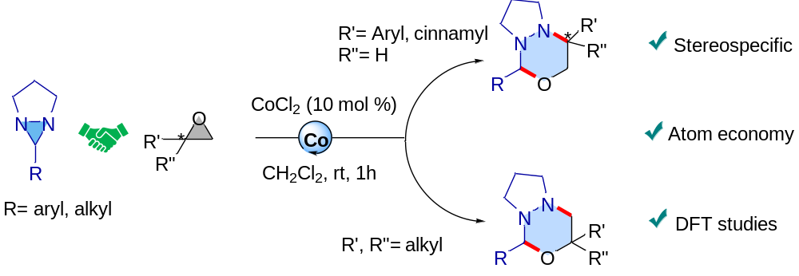
figure 1. Stereospecific cobalt catalyzed coupling of oxiranes with diaziridines
Research & Industrial Conclave 2023 "An amalgamation of Academia, Industry & Start-up”
"

Keywords: Stereospecific, Atom economy, Substrates scope

References
- Chagarovskiy, A. O.; Vasin, V. S.; Kuznetsov, V. V.; Ivanova, O. A.; Rybakov, V. B.; Shumsky, A. N.; Makhova, N. N.; Trushkov, I. V. (3+3)-Annulation of Donor-Acceptor Cyclopropanes with Diaziridines. Angew. Chem., Int. Ed. 2018, 57, 10338-10342.
- Sarkar, T.; Talukdar, K.; Roy, S.; Punniyamurthy, T. Expedient Iron-Catalyzed Stereospecific Synthesis of Triazines via Cycloaddition of Aziridines with Diaziridines. Chem. Commun. 2020, 56, 3381-3384.

