Reductive Alkylation of Quinolines to N-Alkyl Tetrahydroquinolines Catalyzed by Arylboronic Acid

Priyanka Adhikari ¹, Animesh Das ¹*

1 Department of Chemistry, IIT Guwahati, India

E-mail: adhikari18@iitg.ac.in

Abstract

Student Academic Board (SAB), Indian Institute of Technology Guwahati, Guwahati, Assam, India
A boronic acid catalyzed one-pot tandem reduction of quinolines to tetrahydroquinolines followed by reductive alkylation by the aldehyde has been demonstrated. This step-economcial synthesis of N-alkyl tetrahydroquinolines has been achieved directly from readily available quinolines, aldehydes, and Hantzsch ester under mild reaction conditions. The mechanistic study demonstrates the unique behaviour of organoboron catalysts as both Lewis acids as well as hydrogen-bond donors.

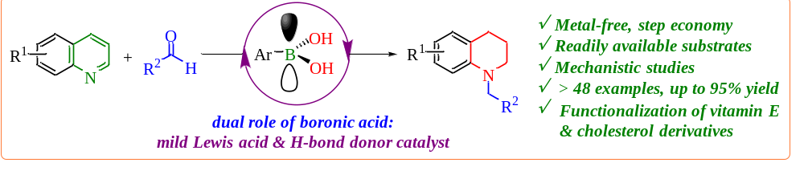
Keywords: boronic acid, N-alkyl tetrahydroquinolines, Hantzsch ester, aldehydes.
References:
- Adhikari, P.; Bhattacharyya, D.; Nandi, S.; Kancharla, P, K.; Das, A. Org. Lett, 2021, 23., 2437–2442
- Bhattacharyya, D.; Nandi, S.; Adhikari, P.; Sarmah, B. K.; Konwar, M.; Das, A. Org. Biomol. Chem. 2020, 18, 1214–1220.

