Study of Sterically Hindered Pyridinium Salts in Stereoselective Glycosylation Reactions of Glycals

Priyanka Pradhan¹, and Pavan K Kancharla¹*
1 Department of Chemistry, IIT Guwahati, India

E-mail: pavankancharla@iitg.ac.in
Abstract

2,4,6-Tri-tert-butylpyridine (TTBPy), a highly hindered pyridine derivative. TTBPy, along with its well-studied analogue, 2,6-di-tert-butylpyridine (DTBP)¹, are known for their inability to coordinate even to smaller Lewis acids like CH₃⁺ or BF₃ except with a proton. This typical non-nucleophilic basicity has been exploited in a variety of reactions, in particular, as an acid scavenger or as a buffering agent in studies of reactions of metal ions in aqueous solutions.
Student Academic Board (SAB), Indian Institute of Technology Guwahati, Guwahati, Assam, India
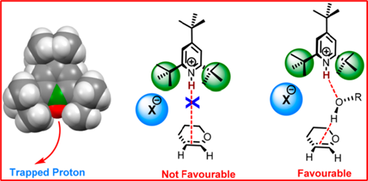

We demonstrate here that the strained and bulky protonated 2,4,6-tri-tert-butylpyridine salts serve as efficient catalysts for highly stereoselective glycosylations of various glycals. Moreover, the mechanism of action involves an interesting single hydrogen bond mediated protonation of glycals and not via the generally conceived Brønsted acid pathway. The counter-anions also play a role in the outcome of the reaction.²
Research & Industrial Conclave 2023 "An amalgamation of Academia, Industry & Start-up”
"

Keywords: TTBPy salt, catalyst, stereoselective glycosylation.

References

1. Brown, H. C.; Kanner, B. J. Am. Chem. Soc. 1966, 88, 986.
2. Ghosh, T.; Mukherji, A.; Kancharla, P. K. Org. Lett. 2019, 21, 3490.

