Modification and designing of tongue depressors, for an efficient depression.

Prateek Malviya

Department of medical devices, NIPER- Guwahati, India

E-mail: md22mt3038@niperguwahati.in

Abstract
Student Academic Board (SAB), Indian Institute of Technology Guwahati, Guwahati, Assam, India
Tongue depressor is a simple Class-I medical device, it is intended for use during a medical examination which allows to depress the tongue in order to allow the clinician for an easier examination of mouth and throat¹. A tongue depressor also known as tongue spatula or abslangs. Accessible regions with the tongue depressors are the soft palate, tonsil i.e., the oropharyngeal region. Can be inserted till anterior 2/3 of the oral cavity till V-shaped sulcae-circum vellate papillae, it should be used cautiously in posterior cavity to prevent gag reflex. The basic design idea about tongue depressor is such that it withstands the basic anatomy of the tongue.
Research & Industrial Conclave 2023 "An amalgamation of Academia, Industry & Start-up”
"
The perspective of the design is such that, the length is enough to reach the posterior of tongue. Truly right-angled depressors are not ideal as they give poor visualization i.e., a narrower view of oropharynx, 120° obtuse angle is considered ideal². The right-angle blade also prevents the mandible from opening fully because it places most of its pressure on the back side of the tongue because the jaw is a hinge joint. The tonsillar pillars are stretched as a result of direct pressure being applied to the back, the direct pressure on the posterior part results in the stretching of the tonsillar pillars.
Previously, flat faced blades were used in order to avoid any trauma to the tongue, but it rather offers slippery surface as the buccal mucosa is rich in saliva. Therefore, efforts are being made to design the under surface into oblique grooves which resists the slip and ensures good adherence with the vallete papillae at the base of the tongue with a combination of efficient obtuse angle.
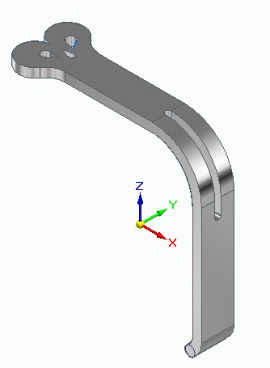
Fig. The proposed design of the modified tongue depressor.

Keywords: Tongue depressor, oropharynx, obtuse angle

References:
- Sahin, Caner, and Bora Dogan. "The development of a new medical instrument: modified tongue depressor. " Journal of Craniofacial Surgery 30.7 (2019): e595-e597.
- Swenson, Rudolph E. "The Obtuse Angle Tongue Depressor: Physiologic Advantages in Throat Surgery and Lesions of the Hypopharynx." Otolaryngology—Head and Neck Surgery 90.6 (1982): 761-763.

