UV-Ozone treatment for improving work function of V₂O_{x} layer to be used as a hole transport layer in silicon heterojunction solar cell

Rahul1 , Juhi Kumari², Jaishree Bhardwaj², and Pratima Agarwal1,2

1 Department of Physics, IIT Guwahati, India
2 School of Energy Science and Engineering, IIT Guwahati, India

E-mail: rahul_1997@iitg.ac.in

Abstract

Effective carrier selective contacts (CSCs) are required for fabricating an efficient solar cell. Basically, CSCs are of two types, one which supports flow of electrons and other which supports flow of holes. The selectivity of a particular layer is decided by the nature of band bending at the c-Si(n) and CSC interface as shown in figure 1 (a). Selectivity of these contacts depend on their work function (𝛷). Due to low cost of production and no usage of hazardous gases, transition metal oxides (TMOs) provide excellent substitutes for silicon-based n/p layers in silicon-based heterojunction solar cells. TMOs can be fabricated by techniques like thermal evaporation, rf-sputtering and solution processes etc. TMOs are highly transparent (~85%) and wide bandgap material (~3.3 eV). Vanadium Oxide (V₂O_{x}), a TMO is widely used as hole selective contact (HTL) in silicon heterojunction solar cell. In order to have good hole selectivity, high work function of V₂O_{x} is needed. So, in this work UV-Ozone treatment was used as a method to enhance the work function of V₂O_{x} films. V₂O_{x} (~100nm) films were deposited on c-Si(n) at room temperature by thermal evaporation technique. Afterwards, V₂O_{x} films were treated with UV-Ozone (UVO) for different times (5, 10, 15 and 20 minutes), to find its effect on work function. Work function values were determined using Kelvin probe force microscopy (KPFM). Work function for different times of UVO treatment is shown in figure 1 (b). As deposited V₂O_{x} films had work function of 4.69 eV, which increases up to 5.10 eV when treated with UVO. Not much change in transmission was noticed for as deposited and UVO treated V₂O_{x} films. AFM and FESEM images show that all films were uniform and compact. Condition in which high work function was achieved will be used in future to fabricate c-Si(n)/V₂O_{x} silicon heterojunction solar cells.
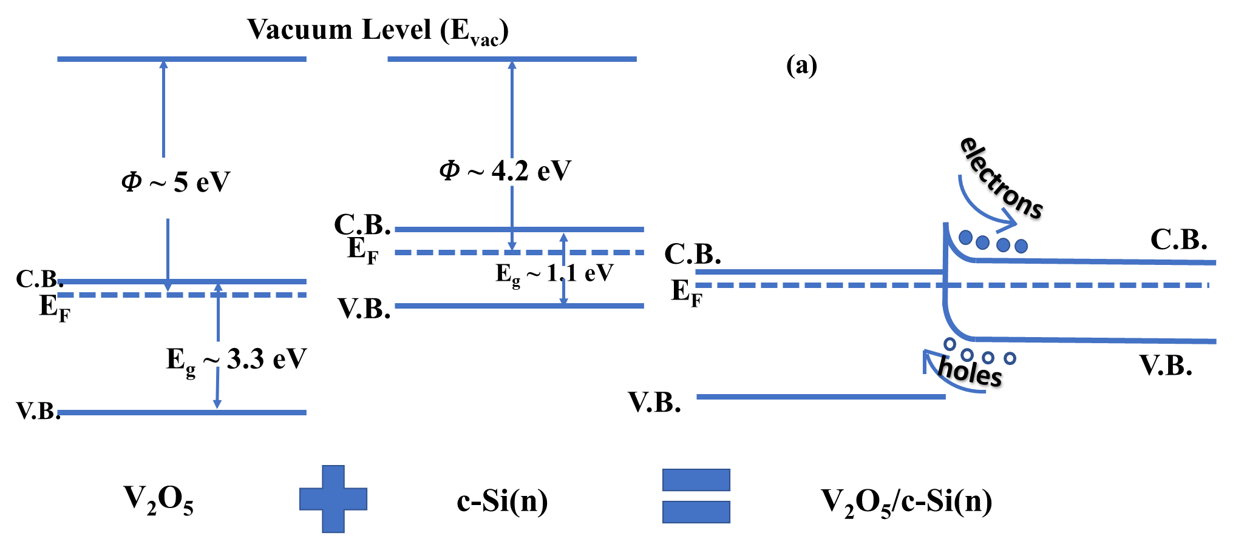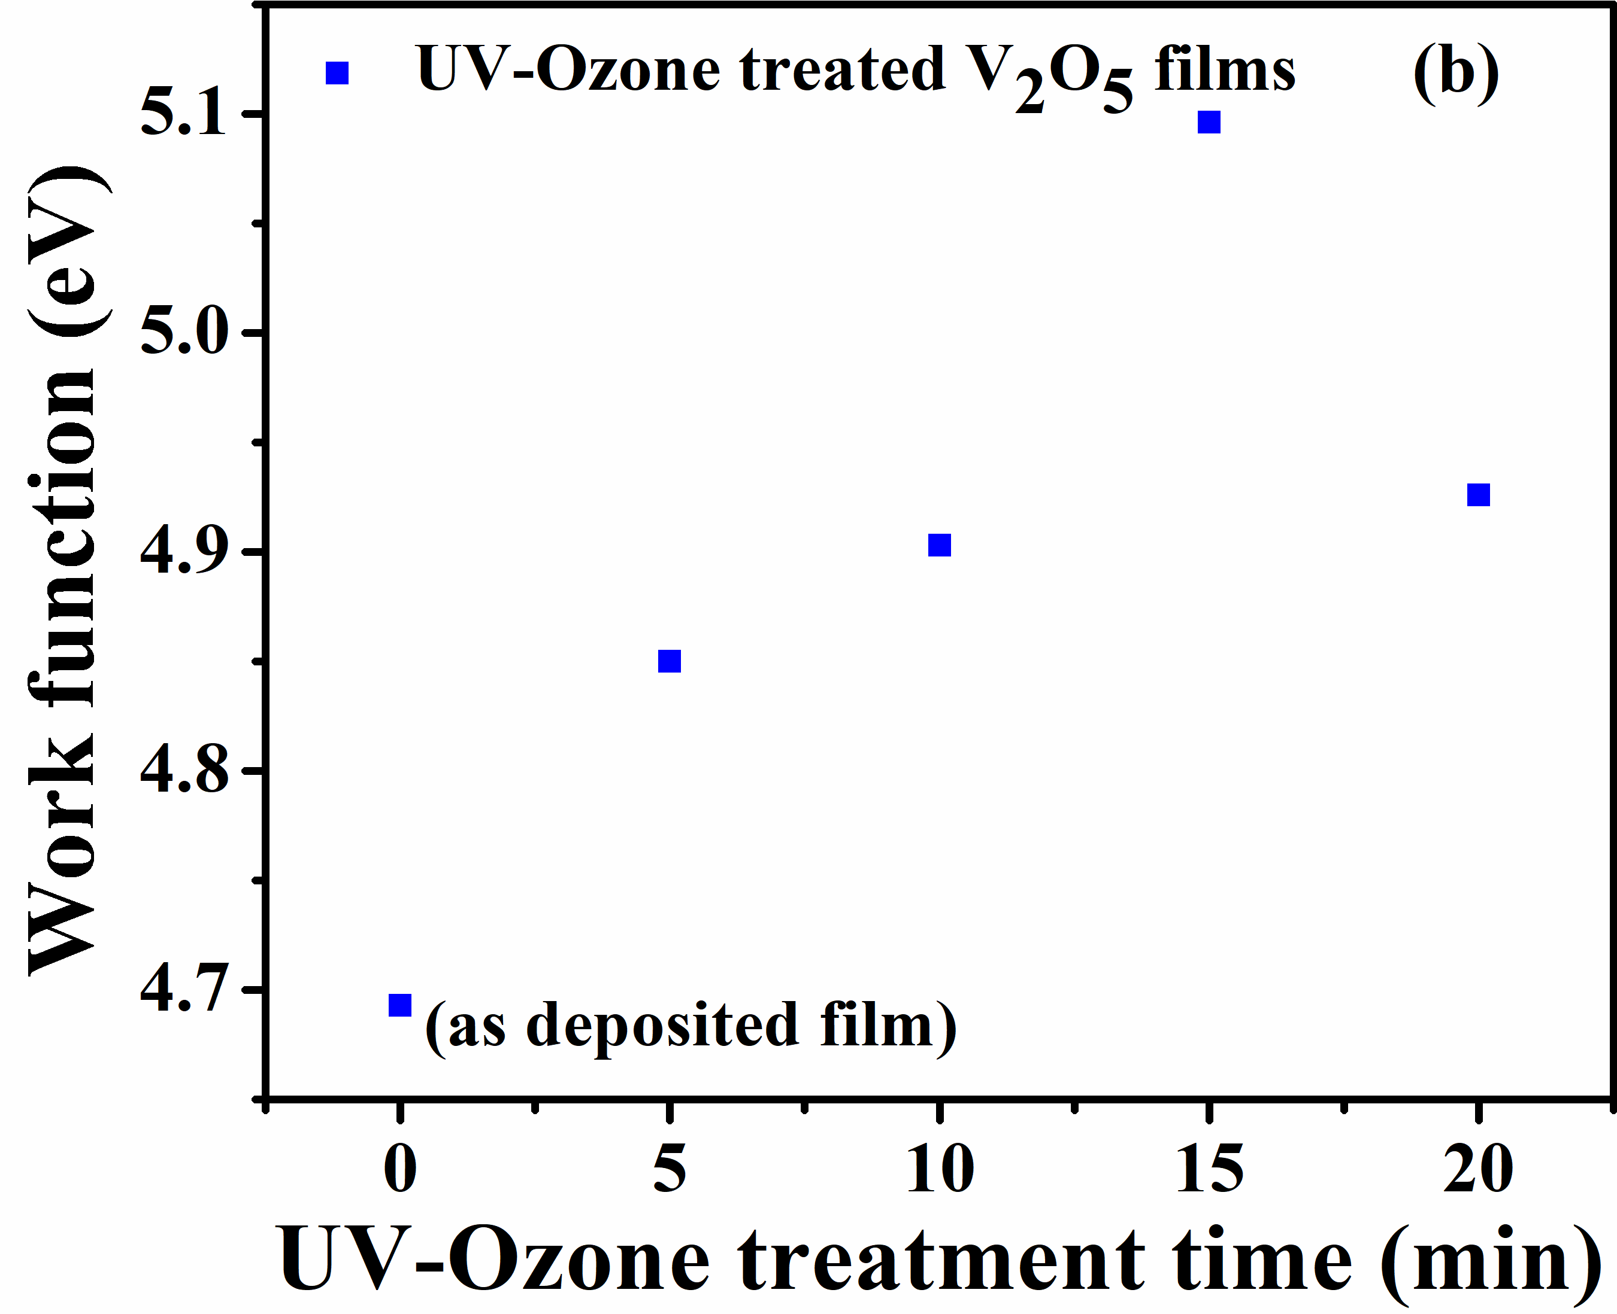
Figure 1. (a) Band bending at V₂O_{x}/c-Si(n) interface and (b) work function of different UV- ozone treated films.
Keywords: Transition metal oxides, Carrier selective contacts, UV-Ozone treatment and silicon heterojunction solar cells.

