Programmable Surface Acoustic Wave Device

Rahul Sharma*and H. B. Nemade

Department of Electronics & Electrical Engineering, IIT Guwahati, India
E-mail: rahul.shsr@iitg.ac.in

Abstract

This work demonstrates a surface acoustic wave (SAW) device based on photopatterned interdigital transducer (IDT) created on a cadmium sulfide layer deposited over a lithium niobate substrate using two methods, viz. chemical bath deposition (CBD) and spin-coating. It allows SAW generation when the photo pattern shines on the photoconductive layer. I-V characteristics are measured for photo pattern-based SAW devices with electrode separation widths of 1 mm, 2 mm, 3 mm, and 5 mm. It is found that a 2 mm sample is best suited for this application in which we need to make photo patterns within this area. For 2 mm CBD sample, I_{on} = 3.36 × 10⁻⁹ A (obtained by the light exposure) and I_{dark} = 5.4 × 10⁻¹² A (obtained in the absence of light) with an I_{on}/I_{dark} ≈ 10³ is achieved. Similarly, for the spin-coated 2 mm sample, I_{on} = 2.4 × 10⁻¹⁰ A and Idark = 2.9 × 10⁻¹³ A with I_{on}/I_{dark} ≈ 10³ is obtained. In both methods, x-ray diffraction provides the major reflections at 2θ = 26˚. Other important analyses such as SEM, PL, and XRD have been done to justify the results. Finally, S₁₁ parameters with and without photopatterned IDTs have also been measured using a vector network analyzer. .
Student Academic Board (SAB), Indian Institute of Technology Guwahati, Guwahati, Assam, India
Research & Industrial Conclave 2023 "An amalgamation of Academia, Industry & Start-up”
"
Surface acoustic wave (SAW) devices find their applications in electronic functional units (example- delay lines), radios (mixer, oscillator etc.), microfluidics, flow measurement and for designing various electronics blocks in the communication system (exp - filters) [1]. Applications like mobile phone use high Q bandpass filters that can be designed using SAW devices [2]. Apart from its many advantages the SAW device is limited due to its fixed frequency characteristics. This limitation is due to fixed IDT structures which are made using metal such as Aluminium as shown in Fig. 1
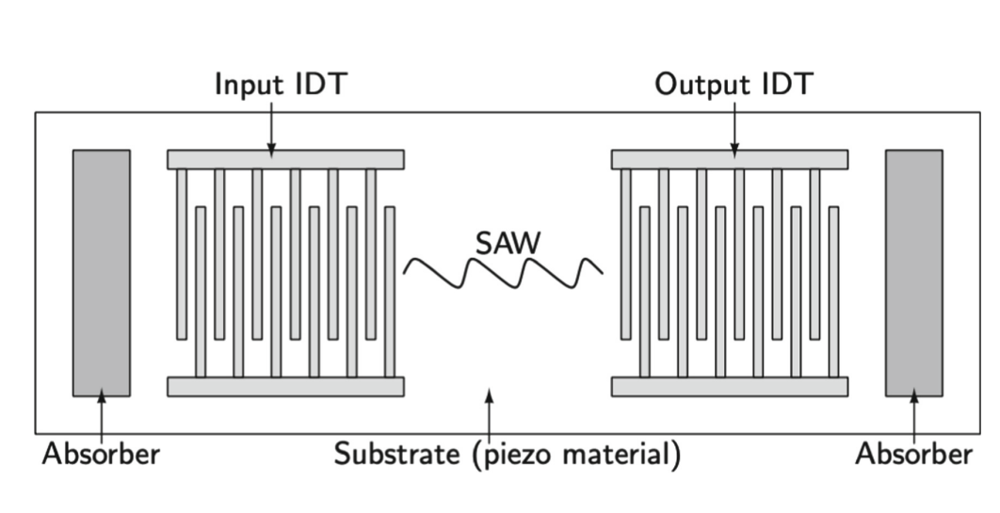

Fig. 1. Conventional surface acoustic wave device with two set of IDTs

Fig. 2. Photoconductively tunned surface acoustic wave with light pattern IDT setup.

Since the IDTs are conventionally made using aluminium material in comb like structure as shown in Fig. 1, it limits the tunability of SAW. Generated SAW wave frequency (f) depends on the pitch size of IDTs in this manner, f = v/λ and pitch = λ/2. Here v is the SAW velocity in the material and λ is the wavelength of generated wave [3]. To eliminate these limitations, there are many ways available in literature such as use of variable material velocity [4], utilizing MEMS techniques [5], use of quantum well structure and programmable SAW [6]. In this work, we have considered photoconductive technique for making tunable SAW device. In this technique we are making the IDTs (conventionally made using metal) using light pattern on a grown photoconductive layer over piezoelectric substrate as shown in Fig. 2. Before actually making these patterns, we need to fix the method for growing photoconductive layer over piezoelectric substrate for this phenomenon to happen.
This work proposes a solution in the form of a photopatterned SAW device and also discusses the Ways to deposit a photoconductive layer over a piezoelectric substrate. Two methods i.e. CBD and spin-coating have been used to prepare the sample for the newly proposed device. Structural characterization, surface morphology, and optical analysis have been done by optimizing the device for targeted application. In the end, the reflection coefficient has also obtained from the fabricated device.

Keywords: SAW, programmable, IDT, photopatterned, piezoMEMS.
References:
[1] Morgan, D.: Surface Acoustic Wave Filters, Academic Press; 2 edition (2007)
[2] Mohan, S.: The 5G effect on RF filter technologies. IEEE Trans Semiconductors Manuf. 30(4), 494–499 (2017)
[3] Kosinski, J.A., Pastore Jr, R.A.: Programmable saw filter including unidirectional transducers. Google Patents. US Patent 6,459,345 (2002)
[4] Seiwatz, R.F.: Solid state acoustic signal translating device with light activated electrode interconnections. US Patent 3,446,974 (1969)
[5] Zhu, J., Lu, Y., Kosinski, J., Pastore, R.: Programmable surface acoustic wave (SAW) filter. Google Patents. US Patent 6,541,893 (2003)
[6] Hong, J.: Method and apparatus for modifying acoustic wave characteristics. Google Patents. US Patent 6,710,510 (2004)

