Microwave-assisted Bio-based Pd-doping onto TiO₂ using S. edule Vegetal-extract for Photocatalytic Degradation of Ciprofloxacin
Ravi^{1,}* and Animes Kumar Golder^{1,2}
¹Centre for the Environment, IIT Guwahati, Assam, INDIA -781039
²Department of Chemical Engineering, IIT Guwahati, Assam, INDIA -781039

E-mail: r.vashist@iitg.ac.in

Abstract
The presence of pharmaceutically active compounds (PhACs) in waterbodies could hinder the growth of flora and fauna. As a result, it has a significant impact on maintaining the environmental health. The existence of Ciprofloxacin (CIP, an antibiotic), could develop some lethal antibiotic-resistant microbes, i.e., E. coli, Enterobacteriaceae spp., and Staphylococcus spp. Therefore, PhACs wastewater must be treated before releasing into the environment. Photocatalytic wastewater treatment processes using TiO₂ have many advantages among various catalysts due to its high chemical and photo-stability, and eco-friendly nature. However, high bandgap of TiO₂ limits its use only in the UV light range. Herein, we have synthesized a visible-light-driven Pd/TiO₂ photocatalyst via a bio-based route using S. edule vegetal extract in a microwave reactor. The proposed route makes use of ascorbic acid and other constituents found in S. edule for Pd-doping onto TiO₂ along with its stabilization, which could minimize the use of hazardous chemicals in the conventional route. The bandgap of Pd_{0.0}/TiO₂(bare) was reduced from 3.29 to 2.73 eV with Pd doping (Pd_{1.0}/TiO₂(bio)) (Fig. 1a). A better charge trapping efficiency and low recombination rate (due to Pd defect and oxygen vacancies) of Pd_{1.0}/TiO₂(bio) was noted over Pd_{0.0}/TiO₂(bare) photocatalyst (Fig. 1b). The hydrophobic Pd_{0.0}/TiO₂(bare) with a water contact angle of 120.8° transformed to highly hydrophilic Pd_{1.0}/TiO₂(bio) with a water contact angle of 37.5°. The lower bandgap, reduction in charge recombination, and hydrophilic surface facilitate enhanced photocatalytic activity of Pd_{1.0}/TiO₂(bio) under visible light. Pd_{1.0}/TiO₂(bio) showed a superior CIP degradation of 72.1% than Pd_{0.0}/TiO₂(bare), where the later showed only 41.6% CIP degradation under 50W visible light irradiation. Hence, Pd-doped TiO₂ is a potential candidate for the photocatalytic degradation of emerging pollutants under visible and solar light irradiation.
Student Academic Board (SAB), Indian Institute of Technology Guwahati, Guwahati, Assam, India
Research & Industrial Conclave 2023 "An amalgamation of Academia, Industry & Start-up”
"

Keywords: Pd/TiO₂; Microwave-assisted; S. edule extract; CIP photodegradation

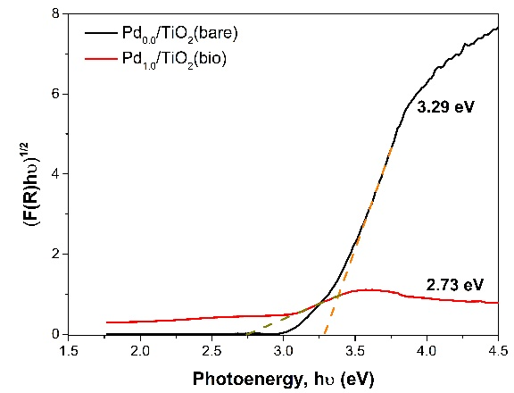
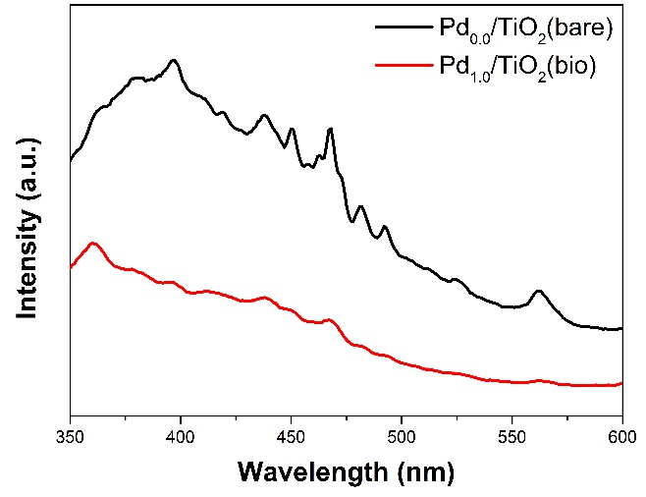
a
b

Figure 1: (a) Tauc’s plot (Kubelka-Munk function) for optical bandgap and (b) Photoluminescence (PL) spectra of Pd_{0.0}/TiO₂(bare) and Pd_{1.0}/TiO₂(bio).

