Black rice starch: A nutritive alternative to conventional starch sources

Rubeka Idrishi1, Siddhartha Singha1 and Latha Rangan1,2

1 School of Agro and Rural Technology (SART), IIT Guwahati, India
2 Department of Biosciences and Bioengineering (BSBE), IIT Guwahati, India

E-mail: rubeka1995@iitg.ac.in

Abstract

Approximately 95% of rice is cultivated in Asia out of which many are pigmented, it is primarily consumed in Asian countries especially in China, Indonesia and Korea. India constitutes about 5.1 % of the total world production of pigmented rice. Out of many unexplored pigmented rice, Black rice (Oryza sativa L) of North East (NE) India is widely popular for its distinct flavour and has immense significance in the rice value chain system. The pigment, flavour and aroma, its chemical composition and volatility are still being studied by many researchers. Black rice is found to be advantageous as compared to white rice due to its high anthocyanin, protein, vitamin and mineral content, which varies with different cultivars.
Student Academic Board (SAB), Indian Institute of Technology Guwahati, Guwahati, Assam, India

The chemical composition of rice highly depends on the amount of starch, lipids and protein profile of the variety, which ranges from 60-80% starch, 1-4% lipid and 6-9% protein on the basis of which the functional quality of black rice also differs. In this study, the nutritional, physicochemical characteristics, functionality, isolation, modification and applications of black rice starch have been studied in detail with a focus on Indian black rice. It has been found that the nutritional and functional quality of starch in black rice cultivars vary differently with different landraces. Black rice starch is found to have better physicochemical and nutritional profile in terms of its thermal, rheological and presence of bioactive compounds as compared to conventional starch sources such as white rice, wheat, tapioca, sago, arrowroot etc. It has more resistant starch content and the starch profile tends to have a bit longer cooking time, moderate gruel solid loss, low water uptake ratio and swelling capacity while cooking. The black rice starch finds applications

Keywords: Black rice, Nutrition, Starch, Pigmented rice, North East India

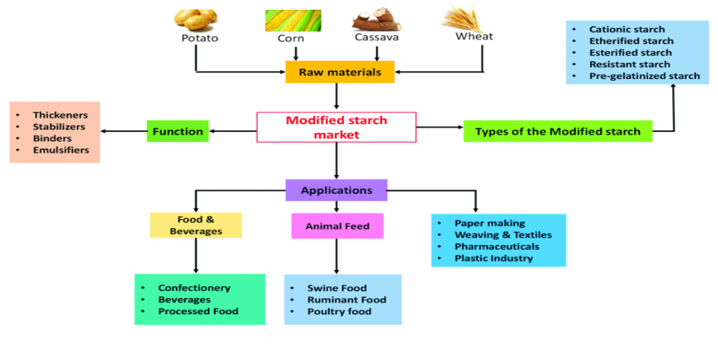

Figure 1: Modified black rice starch applications

