Skaro – The Robotic Scavenger

A. Saahil Somani1 ,

1 Department of Science, Sanskriti The Gurukul, Guwahati, India

E-mail: saahil.somani@sanskritithegurukul.in

Abstract

Department of Physics, Sanskriti The Gurukul, Guwahati, India
Manual scavenging has been a great problem for mankind for ages. Manual scavengers suffer from a lot of harmful diseases like bronchitis, asthma, tuberculosis etc. which, in many cases, become the cause of their death. I want to completely discard manual scavenging, and with the help of Skaro - The Robotic Scavenger, this hazardous practice can be stopped without leaving the workers unemployed. Skaro is a fully-automatic machine which replicates the actions of a manual scavenger. It is equipped with an Electromagnet, a Suction Pipe and a Claw to extract the wastes from sewers. The Electromagnet will extract metallic wastes from the drains. The Suction Pipe has an ultrasonic sensor at the bottom rim which will detect the size of the waste and will only pull the wastes which are smaller than its diameter. Then, the claw will extract the wastes which were left behind by the other tools. The machine also has cameras set up at different angles which assist in controlling the machine properly. The movement of the tools will be controlled by a controller attached at the back. The controller will also have a screen to monitor the tools' movement and to look for waste.
Department of Physics, Sanskriti The Gurukul, Guwahati, India

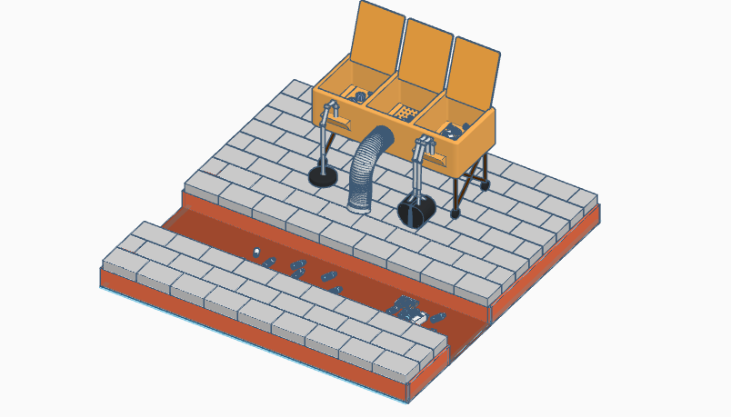

Figure 1: The 3D model of Skaro – The Robotic Scavenger

