Abstract for Research & Industrial Conclave 2023

Prakhar Sethiya1 , Sahaj Sethi2

1 Department of Electronics & Electrical Engineering, IIT Guwahati, India
2 Department of Mechanical Engineering, IIT Guwahati, India

E-mail: psethiya@iitg.ac.in¹, sahaj.sethi@iitg.ac.in²

Abstract

According to World Health Organization, a worldwide estimate of 684,000 people die from falls each year, and 37.3 million falls are severe enough to need medical attention. Falls are the second biggest cause of unintentional injury deaths. Most fatal falls occur to adults 60 years of age and older. For older persons, falls are a major cause for concern since they can result in life-threatening injuries, a loss of independence, or even death. In order to improve the quality of life for older individuals, it is essential to develop systems for detecting falls.
Student Academic Board (SAB), Indian Institute of Technology Guwahati, Guwahati, Assam, India
Research & Industrial Conclave 2023 "An amalgamation of Academia, Industry & Start-up”
"
A walking aid is a type of an external biomedical device that may be given to a patient to help them move independently while improving their gait, balance, and safety. Even while using a walking aid, an older person or someone with a disability still runs the risk of falling. Because of this, it makes fall detection crucial for immediate treatment for the patient.
The primary objective of fall detection in walking aids is to improve the safety and well-being of elderly and individuals with disability. In our project we have designed a fall detection system using different sensors and algorithm to accurately detect falls. This system can be integrated into a variety of walking aids, including canes, walkers, and crutches, and it provides real-time alerts in the event of a fall to caregivers or emergency services. The figure below (fig.1) gives an overview of working of our fall detection system and panic button. The fall detection system can accurately detect falls leading to reduction in injuries related to fall.

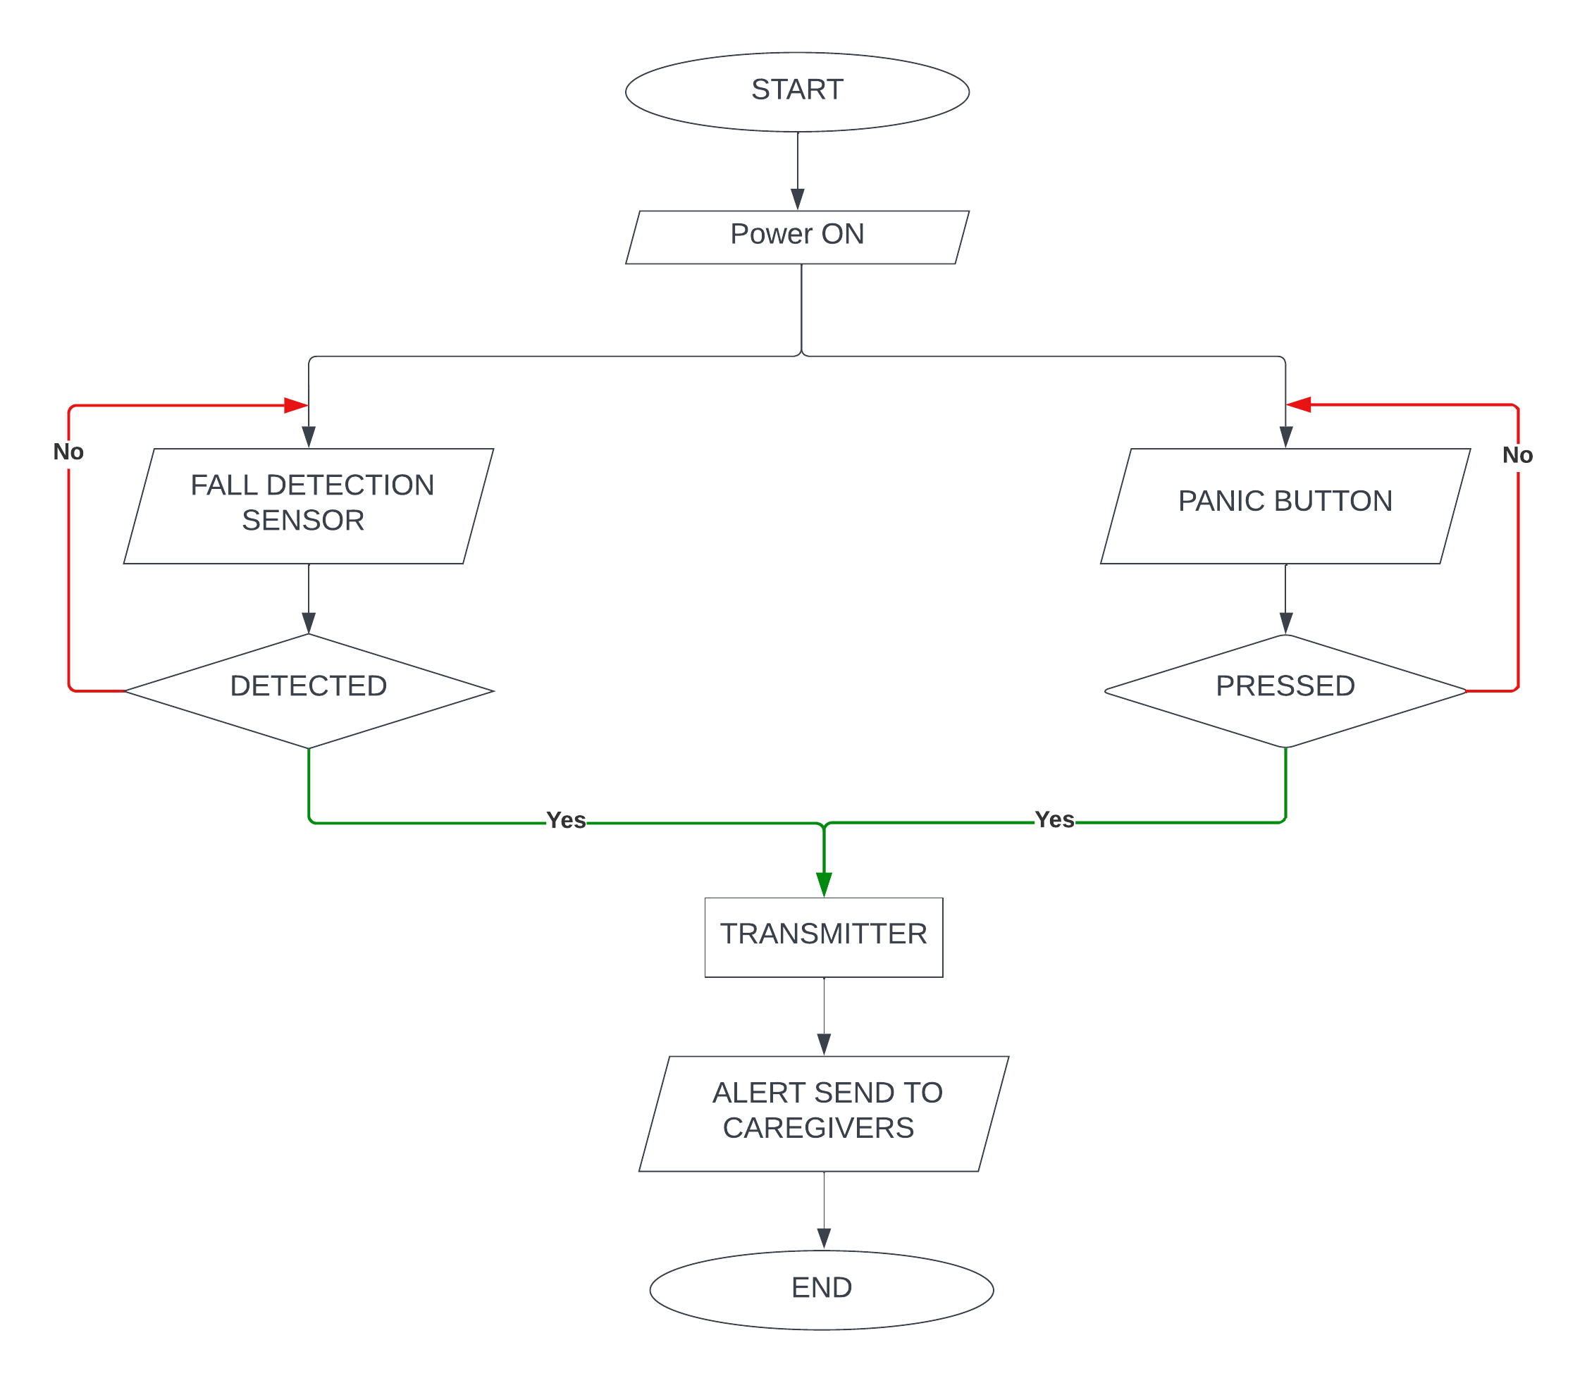
Fig 1. Working of fall detection system and panic button

