A novel mechanized cardiopulmonary Resuscitation (CPR) device

A. Sandipan Datta1 ,
B. Abhishek Singh*2 and
C. Saurabh Khare*2

1 Department of Design , IIT Guwahati, India
2 Department of Mechanical Engineering , IIT Guwahati, India

E-mail: d.sandipan@iitg.ac.in

Abstract-

Failure of the pumping activity of heart due to the loss of electric conduction occurs Sudden Cardiac Arrest (SCA) and it is a major cause of mortality in worldwide. At the time of cardiac arrest, Cardiopulmonary Resuscitation (CPR) is a common first aid that needs to be given immediately to a patient. Sometimes, the process takes more than an hour continuously to make the patient alive. But, it is very difficult to provide CPR continuously for such a long duration. An availability of CPR machines in the Indian healthcare system is a major issue. The objective of the present research is to design a mechanized CPR machine that can provide CPR as per the requirement without the need of human intervention. In order to develop a mechanized CPR device, 5 different mechanisms namely i) Cam- Follower Mechanism, ii) Offset slider Crank Mechanism iii) Scotch yoke Mechanism, iv) piston cylinder housing mechanism, and v) Crank & shaft lever Mechanism were considered. Based on the efficiency of mechanism and considering other advantages and limitations of them, Scotch Yoke and Offset Slider Crank Mechanisms are found to be the best to use in CPR. However, the Scotch Yoke Mechanism is finally selected based on the size criterion. Further, considering different essential operational factors such as 2”-2.4” (According to American Heart Association) depth of compression with 100-120 stroke/min (According to American Heart Association) during CPR process, the proposed mechanism is tested and simulated through CAD software and it is shown in Figure 1. Its analysis and prototype making are under process. It is concluded that the CPR machine which works automatically with desired stroke and compression along with feedback mechanism is compact in nature, easy to use, portable among many other advantages that can potentially save many lives irrespective of geographical location in India.

Figure - 1
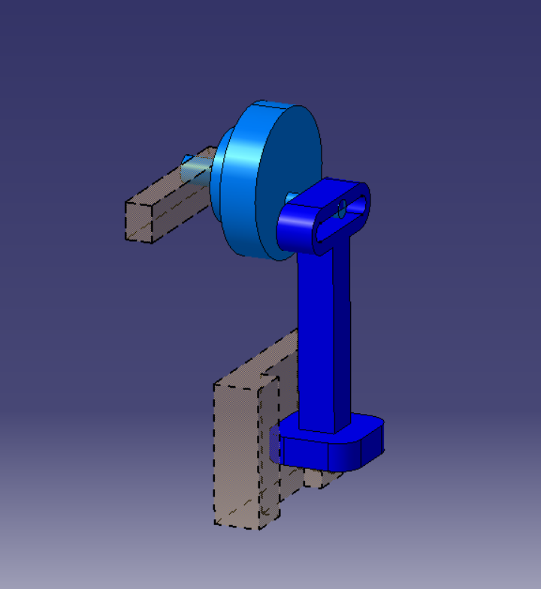

Keywords: Cardiopulmonary Resuscitation (CPR), Hand-free, Machine.

