Expedient Cobalt Catalyzed Stereospecific Cascade C–N and C–O Bond Formation of Styrene Oxides with Hydrazones

M. Mishra, P. K. Maharana, P. Karjee and T. Punniyamurthy*

1 Department of Chemistry, IIT Guwahati, India
E-mail: manma176122051@iitg.ac.in

Abstract

Co(II)-catalyzed stereospecific coupling of styrene oxides with bisaryl hydrazones is described to produce 1,3,4-oxadiazines in high yields. Optically active styrene oxides can be reacted with high optical purity (up to > 99% ee).
Student Academic Board (SAB), Indian Institute of Technology Guwahati, Guwahati, Assam, India
Research & Industrial Conclave 2023 "An amalgamation of Academia, Industry & Start-up”
"

Keywords: Inexpensive cobalt-catalysis, tandem C-n/C-O bond formation, broad functional group compatibility.

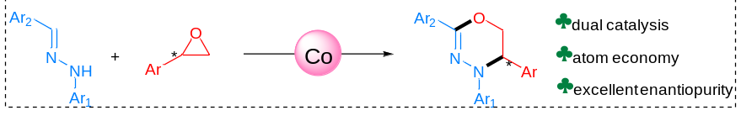

1. M. Mishra, P. K. Maharana, P. Karjee and T. Punniyamurthy, Chem.Commun., 2022, 58,7090.
2. Liu. L and Sun. H, Angew.Chem., Int. Ed., 2014, 53, 9865.

