Directed C8-H Allylation of Quinoline N-oxides with Vinylcyclopropanes via Sequential C-H/C-C Activation

S. Mandal¹, P. Karjee¹, S. Saha¹ and T. Punniyamurthy^{1,*}

¹Department of Chemistry, IIT Guwahati, India
E-mail: tpunni@iitg.ac.in

Abstract
The heteroaromatic scaffold quinoline is ubiquitous in a variety of functional molecules with applications in drug discovery, synthetic chemistry and material science.¹ As a result, there has been a great surge of research interest towards the synthetic modification of the quinoline core.² The more reactive C2-H functionalization has made a considerable progress compared to C8-H bond functionalization.³ Thus, functionalization of the remote and less reactive C8-H bond, continues to be a challenging synthetic goal. Moreover, C8-functionalized quinolines show very good pharmacological activities such as antimalarial, antihepatitis and antibacterial properties.⁴ Here, our investigation started for the conventional metal catalyzed C-H allylation reactions⁵ owing to the higher hepatoprotective effect by 8-allylquinoline and its lack of presence in the literature for direct synthesis^{4a}. These allylation reactions, however, often suffer from atom economy due to the loss of leaving group (LG) at the allyl coupling partner.⁵ In this context, vinylcyclopropane (VCP) has emerged as a promising allylating agent to deliver the allylated products via the C-H/C-C bond cleavage.⁶ Herein, we outline a Rh(III)-catalyzed C8-allylation of quinoline N-oxides with VCPs via a sequential C-H/C-C activation at room temperature (Scheme 1).⁷ The regio- and diastereo-selectivities, modification to the naturally occurring cinchonidine derivative and post-synthetic transformations are the significant features.
Keywords: Quinoline, C8-H functionalization, Allylation reaction, Sequential C-H and C-C bond activation, Transition metal catalysis.

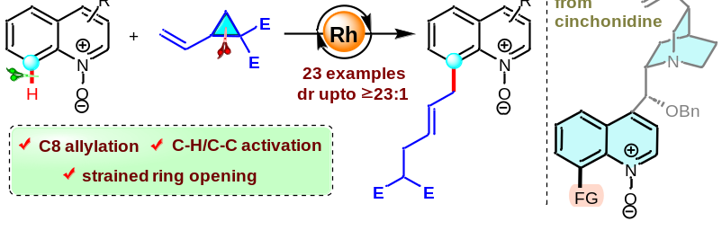
Scheme 1: C8-allylation of quinoline N-oxides
References
- Michael, J. P. Nat. Prod. Rep. 2008, 25, 166.
- Romero, E. A.; Chen, G.; Gembicky, M.; Jazzar, R.; Yu, J.-Q.; Bertrand, G. J. Am. Chem. Soc. 2019, 141, 16726.
- Xiao, B.; Liu, Z.-J.; Liu, L.; Fu, Y. J. Am. Chem. Soc. 2013, 135, 616.
- (a) Okamoto, T.; Kobayashi, T.; Yoshida, S. Med. Chem. 2007, 3, 35. (b) Sridharan, V.; Suryavanshi, P. A.; Menéndez, J. C. Chem. Rev. 2011, 111, 7157.
- (a) Marshall, J. A. Chem. Rev. 2000, 100, 3163. (b)Dutta, S.; Bhattacharya, T.; Werz, D. B.; Maiti, D. Chem 2021, 7, 555.
- (a) Zell, D.; Bu, Q.; Feldt, M.; Ackermann, L. Angew. Chem. Int. Ed. 2016, 55, 7408. (b) Lu, Q., Klauck, F. J. R. Glorius, F. Chem. Sci. 2017, 8, 3379.
- Mandal, S.; Karjee, P.; Saha, S.; Punniyamurthy, T. Chem. Commun. 2023, 59, 2823.

