A Comprehensive Review on Paper-Based Microfluidic Fuel Cell (PMFC) Technology and their Applications
Sarmistha Baruah¹, Akshai Kumar^{1,2} and Nageswara Rao Peela*^{1,3}
¹Centre for Nanotechnology, Indian Institute of Technology, Guwahati-781039, Assam, India
²Department of Chemistry, Indian Institute of Technology, Guwahati-781039, Assam, India
³Department of Chemical Engineering, Indian Institute of Technology, Guwahati-781039, Assam, India.
Email: s.baruah@iitg.ac.in, peelanr@iitg.ac.in
Abstract
Paper-based microfluidic fuel cells (PMFC), which were introduced in 2014 are mostly utilized for point-of-care testing, diagnostics, and wearable electronics have drawn a significant attention in recent years. By utilizing the inherent properties of paper substrate and microfluidic reactant stream fluxes, this fuel cell device takes away the requirement of any membranes or external pumps that is necessary in conventional FCs. In co-laminar flow, where PMFCs work, a unique diffusive mixing area serves as a pseudo-membrane by preventing convective mixing of two reactants. Reactants can flow by capillary action with the aid of an absorbent pad due to the hydrophilicity and porosity of paper substrate. Ions can be transported across the channel through the mixing zone, completing ionic conduction on the other side. This not only makes pumping fluids into paper-based systems simpler, but also provide numerous other benefits like low cost, simplicity in manufacture, and easy disposal. However, these cells can only generate a few milliwatts of power because very low reactant flow rates can be produced on paper. Till now, a variety of fuels such as formic acid, borohydride, hydrazine, biofuels and hydrocarbons have been used in PMFCs. Recent studies have demonstrated that using different fuels to build PMFCs boosts power density from a few μW cm⁻² to a few mW cm⁻² by stacking multiple individual cells that raises the working voltage. Due to their capacity to produce adequate power suitable for micro-nano systems (MNS), these types of PMFCs have a lot of potential for application in lab-on-a-chip, wearable technology, and sensors.
Keywords: Paper-based microfluidic fuel cells, diffusive mixing, point-of-care testing, co-laminar flow.
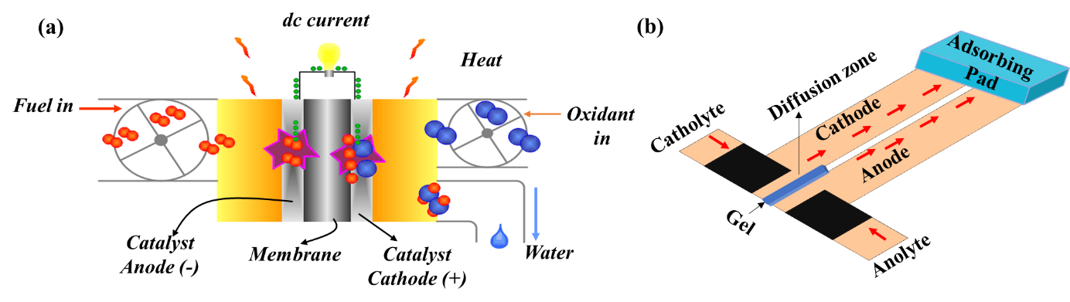
Figure 1. (a) Polymer electrolyte membrane-based fuel cells, and (b) Paper-based microfluidic fuel cells.
References

[1] S. Chandra, S. Lal, V.M. Janardhanan, K.C. Sahu, M. Deepa, Ethanol based fuel cell on paper support, J. Power Sources. 396 (2018) 725–733. https://doi.org/10.1016/j.jpowsour.2018.06.068.

[2] S. Lal, V.M. Janardhanan, M. Deepa, A. Sagar, K.C. Sahu, Low Cost Environmentally Benign Porous Paper Based Fuel Cells for Micro-Nano Systems, J. Electrochem. Soc. 162 (2015) F1402–F1407. https://doi.org/10.1149/2.0251514jes.

