Novel Biomarkers FAM168s in Neurodegenerative Diseases and Cancers
¹DS. Sidharth¹, C. Saswata¹, H. Klaus² and P. Subrata^{*, 1, 3}
¹Jyoti and Bhupat Mehta School of Health Science and Technology, Indian Institute of Technology Guwahati, Guwahati 781039, Assam, India
²Graduate School of Biomedical Science and Engineering, Hanyang University, 222 Wangsimni-ro, Seongdong-gu, Seoul, 133-791, Republic of Korea
³Centre for Nanotechnology, Indian Institute of Technology Guwahati, Guwahati 781039, Assam, India
Presenter email: sidharth23@rnd.iitg.ac.in (SDS), *Corresponding author: subrata.pramanik@iitg.ac.in (SP)

Abstract
The two known major classes of inhibitors that limit mammalian central nervous system (CNS) regeneration are myelin-associated inhibitors (MAIs) and chondroitin sulfate proteoglycans (CSPs). FAM168B is a novel CNS-specific neuronal protein Mani (Myelin-associated neurite-outgrowth inhibitor). Computational analysis revealed that families with sequence similarity 168-member A (FAM168A) and FAM168B have shown some important similarities in the coding sequence (CDS) region. Previous findings have shown that FAM168B is an affecting factor in neurodegenerative diseases, and also it has shown promoter hypermethylation in the Cu²⁺-induced zebrafish embryos. Also, it was found that both FAM168A and FAM168B have been found to interact with numerous proteins involved in the cell cycle, e.g., cell division cycle protein 27 homolog (CDC27) and CDC42. Our phylogenetic studies between the FAM168A and FAM168B showed keen similarities in terms of genomic analysis. The outcomes of these studies should reveal key neuronal regulators of cancer, which are embedded in the interplay between the nervous system and cancer. This will serve as an example of the connections between cancer and neurodegenerative diseases and lead to the discovery of neural activity that drives malignant processes such as tumor genesis, development, metastasis, and modification of the tumor immunological microenvironment. In the long run, this idea will lead to a deeper neural knowledge of cancer, and therapies that specifically target connections between the nervous system and cancer will emerge as a promising new therapeutic option.
Research & Industrial Conclave 2023 "An amalgamation of Academia, Industry & Start-up”
"

Keywords: Neurodegenerative Diseases, Cancer, FAM168A, FAM168B, Cell Cycle, Mani
Student Academic Board (SAB), Indian Institute of Technology Guwahati, Guwahati, Assam, India
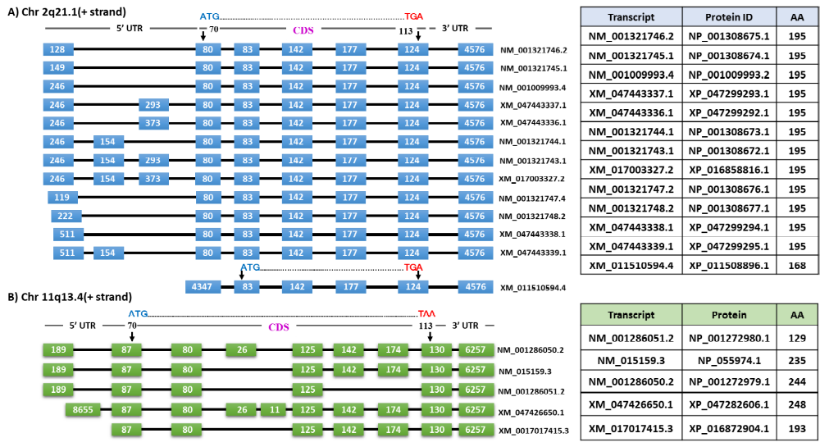

Figure 1. Sequence similarities between FAM168A and FAM168B and their mRNA isoforms and amino acids (AA). The CDS region of FAM168B remains stable across the isoform (195 AAs) except for one isoform with 168 AA. Whereas, the CDS region of FAM168A varied among the isoforms.

References:
Mishra, M., Lee, S., Lin, M. K., Yamashita, T., & Heese, K. (2012). Characterizing the neurite outgrowth inhibitory effect of Mani. FEBS letters, 586(19), 3018–3023.
Mishra, M., Akatsu, H., & Heese, K. (2011). The novel protein MANI modulates neurogenesis and neurite-cone growth. Journal of cellular and molecular medicine, 15(8), 1713–1725.
Pramanik, S., Kutzner, A., & Heese, K. (2017). Livebearing or egg-laying mammals: 27 decisive nucleotides of FAM168. Bioscience trends, 11(2), 169–178.
Zhang, T., et al (2020). Copper stress induces zebrafish central neural system myelin defects via WNT/NOTCH-hoxb5b signaling and pou3f1/fam168a/fam168b DNA methylation. Biochimica et biophysica acta. Gene regulatory mechanisms, 1863(10), 194612.

