Investigating the potential of the ErpY-like protein of Leptospira in regulating hemostasis
Saswat Hota and Manish Kumar*
Department of Biosciences and Bioengineering, Indian Institute of Technology Guwahati, Guwahati, Assam, 781039
E-mail: saswat.hota@iitg.ac.in
The onset of leptospirosis caused by the pathogenic Leptospira depends on its ability to survive in the host by evading and countering the immune response and spreading to different host tissues [1, 4]. Like other pathogens, Leptospira expresses multiple virulence factors that interfere with immune signalling pathways, inhibiting the host's defence mechanisms to facilitate infection and pathogenesis [3, 4]. In a recent study, an outer membrane surface-exposed ErpY-like lipoprotein (LIC11966) has been proposed to be expressed exclusively by pathogenic Leptospira and helps increase the virulence capacity. Our research group has shown that the ErpY-like protein is a supramolecule with moonlighting effect [3]. ErpY-like protein contributes to the bacterium's virulence by binding to different extracellular matrix components in mammalian hosts. The protein's interaction with complement regulators factor H (FH) and factor I (FI) enables Leptospira to evade the host complement system, further enhancing its pathogenicity [3,4]. Here we show that the recombinant form of this protein inhibits the clotting of platelet-poor citrated bovine plasma in a concentration-dependent manner. In fact, adding 2 µM of rErpY-like protein to 20% diluted bovine plasma completely halts the clotting process. Furthermore, rErpY-like protein at a concentration of 2 µM reduces fibrin clot formation in diluted bovine plasma by approximately 95%. The recombinant ErpY-like protein is capable of prolonging the clotting time of bovine plasma by more than 1.5-fold, by targeting both the extrinsic and common pathways of coagulation. These findings demonstrate the multifaceted function of ErpY-like lipoprotein in leptospiral infection, including its ability to impact coagulation rates in host organisms.
Keywords: Leptospira, Host-pathogen interaction, ErpY-like protein, anti-coagulation
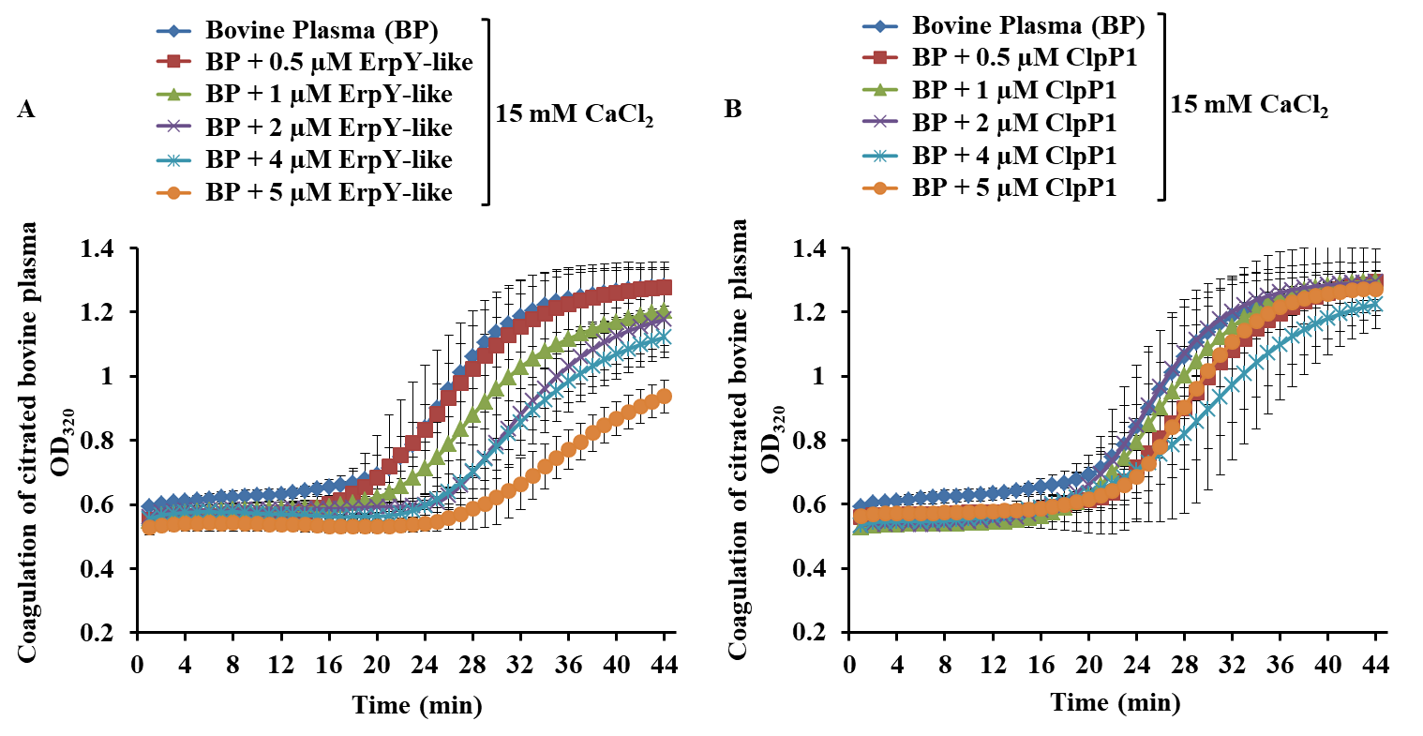
Figure 1. The results of a time-dependent absorbance assay investigating the inhibitory effect of the recombinant ErpY-like protein on bovine plasma coagulation. Citrated bovine plasma (80 µL) was incubated with increasing concentrations (0.5 – 5 µM) of rErpY-like (A) or rClpP1 (negative control; B) for 15 min at 37°C in a microtiter plate. Following incubation, CaCl2 (15 mM) was added to the plasma, which was then mixed by pipetting after adjusting the volume to 100 µL with Tris-HCl buffer (pH 8.0). The absorbance at 320 nm was recorded at 37°C over time, and reactions were performed in duplicates, thrice independently. ClpP1 instead of ErpY-like was used as a control.

