An Efficient Numerical Method for Solving Generalized
Black-Scholes Equation Arising in Finance

Saurabh Bansal¹ and Srinivasan Natesan²*
Department of Mathematics, Indian Institute of Technology, Guwahati, 781039 – India
¹E-mail : sbansal@iitg.ac.in
²E-mail : natesan@iitg.ac.in

Abstract
Student Academic Board (SAB), Indian Institute of Technology Guwahati, Guwahati, Assam, India
Research & Industrial Conclave 2023 "An amalgamation of Academia, Industry & Start-up”
"

In this article, we consider a generalized Black-Scholes equation for European options.
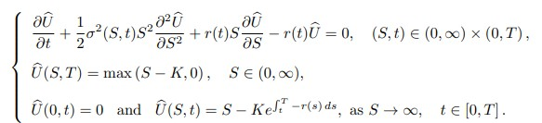
Here Ȗ(S,t) is the European call option price at asset price S and at time t, K is the exercise price, T is the maturity, r(t) is the risk-free interest rate, and σ(S,t) represents the volatility function of underlying asset.
First we discretize the temopral variable by Crank-Nicolson scheme, and then the resultant semi-discrete problem by the central difference scheme. From this we got second order convergence in both spatial and temporal variable. To improve the accuracy we apply the Richardson extrapolation technique, by solving the fully discrete problem on two different meshes and got approximately fourth-order accuracy. The stability and convergence are studied. Also we showed the proposed method is efficient to solve not only vanilla options but exotic options as well. Numerical examples are presented to validate our scheme.

Keywords: Option pricing, European call, Black-Scholes PDEs, Crank-Nicolson scheme, finite difference schemes, Richardson extrapolation technique.

