Supramolecular Nanostructures of alternating L/L and D/L amino acid containing dipeptides

Sayanta Roy¹, Rajat Subhra Giri¹ and Bhubaneswar Mandal¹*
1 Department of Chemistry, IIT Guwahati, India

E-mail: bmandal@iitg.ac.in

Abstract

Self-association of the small peptides has important applications in bioorganic chemistry, material sciences, and medicinal chemistry.¹ Alternating D/L amino acids containing peptide-based supramolecular structures are not explored enough. The self-assembly of N- and C-protected alternating L/L and D/L amino acids containing dipeptides, Boc-L-Val-L-Ile-OMe (1), Boc-D-Val-L-Ile-OMe (2), Boc-L-Ile-L-Val-OMe (3), and Boc-L-Ile-D-Val-OMe (4) has been investigated. Field emission scanning electron microscopy (FESEM) and atomic force microscopy (AFM) anlysis indicated that 1 and 3 self-associated to form highly organized straight net microrods, whereas 2 and 4 self-assembled to form hexagonal hollow microtube-like architecture in solution.
Student Academic Board (SAB), Indian Institute of Technology Guwahati, Guwahati, Assam, India
Research & Industrial Conclave 2023 "An amalgamation of Academia, Industry & Start-up”
"
To understand the physical basis of such differential behaviour, we also performed X-ray diffraction study. The single-crystal X-ray diffraction (SC-XRD) study revealed that 1 and 2 self-assembled to form slightly different helix-like architectures. The higher-order association of 2 exhibited a hollow hexagonal tube-like superstructure. The thermal stability of the nanostructures also varied based on the chiroptical composition of the dipeptides. Experimental findings were correlated with computational studies.² The obtained results may be helpful in nano-biotechnology, biomedical as well as in material science.

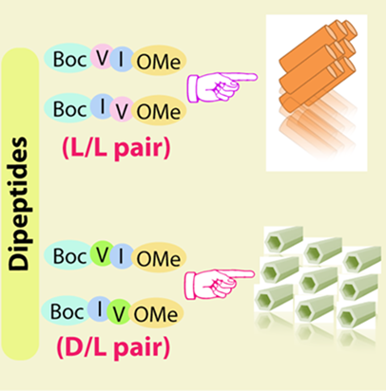

Figure 1. Molecular self-assemble in crystalline state.

Keywords: L/L and D/L amino acids containing peptides, self-assembly, nanorod, nanotube.

References

- Li, Y.; Wang, Y.; Huang, G.; Gao, J. Chem. Rev. 2018, 118, 5359.
- Giri, R. S.; Pal, S.; Roy, S.; Dolai, G.; Manne, S. R.; Paul, S.; Mandal, B. Pept. Sci. 2021, 113, e24176.

