Magnetic glass like signature and path dependent magnetization reversal and spin reorientation phenomenon in Gd substituted SmCrO₃

S. Das*, R. K. Dokala, P. K. Mishra, and S. Thota
*Lead presenter
Department of Physics, Indian Institute of Technology Guwahati, 781039, Assam, India

Abstract

The magnetic properties of rare earth chromites with Pbnm/Pnma space group and slightly distorted orthorhombic crystal structure have been thoroughly investigated over past few decades because of their intriguing characteristic bipolar switching of magnetization and spin-reorientation phenomena which have direct application towards thermo-magnetic switches, volatile magnetic memory, thermally assisted-MRAM, thermomagnetic power generation etc., [1-3]. The viscous retardation of nucleation and (or) crystallization of a magnetic phase in the background of another magnetic phase is nomenclatured as magnetic glass like signature. In this work we present the field driven magnetic switching and spin reorientation and magnetic glass property of the Ce substituted SmCrO₃ which were synthesized using standard solid state reaction method. The single phase nature of the compound and its electronic structure has been probed by X-ray diffraction and X-ray photoelectron spectroscopy, respectively. Cerium substitution at Sm sites lead to a significant enhancement in the antiferromagnetic Néel temperature (T_{N} to 202 K) with G-type Γ₄ (G_{x}, A_{y}, F_{Z}) spin configuration as compared to pristine SmCrO₃ which shows T_{N} ~191 K accompanied by a spin reorientation temperature (T_{SR}) at ~ 33 K with an altered magnetic phase Γ₁ (A_{x}, G_{y}, C_{z}) along with the high temperature Magnetic-compensation point (T_{Comp}) ~ 200 K. We have taken a few loops within the range of magnetic glass temperature (T_{MG} ~ 37 K) using field cooled cooling (FCC) and Field cooled warming (FCW) protocols (see Figure) and in each case below T_{MG}, the FCW followed the lower magnetization than that of FCC and merges just above T_{MG}. The magnetization switching at higher tempearture make the Ce-SmCrO₃ as a perfect candidate for aforementioned applications. In the present case Cr³⁺ induced internal field (H_{int}) below T_{N} which aligns the rare earth Sm³⁺ and Ce³⁺ antiparallel and parallel to the external applied field (H_{DC}) under zero-field cooled warming (ZFCW) and field cooled warming (FCW) condition respectively. The rare earth sublattice magnetization intensifies the anti-parallel component resulting the magnetization switching below T_{Comp}. The intriguing feature lies in the field dependence magnetization switching as H_{int} fails to hold the antiparallel moment and the negative magnetization vanishes (for H_{DC} = 200 Oe) whereas it persists upto H_{DC} = 100 Oe under ZFCW protocol. The T_{SR} originates as a result of competing interaction between H_{DC} and net magnetic moment (M_{Net}) with positive Zeeman energy which abruptly switches to negative magnitude (from = 0 to Π) resulting a first order phase transition.
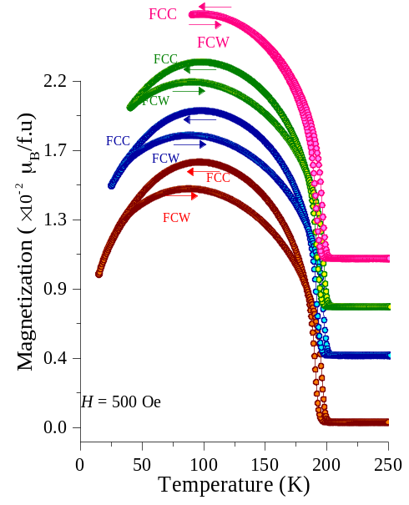

Figure. 1. M vs T representing the magnetic glass characteristics which shows the clusters of Γ₁ (A_{x}, G_{y}, C_{z}) in the Γ₄ (G_{x}, A_{y}, F_{Z}) background.

