Realization of Borophene Quantum Dots through Chemical Exfoliation and their Application in Metal Ion Sensing

Shipra Aswal1 , P.K. Giri1,2

1 Centre for Nanotechnology, 2 Department of Physics,
Indian Institute of Technology Guwahati, Guwahati- 781039, India

E-mail: shipra@iitg.ac.in

Borophene is a relatively unexplored two dimensional (2D) layered material that is known for its high carrier mobility and high robustness. Being the lightest 2D layered material, borophene quantum dots (BQDs) with small lateral dimension have triggered a surge of interest in the material research community due to its distinct electronic and optical properties. In this work, we have carried out a sonication-assisted liquid-phase exfoliation method assisted with ball milling of low-cost boron chunks to synthesize ultra-small sized BQDs of dimensions ~5 nm. The BQDs are few layered in nature, confirmed by atomic force microscopy. The as-synthesized BQDs exhibit extraordinary visible photoluminescence (PL) with high quantum yeild and emission wavelength is found to be excitation wavelength-dependent ( Figure 1). Interestingly these QDs shows quenching in PL in the presence of different metal ions at ultra-low concentration. The selective coordination to different ions (Fe³⁺, Ag⁺, Mg⁺, Na⁺,Ca²⁺) with the BQDs has been studied systematically. The proposed sensor is successfully implemented, for the first time, for the sensitive detection of Fe³⁺ ions at nanomolar level, and mechanism of sensing is explored in detail. Our results indicate that BQDs hold great potential for development of highly sensitive ion sensors in the future.

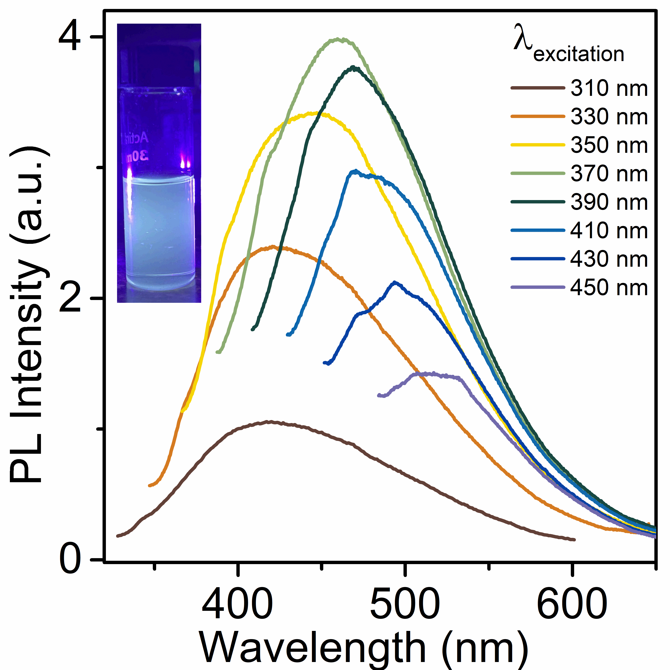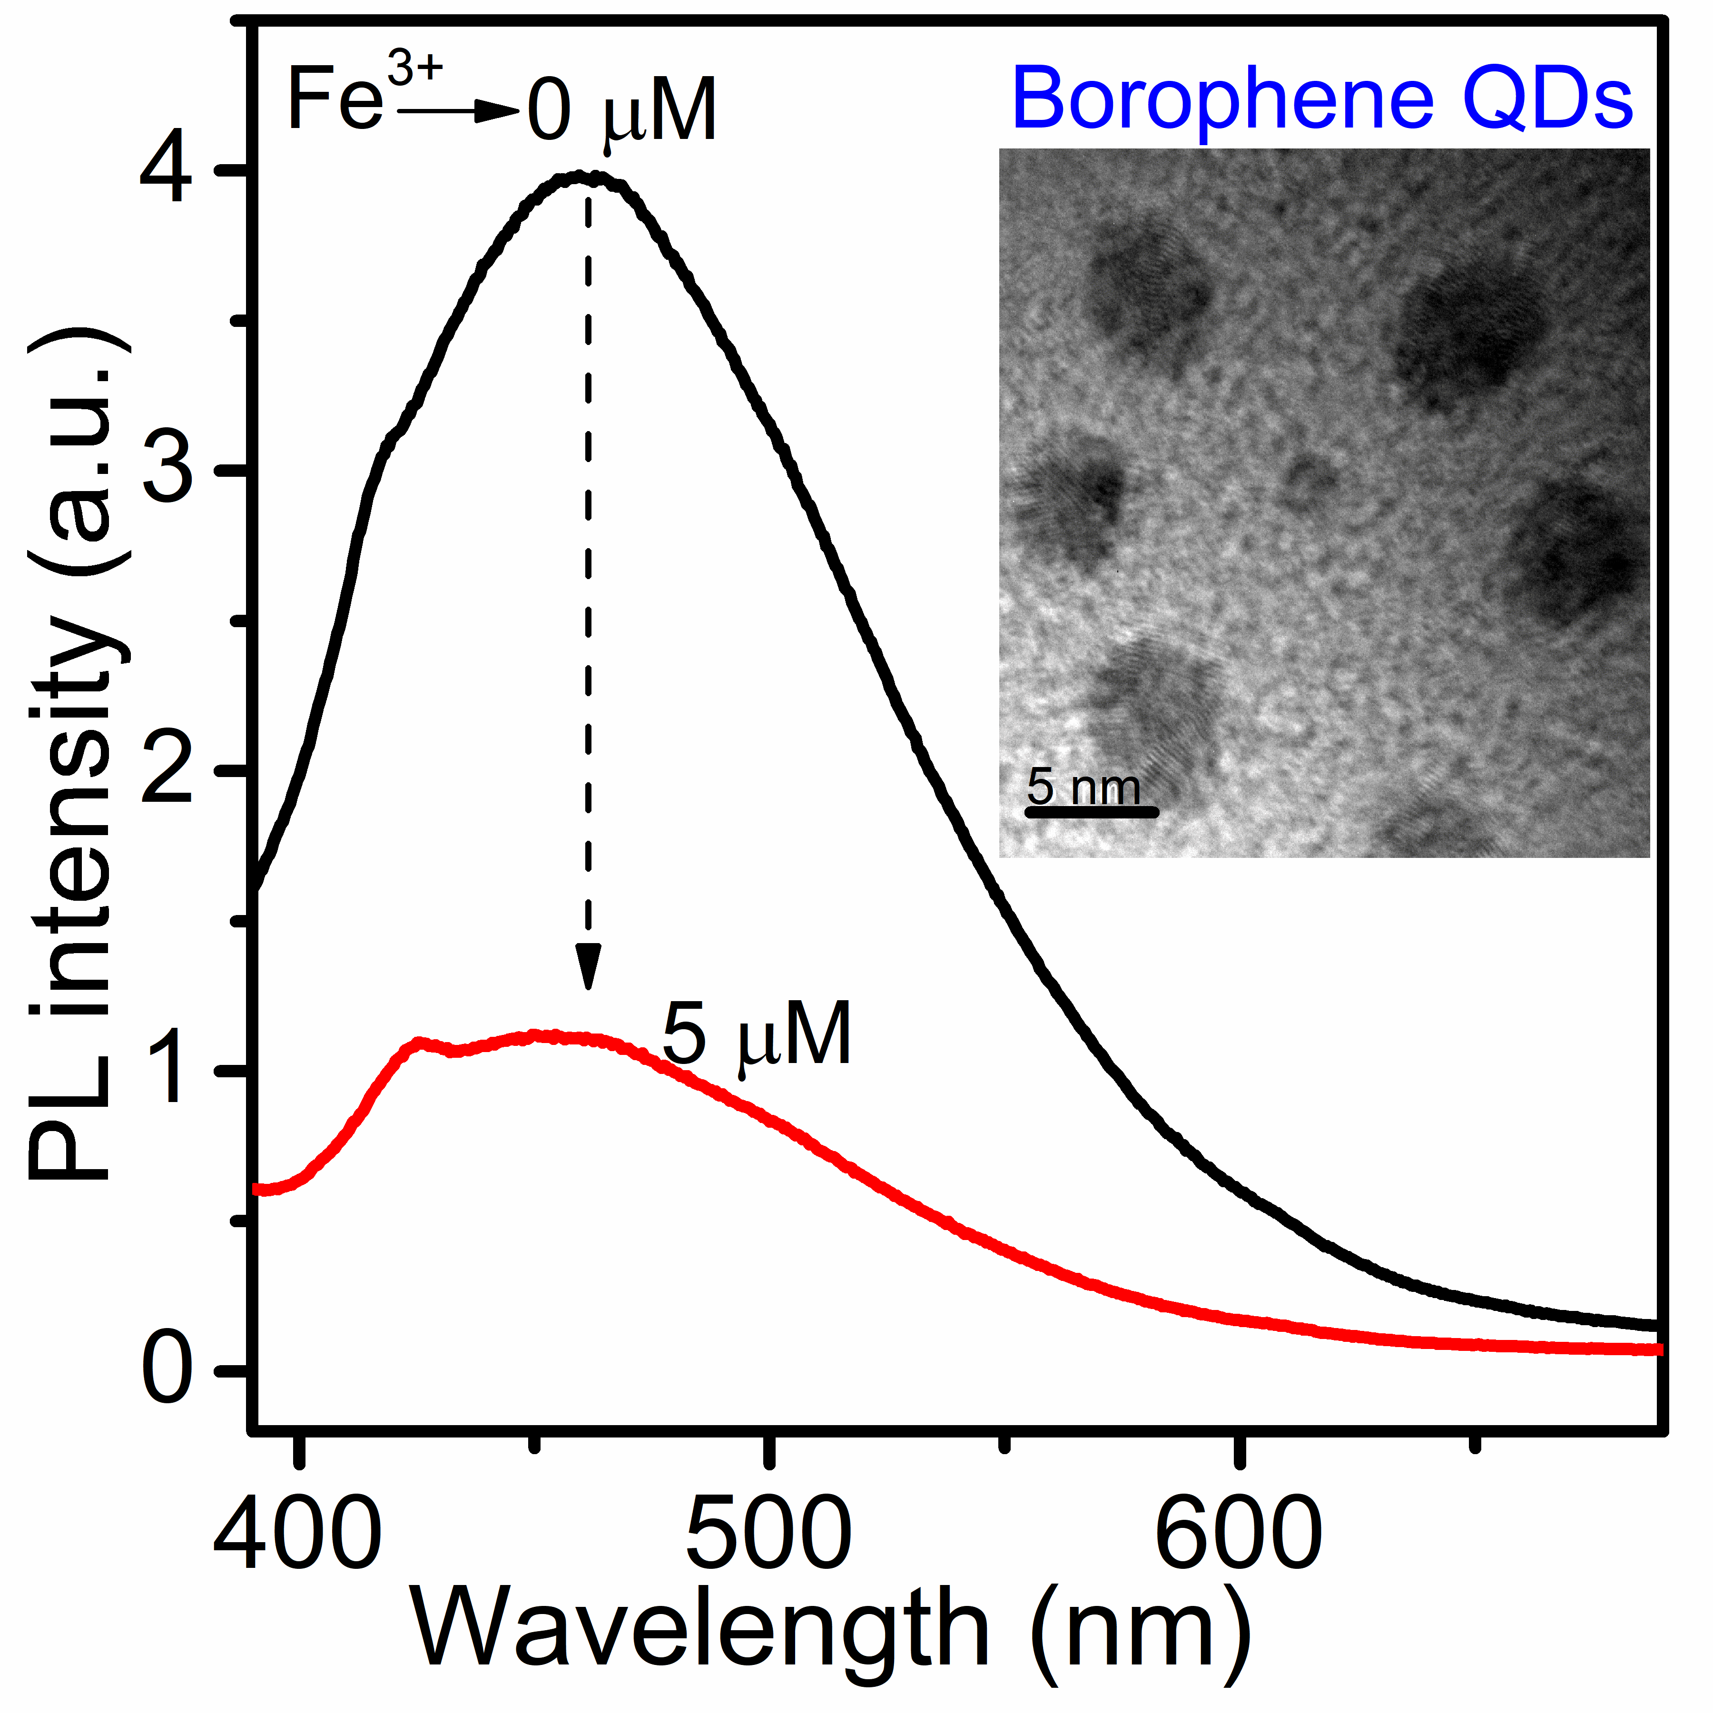

Figure 1: Excitation-dependent PL emission spectra of BQDs. The inset shows the digital photograph of the green emission from BQDs with UV-excitation.

Figure 2: PL spectra of BQDs before and after addition of Fe³⁺. The inset shows a TEM image of the BQDs.

Keywords: Borophene, 2D Quantum dots, ion sensor.

