Emergency Braking of Overhead Crane

Shivani Raj1 *, Arup Deka1 and
B. Sandeep Reddy1

1 Department of Mechanical Engineering, IIT Guwahati, India

E-mail: rshivani@iitg.ac.in

Abstract

Overhead cranes (OHC) are machines commonly used in transportation industries for carrying heavy loads. The control problem in OHC deals with the development of anti-swing control systems to ensure that payload swing is minimized during travel. A large fraction of the literature on OHC overlooks the safety aspect of it; namely the development of industrial braking systems for emergency scenarios, which are necessary to avoid industrial accidents. This is known as the emergency braking problem and very few researchers have addressed this problem comprehensively. This paper presents the development of controllers for addressing the emergency braking problem in an OHC. The pendulum stabilization problem is also important for another type of engineering systems - namely, drones carrying payloads, and given that such a system has similar dynamic properties as the OHC, this work has future prospects. The schematic diagram of OHC is represented in figure 1 and figure 2.
Student Academic Board (SAB), Indian Institute of Technology Guwahati, Guwahati, Assam, India
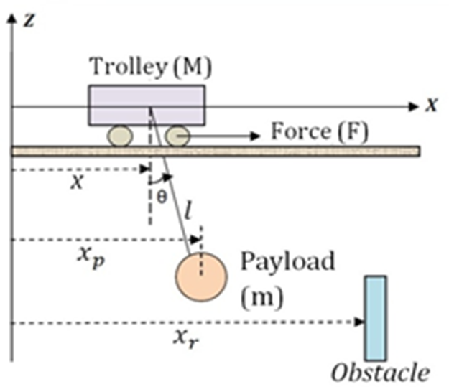 | 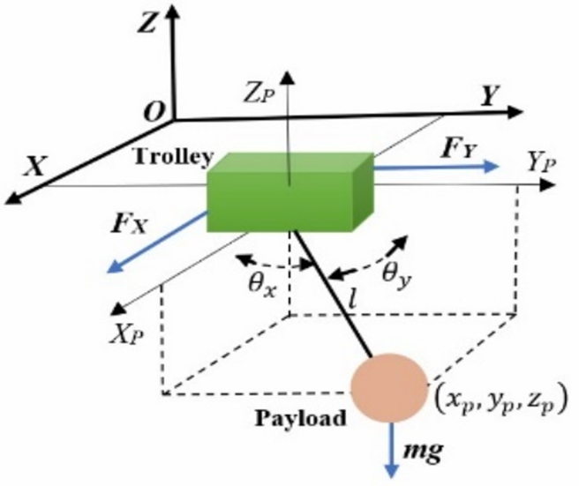
Fig 1. Schematic diagram of 2D OHC model | Fig 2. Schematic diagram of 3D OHC model

The work on the emergency braking, which was initially studied for the 2D problem can be extended to the 3D case, as shown in Figure 2. Emergency braking controllers have been designed using Fuzzy Logic, Sliding Mode Control and Adaptive feedback control. Few of the results are shown in the figures below.
Research & Industrial Conclave 2023 "An amalgamation of Academia, Industry & Start-up”
"
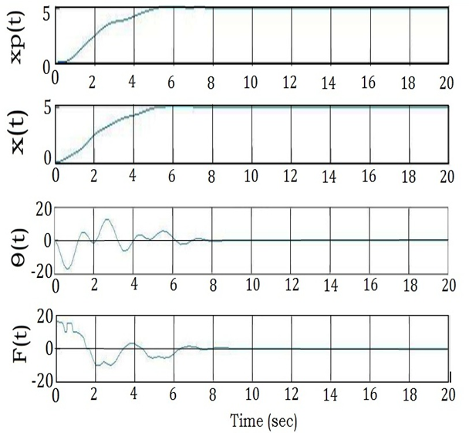 | 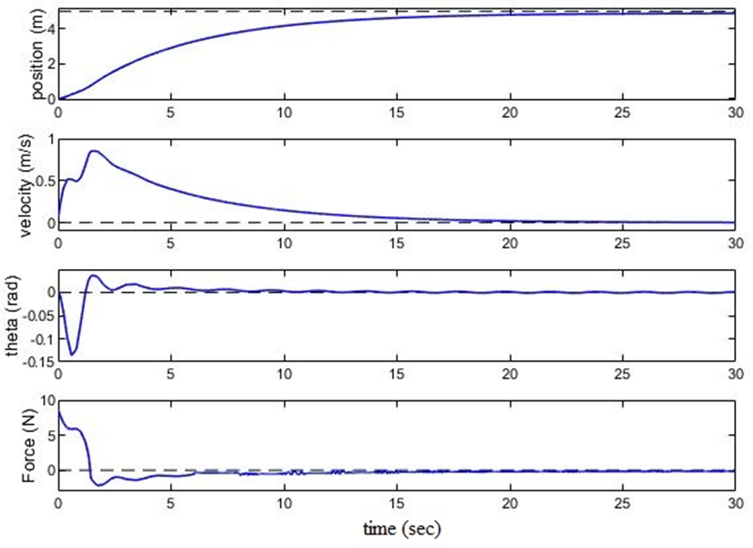
Fig 3. Results of Fuzzy logic controller in 2D OHC | Fig 4. Results of Sliding mode controller in 2D OHC
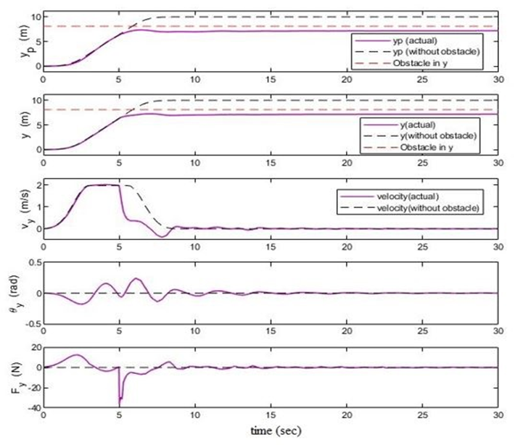 | 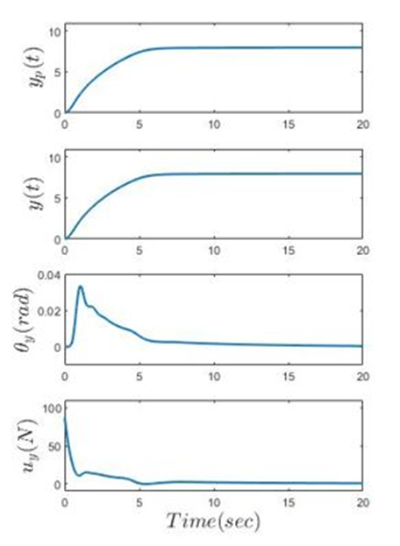
Fig 5. Results of PD-Fuzzy controller in 3D OHC | Fig 6. Results of Adaptive feedback controller in 3D OHC

Keywords: OVERHEAD CRANE, EMERGENCY BRAKING, FUZZY LOGIC, OBSTACLE, CONTROLLER

