In vitro callus induction from flower explant of night-blooming jasmine
(Cestrum nocturnum)

Shrushti Jain, Chetna Sharma, Krishna Kant Pachauri and Rakhi Chaturvedi*
Department of Biosciences & Bioengineering, Indian Institute of Technology Guwahati,
Guwahati-781039, Assam, INDIA
*E-mail: rakhi_chaturvedi@iitg.ac.in

Abstract
Student Academic Board (SAB), Indian Institute of Technology Guwahati, Guwahati, Assam, India

Cestrum nocturnum is an evergreen woody shrub belonging to the Solanaceae family. It is commonly referred to as the night-blooming jasmine, is well known for its ornamental, chemical, and bioactive potential. The ethnopharmacological use of night jasmine includes anti-inflammatory, antibacterial, antiepileptic, antimalarial, cardioactive, anticancer and antifungal activity. Flower of Cestrum nocturnum has the ability to produce volatile aromatic compounds, most of which are secondary metabolites. In order to meet commercial demand, the undifferentiated mass of cells (callus) from flower explant can be used as a continuous source of therapeutically relevant secondary metabolites for biotechnological applications. In this present investigation fully opened flower from field grown plant was collected and disinfected by different sterilization protocols. Thereafter flower explant was inoculated in MS media supplemented with 1μm 2,4-D + 1μm NAA + 5μm BAP for callus induction (Fig.1 B). Induction of callus was observed after 20 days of culture. Initially the callus was grown in test-tube (Fig.1 C), after that callus was transferred from test tube to glass jars (Fig.1 E), followed by shake flask culture. Faster multiplication of callus was observed in liquid shake flask culture (Fig.1 F). Callus cultures from flower explant further utilized for sustainable and continued production of secondary metabolites in pharmaceuticals, cosmetics, food, and allied industries.
Research & Industrial Conclave 2023 "An amalgamation of Academia, Industry & Start-up”
"

Keywords: Aromatic, bioactive, metabolites, solanaceae, volatile
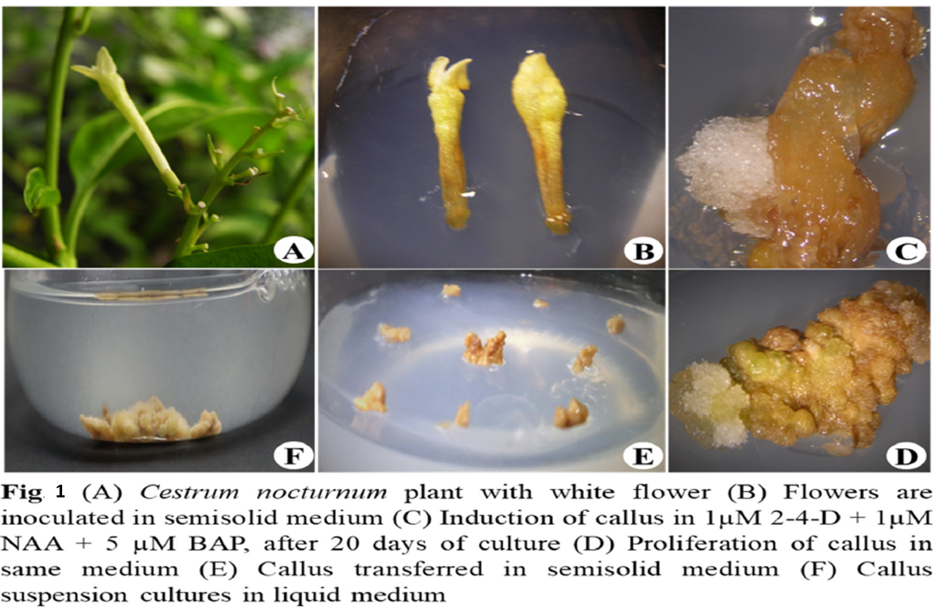

Reference:

1. Haggag M. I. (2022). Phytochemical profile for Cestrum nocturnum leaves ethanolic extract and isolation of a rare flavonoid using different chromatographic and spectroscopic techniques. J. Med. Plants, 10, 143-150

