p-TSA•H₂O Catalyzed Synthesis of 2,4-Diarylquinoline under Metal- and Solvent-free conditions

S. Faraz1 , and A.T. Khan1

Department of Chemistry, Indian Institute of Guwahati, Guwahati-781039, Assam, India

E-mail: atk@iitg.ac.in

Abstract

Quinoline is one of the most ubiquitous and privileged nitrogen-containing heterocycles and it is an integral part of naturally occurring alkaloids.^{1a,b} These derivatives have a significant role in drug discovery due to their numerous pharmacological activities. Very recently, the usefulness of p-TSA•H₂O is demonstrated for the synthesis of 2-benzyl-3-arylquinoline derivatives.² Utilizing three-component reactions, the efficient and straightforward synthesis of 2,4-diarylquinoline³ derivatives using p-toluene sulfonic acid as a catalyst under metal- and solvent-free conditions will be presented. The salient features of the two protocols are the nonrequirement of a metal catalyst, additive, solvent, and inert atmospheric reaction conditions, good yield, a wide substrate scope, shorter reaction time, and the formation of one C−N and two C−C bonds in a single step.
Research & Industrial Conclave 2023 "An amalgamation of Academia, Industry & Start-up”
"
Student Academic Board (SAB), Indian Institute of Technology Guwahati, Guwahati, Assam, India

Keywords: nitrogen-containing, heterocycles

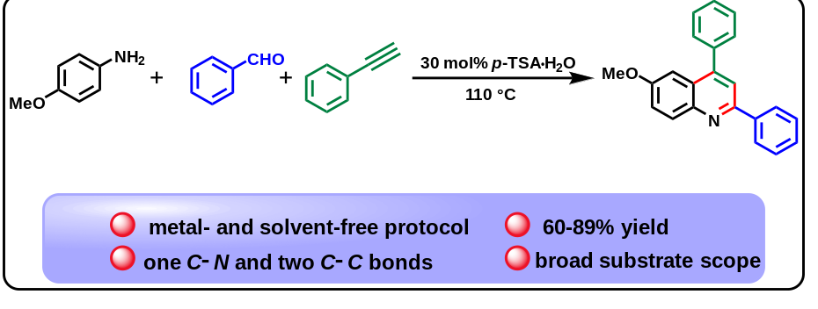

References:
[1] a) V. R. Solomon, W. Haq, K. Srivastava, S. K. Puri, S. B. Katti, J. Med. Chem. 2007, 50, 394– 398; b) X.-F. Shang, S. L. Morris-Natschke, Y.-Q. Liu, X. Guo, X.-S. Xu, M. Goto, J.-C. Li, G.-Z. Yang, K.-H. Lee, Med. Res. Rev., 2018, 38, 775–828.
[2] S. Faraz, M. Kumar, A. T. Khan, S. Ponneganti and P. Radhakrishnanand, Tetrahedron Lett. 2023, 115, 154283.
[3] S. Faraz, S. Yashmin, M. D. Marathe, A. T. Khan, Tetrahedron Lett., 2023, 119, 154433.

