THP1 and NK cell interaction with Breast Cancer cells in the Tumor Microenvironment

Soumik Pal¹, Prof. Bithiah Grace Jaganathan^{1, 2}

1 Department of Biosciences and Bioengineering, IIT Guwahati, India
²Jyoti and Bhupat Mehta School of Health Science and Technology, IIT Guwahati, India

E-mail: p.soumik@iitg.ac.in, bithiahgj@iitg.ac.in

Abstract

Cancer is a multifactorial disease that can be characterized by several hallmarks and evading immune-mediated destruction is one of the major hallmarks. During immune editing (Figure-1), there are three steps elimination, equilibrium, and evasion. During the Equilibrium stage, the cancer cells stop proliferating (dormancy) and derive strategies to evade the immune system. During this process, the cancer cells educate the immune cells to help in their proliferation and cancer progression.
Student Academic Board (SAB), Indian Institute of Technology Guwahati, Guwahati, Assam, India
Research & Industrial Conclave 2023 "An amalgamation of Academia, Industry & Start-up”
"
To understand the crosstalk between immune and cancer cells we have used natural killer (NK) cell line YTS, monocytic cell line THP1, and breast cancer cell line MDA-MB-231. To evaluate the effect of monocyte-secreted paracrine factors on cancer cells we have collected conditioned media (CM) from THP1 cells and treated the MDA-MB-231 cancer cells. We have performed a colony formation assay of MDA-MB-231 cells and observed that there is a decrease in colony number and colony area with THP1 CM treatment conditions. Further cell cycle analysis was performed which shows no significant change in cell cycle before and after treatment with THP1 CM. To check the ability of migration of the MDA-MB-231 cancer cells we performed a wound healing assay with THP1 CM and observed no effect on the migration potential of the cells. From gene expression analysis of MDA-MB-231 cells after treatment with THP1 CM, we observed upregulation of ERK-1/2 and anti-apoptotic protein Bcl-2. From these results, it is clear that paracrine factors secreted by monocytic cells increase cell survival but decrease self-renewal without affecting their migration ability.
Similarly, to understand the interaction between NK cells and cancer cells we have treated the cancer cells with YTS CM and also co-cultured them. From the colony formation assay, we observed that there is a decrease in colony number with YTS CM treatment conditions. To see the effect of direct contact we have co-cultured the YTS and MDA-MB-231 cells and performed a cell cycle of MDA-MB-231 cells and observed G2/M phase arrest which was overcome by the MDA-MB-231 cells with long-time co-culture conditions. Along with proliferation and self-renewal, we wanted to check the effect of paracrine factors secreted by NK cells on cancer cell migration ability, for that we performed a wound healing assay with YTS CM and observed no effect on the migration ability of MDA-MB-231 cells. Thus, it is observed that immune cells modulate the cancer cells and cancer cells derive different strategies to overcome them.
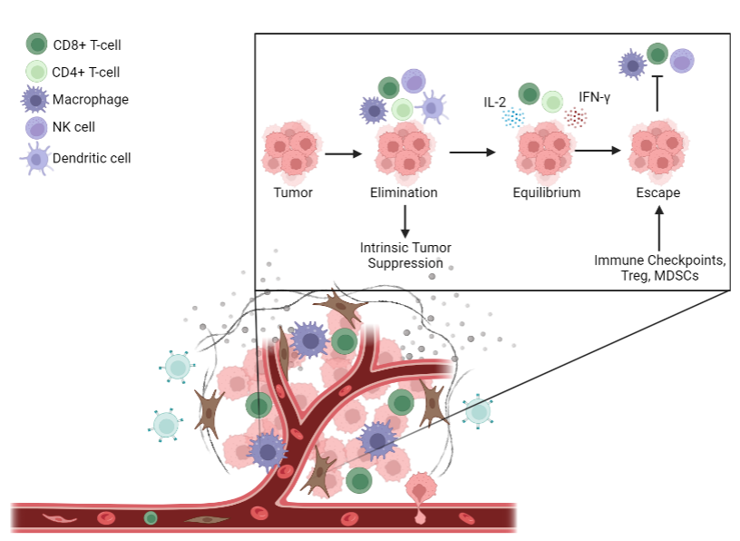
Keywords: Cancer, Immune editing, YTS, THP1, MDA-MB-231

Fig 1: Immune and cancer cell crosstalk in the Tumor Microenvironment

