Targeted Delivery and Stimuli-responsive Release of Transmembrane Chloride Transporter
Soumya Srimayee1 , Nasim Akhtar1 Subhasis Dey¹, Debasis Manna*^{,1,a}

¹Department of Chemistry, IIT Guwahati, India
E-mail: dmanna@iitg.ac.in

Abstract
The development of target-specific synthetic ion transporters may pave the way for novel approaches to treating channelopathies¹. New stimulus conditions are being researched in order to improve the precise distribution of the synthetic system at the injured site while minimizing unwanted toxicity. We reported a multistimuli responsive bis(thiourea) anionophore carbamate connecting biocompatible RGD peptide that is known as a suitable ligand for integrin receptors that are overexpressed in many cancer cells as opposed to normal cells. Glutathione and ROS responsive disulfide linkage and carbamate group are also included for anionophore generation at the target particular spot. A fluorescent assay based on lucigenin was used to determine the mechanism of the anionophore as well as its regeneration from the proanionophore, which was corroborated by MALDI-TOF data.
Keywords: RGD, Glutathione, Integrin receptor

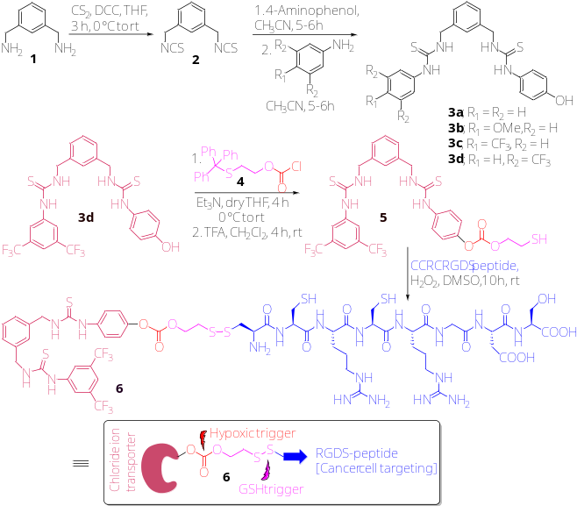
Scheme 1: Synthetic Procedure for preparation of 3a to 3d, and 6.

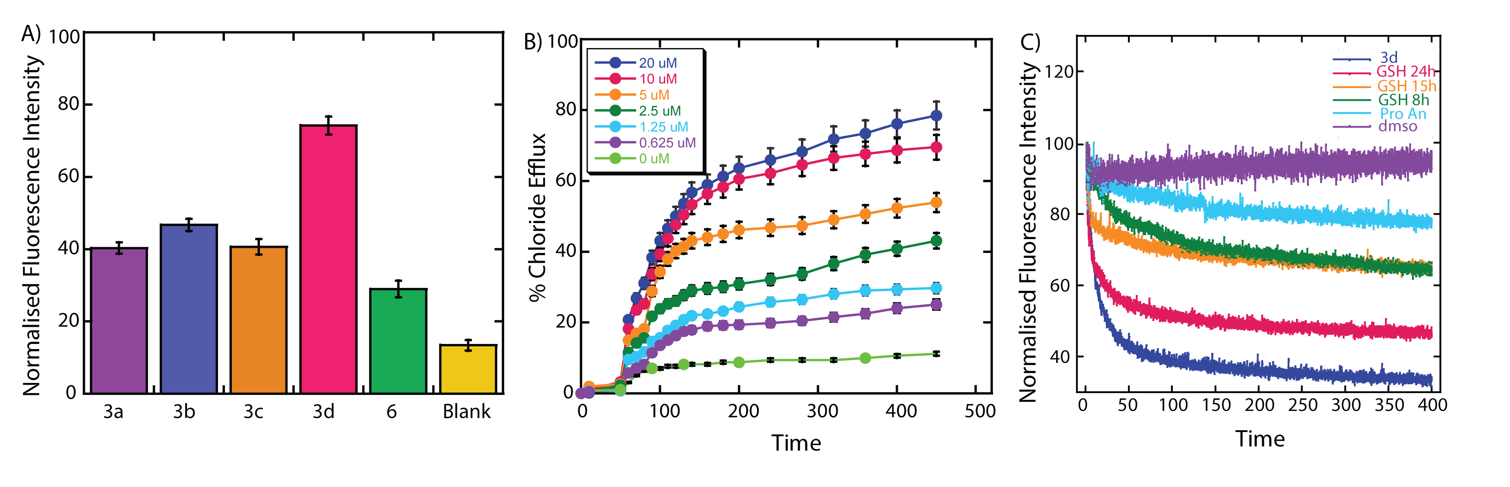
Figure 1: A) Screening of synthesized compound EYPC/CHOL⸧ Lucigenin LUVs. (3a to 6, Blank=DMSO). B) Concentration dependent plot of compound 3d in EYPC/CHOL⸧ Lucigenin LUVs. C) Study of regeneration of anionophore in fluorescence using EYPC/CHOL⸧ Lucigenin LUVs.
Reference: 1. Akhtar, N.; Biswas, O.; Manna, D.*; Chemical Communications, 2020, 56, 14137-14153.

