Numerical Analysis of Perforation of gas cartridges used in Inflation of Personal Floatation Device

S. Jash2 , S. Kapil1,2 and S. Kanagaraj1,2

1 Department of Mechanical Engineering, IIT Guwahati, India
2 Centre for Intelligent Cyber Physical System, IIT Guwahati, India

E-mail: subhojit.jash@iitg.ac.in

Abstract

Gas cartridges are used with inflators in Personal floatation devices(PFD) which afloat a person in case of an emergency inside water. The gas cartridges are made up of carbon steel and contain pressurized gas at 60 bar. The attachment of the gas cartridge with the inflator in PFD is shown in Figure 1. This report describes the piercing of gas cartridges by a projectile under low impact velocity using Abaqus/Explicit finite element code. The mild steel material behaviour was modelled using the Johnson-cook material model [1]. The range of velocities between 3m/s to 5m/s has been covered in the study and the ballistic limit of the cartridge is evaluated. The quantitative evaluation of the force and impact energy for piercing the pressurized gas cartridges under the impact of the conical projectile is estimated and the effect of different conical angles on the values is compared. The numerical results are compared with the analytical equation and trends reported in the literature. The ballistic limit of the gas cartridge estimated from the analysis is 4m/s. The impact force is a non-linear impulse force and the maximum force at piercing obtained from simulation is 142N.
Student Academic Board (SAB), Indian Institute of Technology Guwahati, Guwahati, Assam, India

Keywords: PERFORATION, ABAQUS, NUMERICAL ANALYSIS

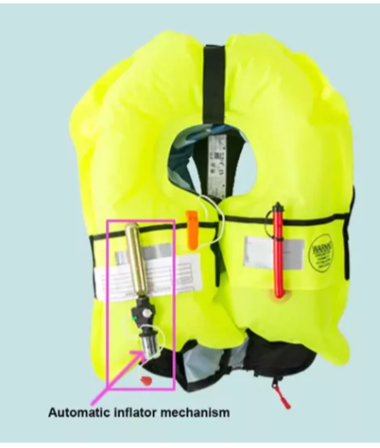

Fig. 1. Gas cartridge attachment in PFD[2]

References:
[1]Kpenyigba, K. M., Jankowiak, T., Rusinek, A., & Pesci, R. (2013). Influence of projectile shape on dynamic behavior of steel sheet subjected to impact and perforation. Thin-Walled Structures, 65, 93–104. https://doi.org/10.1016/j.tws.2013.01.003
[2] https://zenkecn.com/how-does-an-automatic-inflatable-life-jacket-work/

