Bi-Catalysed Unprecedented 1,2-Reactivity of Spiro-Cyclopropyl Oxindoles with Dithianediol: Access to Spiro-Heterocycles

Subhradeep Kar¹ and Tharmalingam Punniyamurthy¹*

¹ Department of Chemistry, Indian Institute of Technology Guwahati, Guwahati-781039
(*Email id: tpunni@iitg.ac.in)

Abstract

Efficient and diastereoselective Bi-catalyzed 1,2-reactivity of spirocyclopropyl oxindoles has been described with dithianediols as the sulphur surrogate to furnish spiroheterocycles at moderate temperature (Fig 1).¹ The procedure provides a potential approach for the construction of spiro-tetrahydrothiphene scaffolds with functional group diversities. The catalytic 1,2-reactivity of cyclopropanes, mechanistic investigation, diastereoselectivity of the products and additive-free mild reaction conditions are the salient features.
Student Academic Board (SAB), Indian Institute of Technology Guwahati, Guwahati, Assam, India

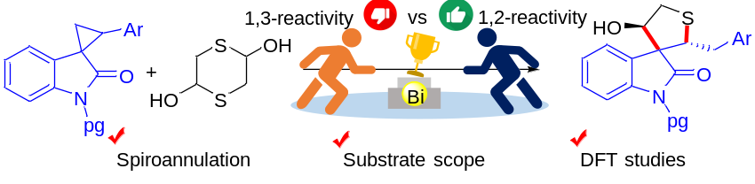.
Research & Industrial Conclave 2023 "An amalgamation of Academia, Industry & Start-up”
"
Figure 1. (3+2)-Annulation of Spiro-Cyclopropyl Oxindoles with Dithianediols.

Cyclopropanes, the smallest carbocycles, are known for their versatile activity as three-carbon synthon in chemical space.² Despite having a ring strain of 115 kJ mol-1, the cyclopropane ring does not easily tend to open up voluntarily in situ. However, specific substitution patterns, including the installation of donor and acceptor (DA) moieties on vicinal positions, endows heterolytic cleavage of the C-C bond in presence of either heat or Lewis acid and provides pivotal driving force to generate 1,3-dipolar species. In this vein, the ring enlargement of oxindole derived DA spiro-cyclopropanes has professed a substantial attention in recent years owing to the abundance of oxindole-core in potent pharmacophore moieties. On the other hand, aside from the classical 1,3-reactivity, DA cyclopropanes have recently been documented to unveil a new fascinating 1,2-dipolar system,³ although formation of such an even-numbered dipole is still a fledging topic. Further, S-containing heterocycles are one of the privileged heterocyclic units, ubiquitous in myriads of natural products and pharmaceuticals with promising anticancer, antimicrobial and antihypertension activities. Consequently, the blend of the sulphur moieties into spirocycles could lead to construct the fascinating bio-mimetic scaffolds. On the other hand, being non-toxic and eco-benign, the reactions involving bismuth(III)-salts as catalyst have been referred to as one of the highly sought-after transformations in scientific fronts. Herein, we report an efficient Bi(III)-catalyzed unprecedented 1,2-reactivity of spirocyclopropyl oxindoles with dithianediols as the sulphur surrogate to assemble spirotetrahydrothiophene structural frameworks at mild reaction conditions.

Keywords: Spirocycles, 1,2-reactivity, DFT Studies

References:
[1] Kar, S.; Sarkar, T.; Maharana, P. K.; Guha, A. K.; Punniyamurthy, T. Org. Lett. 2022, 24, 4965.
[2] Schneider, T. F.; Kaschel, J.; Werz, D. B. Angew. Chem. Int. Ed. 2014, 53, 5504.
[3] Novikov, R. A.; Tarasova, A. V.; Korolev, V. A.; Timofeev, V. P.; Tomilov, Y. V. Angew. Chem. Int. Ed. 2014, 53, 3187.

