Structural and biological Behaviour of Hydroxyapatite based ceramic composite

Subingya Pandey1 and D. Pamu1

1 Department of Physics, IIT Guwahati, India

E-mail: p.subingya@iitg.ac.in

Abstract

Biomaterials have shown great potential in improving the healing process of bone injuries and restoring the normal functionality of the human body. A bone substitute biomaterial must possess various properties, including biocompatibility, bioactivity, osteoconductivity, and osteoinductivity to function without causing any harm to the host. Among various biomaterials, Hydroxyapatite (HAp) is considered as one of the most advanced biomaterials for orthopaedics and dentistry applications. Recently, researchers have been exploring new ways to design bone-mimicking biomaterials by incorporating HAp into composite ceramics. By adding a piezoelectric component to HAp, researchers can enhance the host tissue's response to implants. Composite ceramics such as Barium Titanate (BT) with HAp have been extensively studied for their superior electrical properties in accelerating bone fracture healing, as demonstrated by Jianquing et al. [1]. Other researchers, such as Das et al. [2], have investigated a biocomposite of Strontium Titanate (ST) with HAp that results in improved dielectric properties. This can be used in the development of electrically active smart scaffolds, which can stimulate bone regeneration. However, there is still ample room for designing advanced functional biomaterials that possess non-linear electrical properties to develop the next generation of biomedical devices such as 3D printed scaffolds and electrets. Overall, the use of HAp and composite ceramics in biomaterials engineering is promising and has the potential to revolutionize the field of bone regeneration and tissue engineering.
Student Academic Board (SAB), Indian Institute of Technology Guwahati, Guwahati, Assam, India
Research & Industrial Conclave 2023 "An amalgamation of Academia, Industry & Start-up”
"
In the present work, we aim to develop a novel composite material for biomedical applications by combining the well-known biomaterial hydroxyapatite (HAp) with an efficient piezoelectric material, K_{0.5}Na_{0.5}NbO₃ (KNN). KNN being a biocompatible piezoelectric ceramic is expected to improve the physical, biological, mechanical and piezoelectric properties of the resulting composite. This can lead to enhanced bone regeneration and healing, as well as better integration with host tissues. Moreover, the piezoelectric properties of KNN can also be utilized in developing new biomedical devices and sensors. The composite has been prepared by varying the atomic percentage (At.%) of KNN in HAp (20, 40, 60, and 80%). To begin the synthesis process, we prepared HAp and KNN monoliths using sol-gel and solid-state routes, respectively. Our results showed that the composites sintered at 800°C exhibited no secondary phases and hence, this temperature was chosen as the optimized temperature for preparing the composites. The phase purity has been confirmed by X-ray diffraction (XRD) and XPS confirms the elemental composition along with the electronic states of the atoms present (Fig.1). The average crystallize size of the composites are found to be in the range of 44 – 55 nm. The morphology has been probed by Transmission electron microscopy (TEM) that clearly depicts the presence of both the nano-sized HAp and coarse KNN grains. The average grain size of composites are found to lie between 170 – 300 nm. The dielectric studies carried out in a wide range of frequencies (1 KHz-1 MHz) reveals the room temperature (30°C) dielectric constant to lie between 13 – 33 (1 MHz). In vitro bioactivity and Protein adsorption studies have been performed and the step towards relating the electrical properties with the biological properties have been established (Fig. 2).
Our study adds to the growing body of research on HAp-based composite materials and demonstrates the potential of combining HAp with novel materials for biomedical applications. Further studies on the properties and performance of the developed composite are currently underway, and we hope that our work will contribute towards the development of new and improved biomaterials for medical applications.
.
Keywords: X-ray diffraction, Dielectric constant, Biocompatibilty
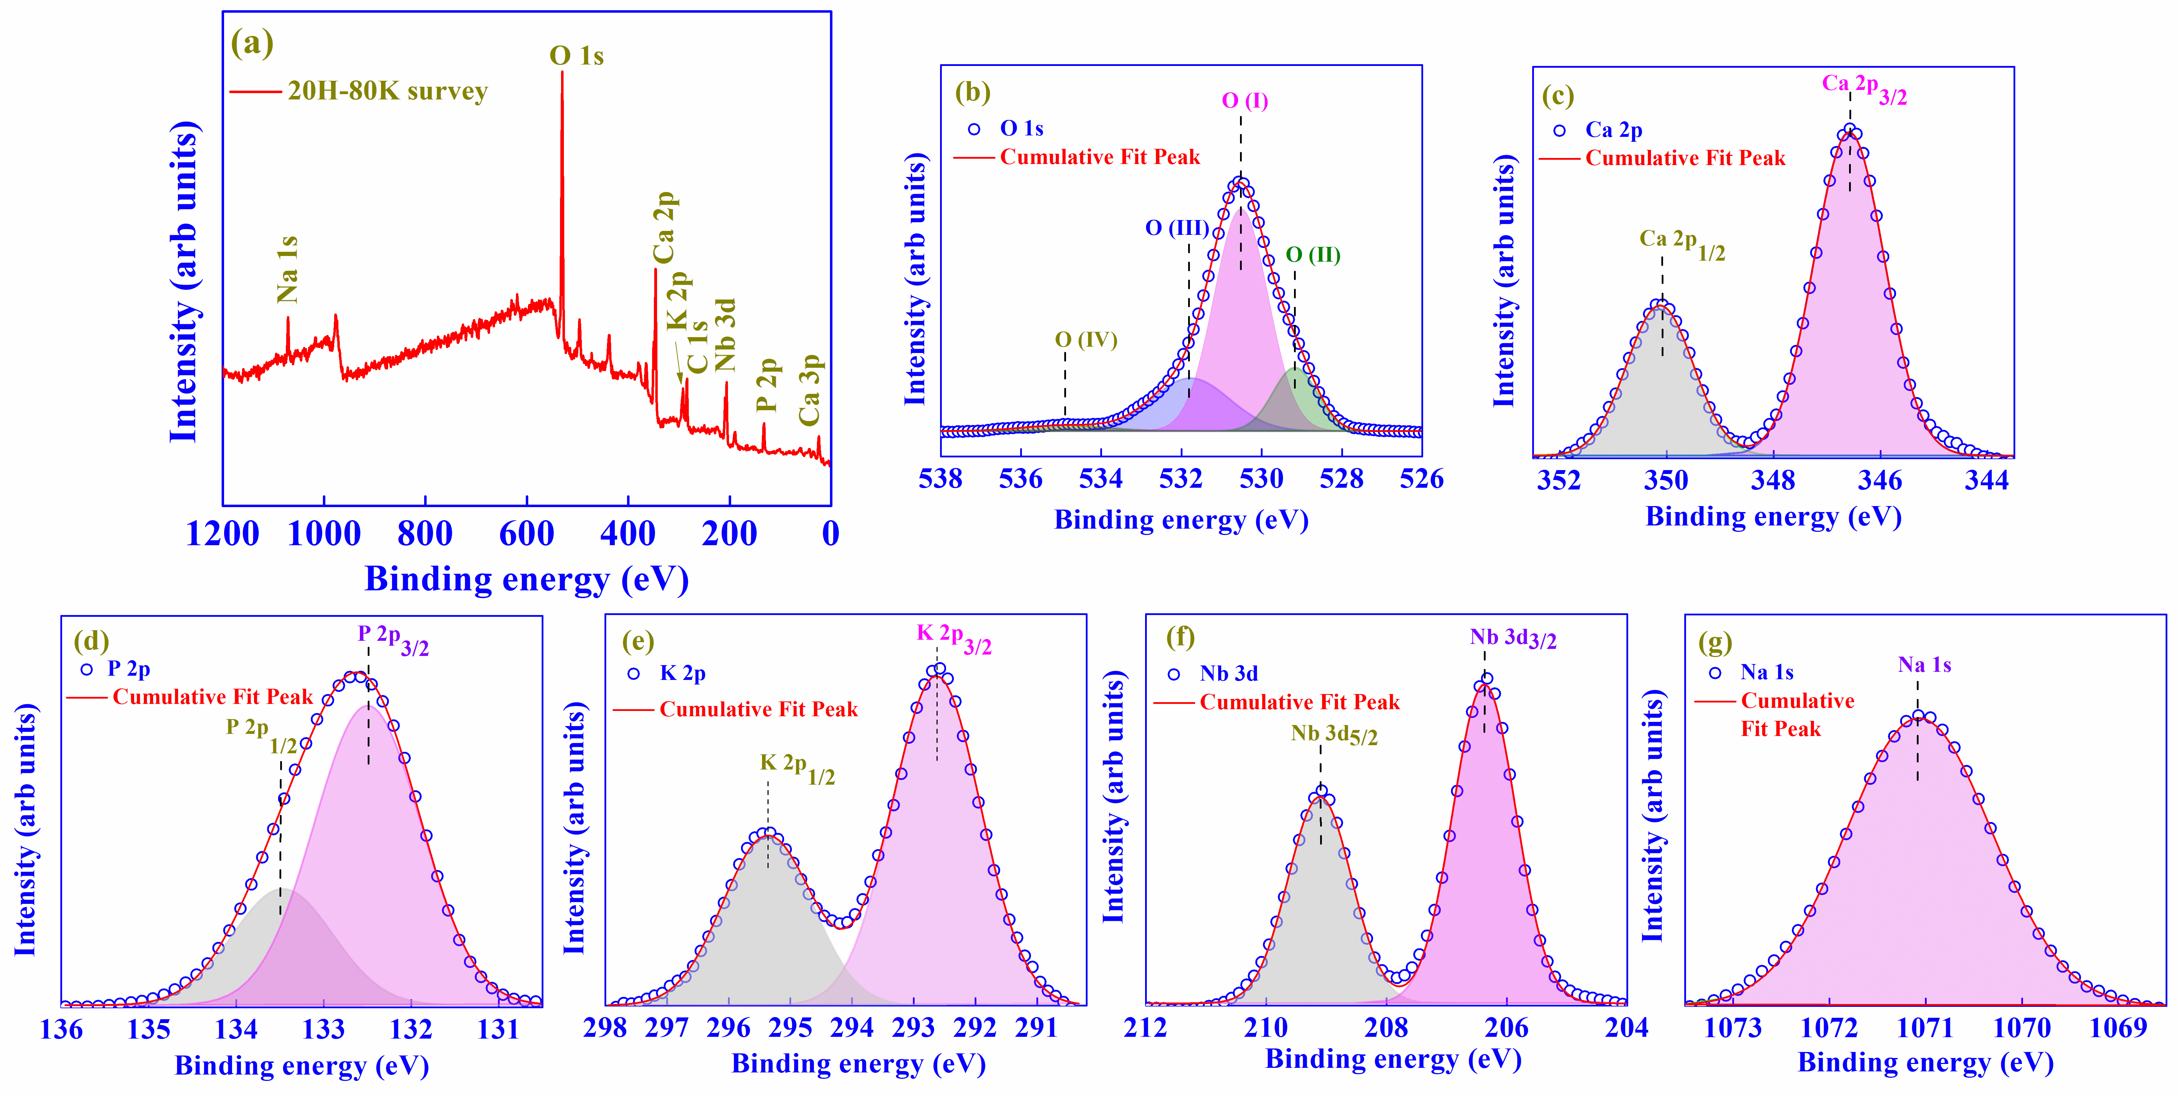
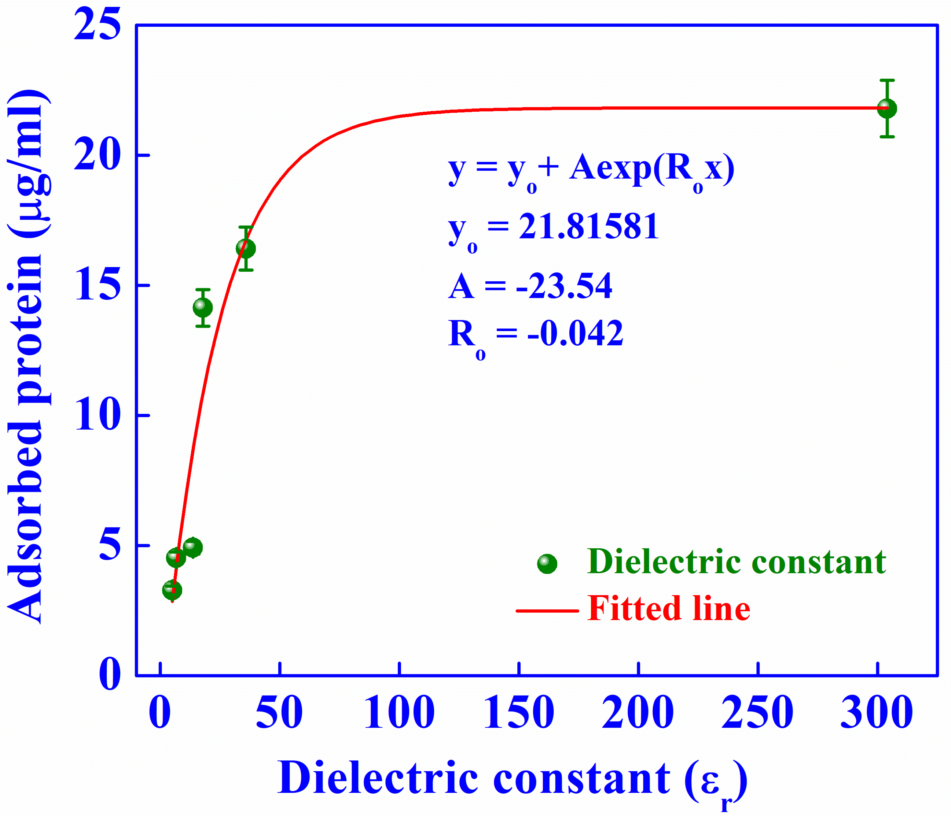

Fig. 2 Variation of adsorbed protein for different specimens as a function of ε_{r.}

Fig. 1 XPS study for the 20H-80K bioceramic composite.

1.F. Jianquing, Y. Huipin, Z. Xingdong, Promotion of osteogenesis by piezoelectric biological ceramic, Biomaterials, 18, 1997, 1531-1534.
2.A. Das, S. Rabha, A Bhardwaj, L. M. Pandey, D. Pamu, Physical, chemical and biological investigations of SrTiO3 − Ca₁₀(PO₄)₆(OH)₂ composites for biomedical applications, J. Am. Ceram. Soc., 105, 2022, 1790-1808.

