Regio- and Chemo-selective Synthesis of 3-(Dihydrofuran-3(2H)-ylidene)isobenzofuran-1(3H)-imines via Tandem Alkynyl Prins and Intramolecular Oxy-Cyclization Reaction

Sudip Shit¹, and Anil K. Saikia¹*

1 Department of Chemistry, Indian Institute of Technology Guwahati, Guwahati-781039, Assam, India
E-mail: asaikia@iitg.ac.in

Abstract
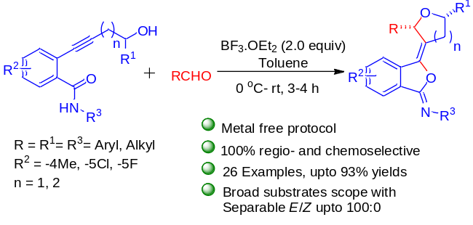

A metal-free Lewis acid initiated protocol for the synthesis of highly substituted 3-(dihydrofuran-3(2H)-ylidene)isobenzofuran-1(3H)-imine from 2-(4-hydroxybut-1-yn-1-yl)benzamides and aldehydes has been demonstrated. The reaction involves the initial formation of dihydrofuranylidene carbocation via Prins cyclization reaction using BF₃.OEt₂, followed by intramolecular cyclization to produce 3-(dihydrofuran-3(2H)-ylidene)isobenzofuran-1(3H)-imines upto E/Z= 6:1 with moderate to good yields. This methodology can also be used for the synthesis of 3-(dihydro-2H-pyran-3(4H)-ylidene)isobenzofuran-1(3H)-imines. The strategy leads to the formation of two C-O and one C-C bond with two different heterocycles connected by a tetra-substituted double bond. The reaction was further extended for the synthesis of furanylidene isobenzofuranones in excellent yields.
Key words: Heterocycles, Tandem reactions, Column chromatography
References:
- Shit, S.; Bora. S. K.; Sahu, A. K.; Saikia, A. K. J. Org. Chem. 2022, 87, 11634−11643.
- Holt, C.; Alachouzos, G.; Frontier, A. J. J. Am. Chem. Soc. 2019, 141, 5461−5469.

