Shear Stresses in a Dredged Channel with Riverbank

Sukhjeet Arora1* , Harish K Patel1 and Abhijit D Lade², Bimlesh Kumar¹

1 Department of Civil Engineering, IIT Guwahati, India
2 Department of Civil Engineering, VNIT Nagpur, India

*E-mail: sukhjeet@iitg.ac.in

Abstract

Riverbank erosion has both geomorphological and anthropogenic reactions. Geomorphological effects include lateral channel movement, meanders, channel extension, and so on. Human habitation in floodplains, agricultural land, and the integrity of instream hydraulic systems and buried pipes are among the anthropogenic influences. Dredging channels for sand and gravel extraction has increased many-fold in the previous few decades. As a result, riverbank erosion as a result of channel mining is becoming more important in river basin management. Sandpits dug in riverbeds can have a substantial impact on downstream riverbank stability. To examine these effects, we conducted a series of laboratory experiments in a recirculating water flume. Three riverbank slopes were tested: 25⁰, 31⁰ (equal to the angle of repose of the bank sediments), and 40⁰. The channel pit caused remarkable alterations in the turbulence structure of riverbank flow. Pit excavation has a direct impact on the riverbank's fluvial erosion characteristics. Pit action produces progressive fluvial erosion of the berm at the bank toe by increasing the Reynolds shear stress fields in the near-bank flow. The erosivity of the riverbank's main channel flow causes channel degradation, which raises the exposed height of the bank slope. Pit dredging causes stronger ejection bursts, which act as a mechanism for berm sediment mobility and erosion. The hydro morphological response of the riverbank due to sand mining was analysed, and process understandings are presented in the paper.
Student Academic Board (SAB), Indian Institute of Technology Guwahati, Guwahati, Assam, India
Research & Industrial Conclave 2023 "An amalgamation of Academia, Industry & Start-up”
"

Keywords: Turbulence, Riverbank Erosion, Sand Mining, Reynold’s Shear Stress

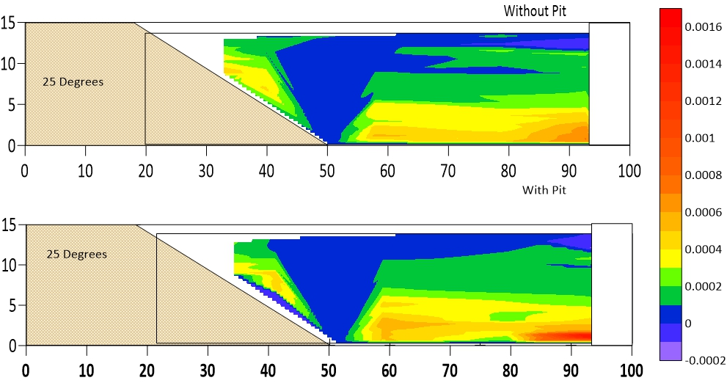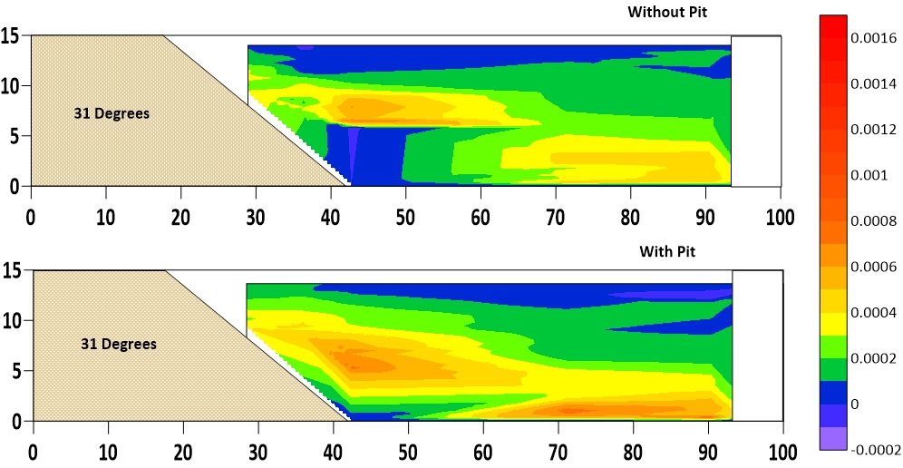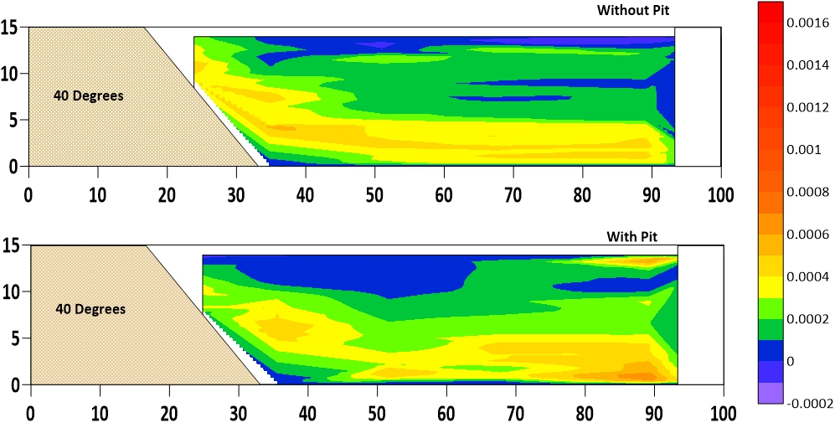

Figure1: Reynold’s Shear Stresses contour in Riverbank cross sections with 25⁰, 31⁰ and 40⁰ slope for No Pit and With Pit condition.

