Breaking seed dormancy followed by direct plantlet regeneration in Musa balbisiana cv. Bhimkol
Sumona Ray and Rakhi Chaturvedi*
Department of Biosciences and Bioengineering, Indian Institute of Technology Guwahati, Assam 781039, INDIA
*Email: rakhi_chaturvedi@iitg.ac.in

Abstract

Musa balbisiana cv Bhimkol, is an indigenous seeded banana variety in northeast India with potential health benefits. Banana plants are naturally propagated through rhizomes or suckers in the field. Seeds, the product of fertilization are non-viable in bananas, hence they are not germinated conventionally. In this present study micro propagation technique has been employed to overcome seed derived dormancy. Initially, immature seeds were collected from unripen fruit of Musa balbisiana cv. Bhimkol having a length of 15.3 cm and breadth of 6.3 cm and yellowish green coat color. Isolated seeds (4mm) were treated with different sterilizing agents, out of which best methodology was selected, showed the highest survivability rate of 84.66 ± 3.39 %. The sterilized seeds were inoculation on MS basal media supplemented with various plant growth regulators. Direct regeneration of shoot was observed from the half cut seed inoculated on MS+ 5 µM NAA+5µM BAP + 1000 mg/l CH medium. Elongated shoots 2 to 3 cm in length were transferred to the shoot multiplication medium MS + 8.8 µM BAP. After a period of 3 to 4 weeks, single isolated plantlet was transferred to the root development medium having ½ MS +0.5 µM IBA. Complete rooted plantlet was formed after a period of 20 days. Hence micro propagation strategy helped to overcome seed born sterility and also the production of large number of disease free identical plantlets in a short period of time.
Student Academic Board (SAB), Indian Institute of Technology Guwahati, Guwahati, Assam, India
Research & Industrial Conclave 2023 "An amalgamation of Academia, Industry & Start-up”
"
.
Keywords: Dormancy, micro propagation, rhizomes, suckers
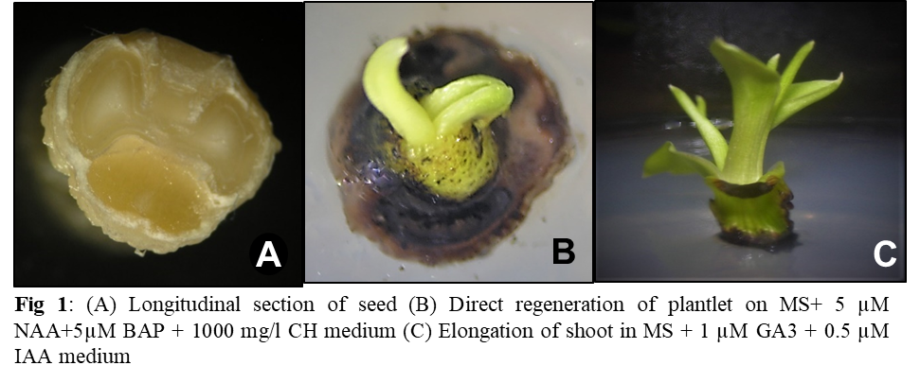
References

1.Uma S., Lakshm S., Saraswathi M. S., Akbar A., & Mustaffa M. M. (2011). Embryo rescue and plant regeneration in banana (Musa spp.). Plant Cell Tissue Organ Cult., 105, 105-111

2. Wong W. C. (1986). In vitro propagation of banana (Musa spp.): initiation, proliferation and development of shoot-tip cultures on defined media. Plant Cell Tissue Organ Cult, 6, 159

