Study of Thermal Bergman Cyclisation and Photophysical Properties of Designer Fluorescent Enediynes

Suravi Paul and Subhendu Sekhar Bag*
Department Of Chemistry, IIT Guwahati, Guwahati, Assam -781039, India
(E-mail: suravi.paul@iitg.ac.in)
Abstract

Natural enediynes gained interest as potent antitumor and antibiotic agent due to formation of reactive diradical species via Bergman Cyclisation which is known to abstract proton from the DNA phosphate backbone causing cancerous cell death.¹
The role of CT/π-π-stacking interactions in lowering the BC temperature have been explored in this work. Our work focuses at bringing the acetylenic centres closer thereby lowering Bergman Cyclization temperature.⁶ In this line, a series of D-D, D-A, A-A enediyne molecule have been synthesized using sequential Sonogashira Reaction. Their solid phase reactivities have been studied using Differential Scanning Calorimetry.^{3,4} In addition, the charge transfer properties of the synthesized fluorescent enediynes were explored using UV-Vis and fluorescent spectroscopic study.⁶
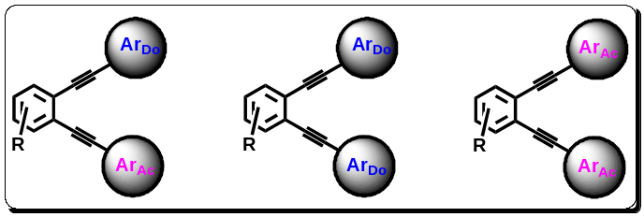
Figure 1. Donor-Acceptor Enediynes.
The trend of the rate of thermal BC observed was A/A > D/A > D/D. As revealed in the trend through bond delocalisation of electronic charge density, is playing a critical role in lowering the cyclisation temperature.⁴ The strong overlapping between the reactive molecular orbitals^{1,2} and flow of charge from the donor in one arm to the acceptor moieties in the other arm might be a factor for the observed trend. In addition, charge flow to and from the central ring through a bond possibly plays a crucial role in controlling the BC.
Keywords: Bergman Cyclisation, Enediyne, Charge Transfer (CT))

References
[1] S. Roy, S.S. Bag, A. Basak, Tetrahedron, 2012, 68, 8600.
[2] A. Basak, S. Mandal, S.S. Bag, Chem. Rev, 2003 103, 4077.
[3] M. Kar, A. Basak, Chem. Rev, 2007,107, 2861.
[4] W.C. Chen, N.Y. Chang, C.H. Yu, J. Phys. Chem. A, 1998, 102, 2584.
[5] K.D. Lewis, A.J. Matzger, J Am. Chem. Soc. 2005, 127, 28, 9968.
[6] H. Lu, W. Wang, X. Li, M. Zhang, X. Cheng, K. Sun, Y. Ding, X. Li, A. Hu, J. Mater. Chem. B, 2021, 9, 4056.

