Diastereoselective Synthesis of 2,6-Disubstituted Tetrahydropyranones via Prins Cyclization of 3-Bromobut-3- en-1-ols and Aldehydes

Surjya Kumar Bora, Sudip Shit, Archana Kumari Sahu and Anil K. Saikia*
Department of Chemistry, Indian Institute of Technology Guwahati, Guwahati, Assam-781039, India
E-mail: asaikia@iitg.ac.in

Abstract

Tetrahydropyrans are the most common heterocyclic structures ubiquitously present in bioactive molecules and natural products. Among them, substituted pyran motifs are structural core unit of numerous biologically active natural products such as diosniponol B, exiguolide, bryostatin 1 etc. Although there are various methods for the synthesis of tetrahydropyran moiety, Prins cyclization reaction is most convenient tool due to its excellent diastereoselectivity and carbon-carbon, carbon-heteroatom bond formation in a single step. Here, we have demonstrated a highly diastereoselective synthesis of tetrahydropyranones from 3-bromo-but-3-en-1-ols and aldehydes mediated by BF₃·OEt₂ in good yields via Prins cyclization reaction (Scheme 1). The methodology is extended for the synthesis of enol ether, ester derivatives and 4-hydroxy 2,6-disubstituted tetrahydropyrans with 2,4- and 4,6-cis configuration and also extended towards the synthesis of aminoguanidine derivatives which are considered as anticancer agent.

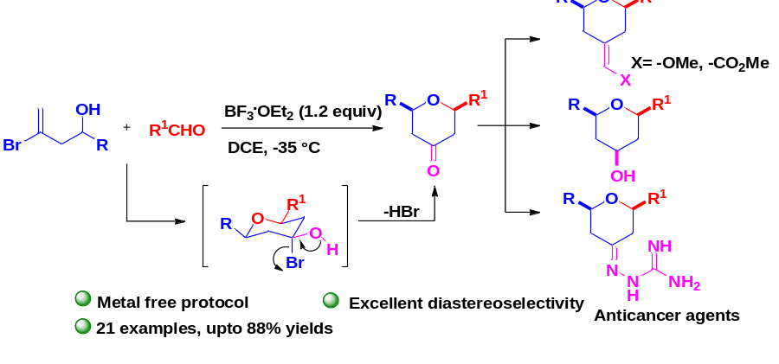

Scheme 1

References
[1] S. K. Bora, S. Shit, A. K. Sahu, and A. K. Saikia, J. Org. Chem. 2023, 88, 3012–3021.
[2] H.-N. Lyu, J. Zhang, S. Zhou, H.-W. Liu, W.-Y. Zhuang, S.-M. Li, W.-B. Yin, Org. Biomol. Chem. 2021, 19, 8377–8383.
[3] F. P. L. Silva, B. B. Dantas, G. Faheina Martins, D. A. M. de Araujo, M. L. A. D. A. Vasconcellos, Molecules 2016, 21, 671.

