HHTI BATTERY FOR ARMY PURPOSE

Sachit Narayan Pandey1 ,
Prof. S.K Dwivedy ²

1 Technology Incubation Hub - TIDF, IIT Guwahati, India
2 Technology Incubation Hub - TIDF, IIT Guwahati, India

E-mail: sachitnarayan@rnd.iitg.ac.in

Abstract

A wide range of sectors that depend on portable power solutions have made customizable battery packs a necessary component. These battery packs are created to specifically address the demands and specifications of each particular customer, offering them a solution that is effective and affordable. Customers that purchase customizable battery packs can select various parameters such as battery chemistry, capacity, size, and shape. In doing so, they are able to tailor the performance of their battery packs to the needs of the specific application, whether it be for consumer electronics, medical devices, robots, or other industries. The demand for adjustable battery packs will only increase as technology develops, making them a more crucial component for companies looking to stay ahead of the curve.
We developed customizable battery packs that are specifically designed for military use. These battery packs can be customized according to the specific needs and requirements of the army, making them an ideal power solution for a wide range of military applications. We understand the importance of reliable and efficient power in the field, which is why we have made sure that our battery packs are durable, long-lasting, and able to withstand even the toughest conditions. By providing customized power solutions, we are proud to contribute to the safety and success of our armed forces.
Student Academic Board (SAB), Indian Institute of Technology Guwahati, Guwahati, Assam, India

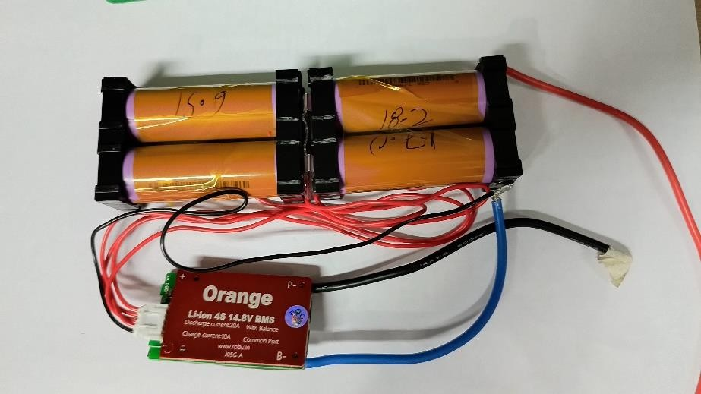

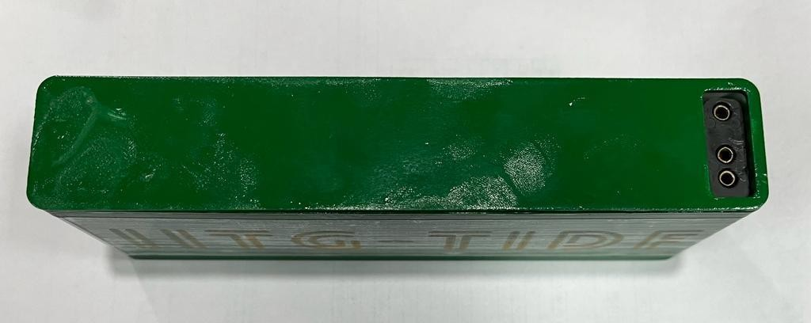
Fig 1: Battery Pack

Fig 2: Casing for Battery Pack

