Abstract for Research & Industrial Conclave 2023
Shweta Tiwari¹, Rajan Singh² and Rajiv K. Kar^{1,2,*}

¹Jyoti and Bhupat Mehta School of Health Sciences & Technology, ²Center for Nanotechnology, IIT Guwahati, India

*E-mail: rajivkar@iitg.ac.in

Accessing the Reproducibility of Amine functionalised Graphene oxide: Synthesis and Characterization of Low-Dimensional Material

Introduction - Graphene oxide (GO) and reduced graphene oxide (rGO) are the variants of pristine graphene, chemically synthesized by Hummers Method [1]. These low-dimensional materials are potential candidates for biomedical applications such as for anticancer therapy, and bioimaging due to their nano(particle) size and less toxicity over environment. Moreover, they are also competent for designing sensors, optoelectronics, and fuel cells, due to their large surface area and semiconducting properties. Furthermore, GO can be chemically functionalized to improve its conductivity, electron mobility, and sensing capabilities. One such surface functionalization is through attachment of amine group. Amine-functionalized graphene oxide (Amine-GO) is created through nucleophilic substitution and amidation reactions [2]. The rapid transportation of surface electron results in the effective separation of e-/h+ pairs. The excellent electrical conductivity of amine-functionalized GO enables unobstructed excitons (e-) trapping, making it a promising material for supercapacitors.
Methodology - The synthetic steps of GO and Amine-GO can be visibly inspected as transformation of charcoal black color of pristine graphite to yellow brown for GO, followed by dark black for Amine-GO in DI water (Figure 1). Spectroscopic methods used for material characterization includes UV/Vis, Raman spectroscopy and X-Ray Diffraction techniques. The reproducibility of the synthesis was confirmed from above characterization methods in triplicate.
Results - Characterization by UV/Vis spectroscopy for GO characteristics peaks at 310 nm and 230 nm. The former peak arises due to π-π* electronic transition mediated via the aromatic C–C bond, whereas the later peak reflects n-π* transitions of C=O bonds. In case of Amine-GO, the peaks are blue-shifted and found at 282 and 224 nm. The intensity of the peaks varies while replicating the material synthesis through oxidative process, which is due to variation in structural defects and varying carbon-to-oxygen ratio. Raman Spectroscopy reveals two peaks for GO and Amine-GO, one at ∼1580 cm−1 called G band. This band appears due to in-plane stretching of C-C sp2-conjugation. The D band was found at ∼1345 cm−1 which is due to disorderness in the lattice of carbon. Results from X-RD shows crystalline structure for GO and Am-GO, and the peak was obtained at ∼11.5 o due to oxygen in the lattice of carbon while the d-spacing was decreased in Am-GO due to less oxygen content in the lattice. This also revealed better thermal stability, Young's modulus and tensile yield strength of GO and Am-GO than pristine graphene.
Keywords: Graphene oxide, Functionalized-GO, UV/Vis, Raman spectroscopy, X-ray diffraction

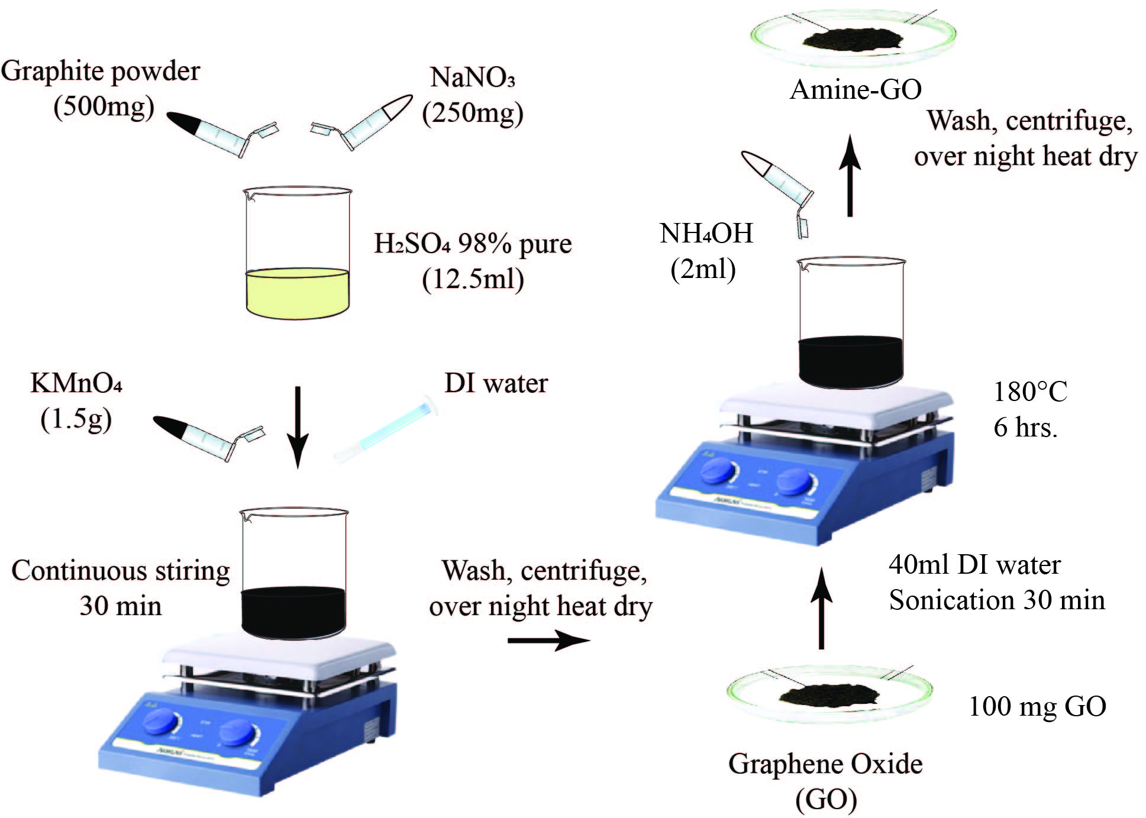
Figure 1: Schematic representation of synthesis steps for GO and Amine-GO

References:
[1] Marcano et al. ACS Nano 2010. DOI: https://doi.org/10.1021/nn1006368.
[2] Caliman et al. RSC Advances 2018. DOI: https://doi.org/10.1039/C7RA13514A.

