Applications of Blockchain in VANET

Surjya Kanta Daimary1 and Hemanta Kumar Kalita2

1 Department of Computer Science & Engineering, CIT Kokrajhar, India
2 Department of Computer Science & Engineering, CIT Kokrajhar, India
E-mail: ph20cse1001@cit.ac.in

Abstract

The Blockchain is a powerful distributed ledger that can help to solve the issues that are experienced in vehicular network. Though much research has previously investigated the integration of blockchain in VANET, many areas are yet to be studied. Thus, a detailed discussion and analysis is presented with a focus on security and resilience. In addition, the integration of blockchain technology with the vehicular network is investigated from the last ten years in order to further explain its uses in VANET. Further the directions of integration-related research are then discussed. Thus, it can be concluded that the difficulty of guaranteeing information security in vehicular communications is very severe due to the characteristics of vehicular network operation and the significance of not interfering with third parties’ interference in VANET. Therefore, the attempt to employ technology in this research is the implementation of blockchain in every node in vehicular network.
Keywords: VANET, blockchain, cyber security, intelligent transport system, internet of vehicles.
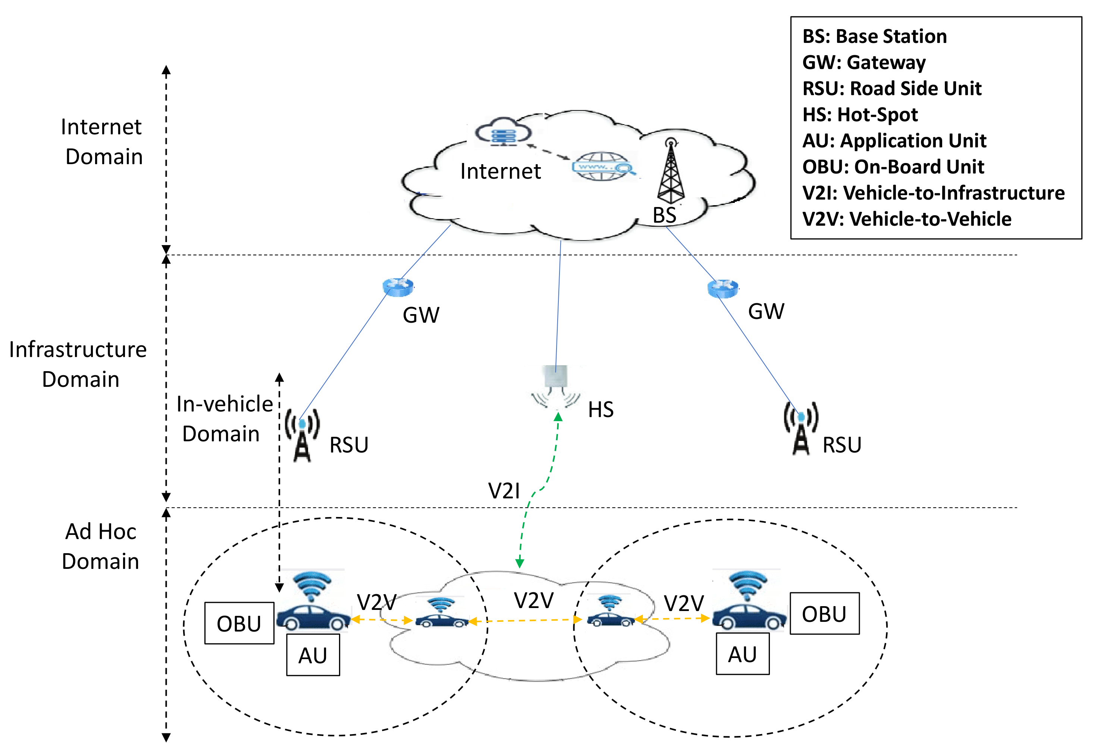
Figure 1. Standard VANET architecture

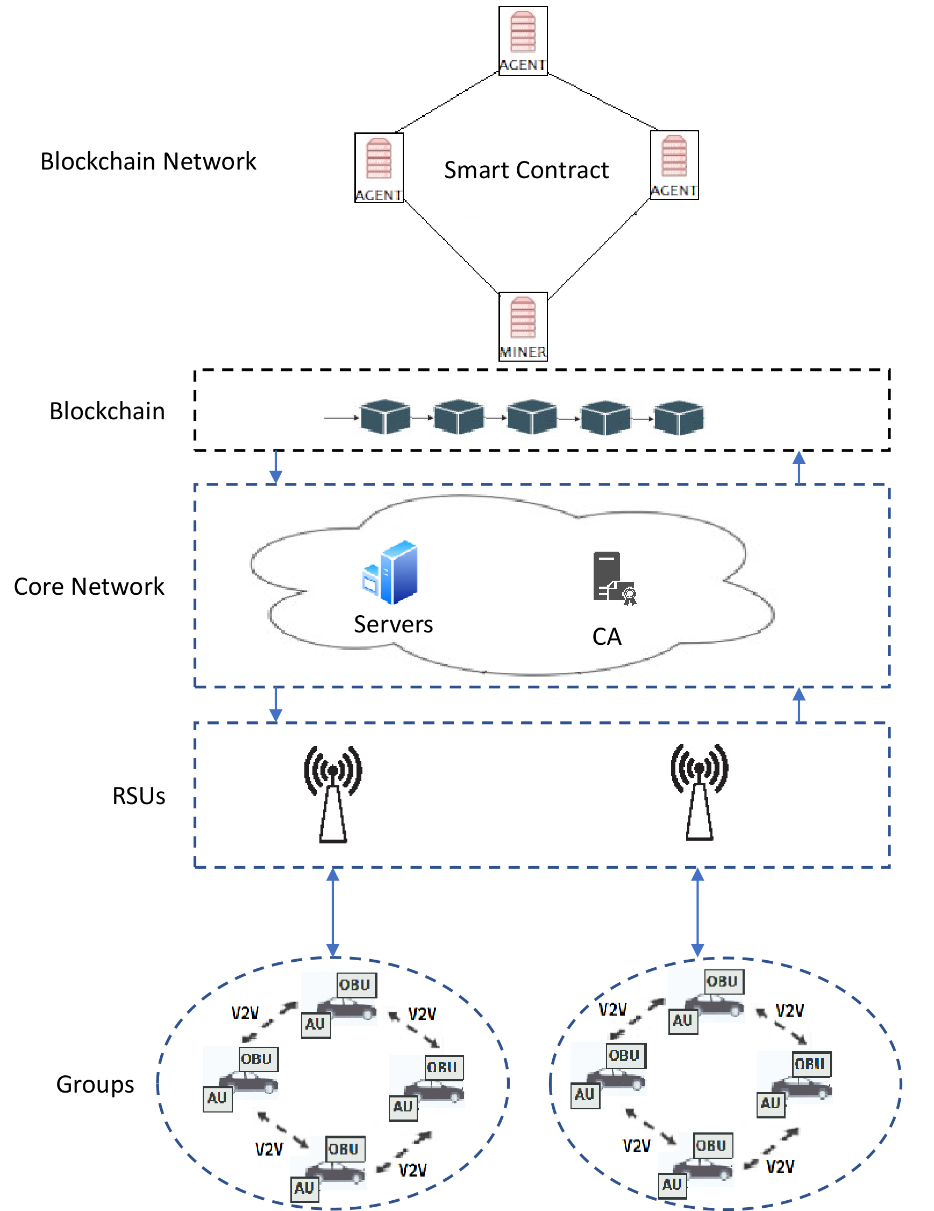
Figure 2. Blockchain-based VANET architecture

