Ultrasmall Peptide Hydrogel-Based Core-Shell Beads and Hollow Capsules with Chemically Tunable Surface

Tanushree Das, Saurav Das, Malay Kumar Baroi, Rahul Maurya, and Debapratim Das*

Department of Chemistry, Indian Institute of Technology Guwahati, Assam 781039, India

E-mail: t.das@iitg.ac.in

Abstract

Hydrogel beads have emerged as a new class of soft materials that infuse the noble properties of macro-dimensional hydrogels in tiny easily operable and robust droplets. However, due to their high structural rigidity and durability, polymeric hydrogels have been primarily used in the production of hydrogel beads. Conversely, low molecular weight hydrogel beads are relatively uncommon because of their fragile structural integrity and propensity to dissolve readily in bulk solvents. In an attempt to create hydrogel beads from LMWG-based hydrogels without the need for combining them with polymeric entities, we employed an ultra-short peptide (Pyrene-Lys-Cys, PyKC) based hydrogel that remains insoluble in bulk solvents.^{1,2} The hydrogel beads are made using a simple extrusion technique. To enhance stability, the beads are coated with a polymeric shell, resulting in a core-shell hydrogel bead with a LMWG-based hydrogel core. The core-shell beads were found to be extremely stable in a variety of solvents, buffers, and at high temperatures. Moreover, the outer surface of the core-shell beads can be modified to present either surface exposed free acrylate or free amine groups, allowing for a variety of organic conjugation reactions to be performed. This permitted easy surface functionalization, which aided in the addition of valuable functional properties to the beads. Surface wettability could be modulated by surface functionalization with appropriate hydrophobic/hydrophilic residues. Immobilized host and guest molecules engaged in host-guest chemistry (involving cucurbituril and cyclodextrin) on the surface of beads. Furthermore, proteins and catalytic enzymes like BSA and HRP were immobilized on the surface of the beads, allowing for easy recovery and reuse. Interestingly, the hydrogel demonstrated dissolution when exposed to disulfide bond-breaking agents and selective solvents (DMSO, DMF). By immersing the core-shell beads in DMSO, the core (PyKC hydrogel) was sacrificed, resulting in the formation of hollow organic capsules. The extremely modular and customizable nature of PyKC-based core-shell hydrogel beads and PyKC templated hollow organic capsules may find utility in a wide range of material and bio-medical applications.
Student Academic Board (SAB), Indian Institute of Technology Guwahati, Guwahati, Assam, India
Research & Industrial Conclave 2023 "An amalgamation of Academia, Industry & Start-up”
"

Keywords: Peptide, Hydrogel, Extrusion, Core-Shell Beads, Hollow Capsules
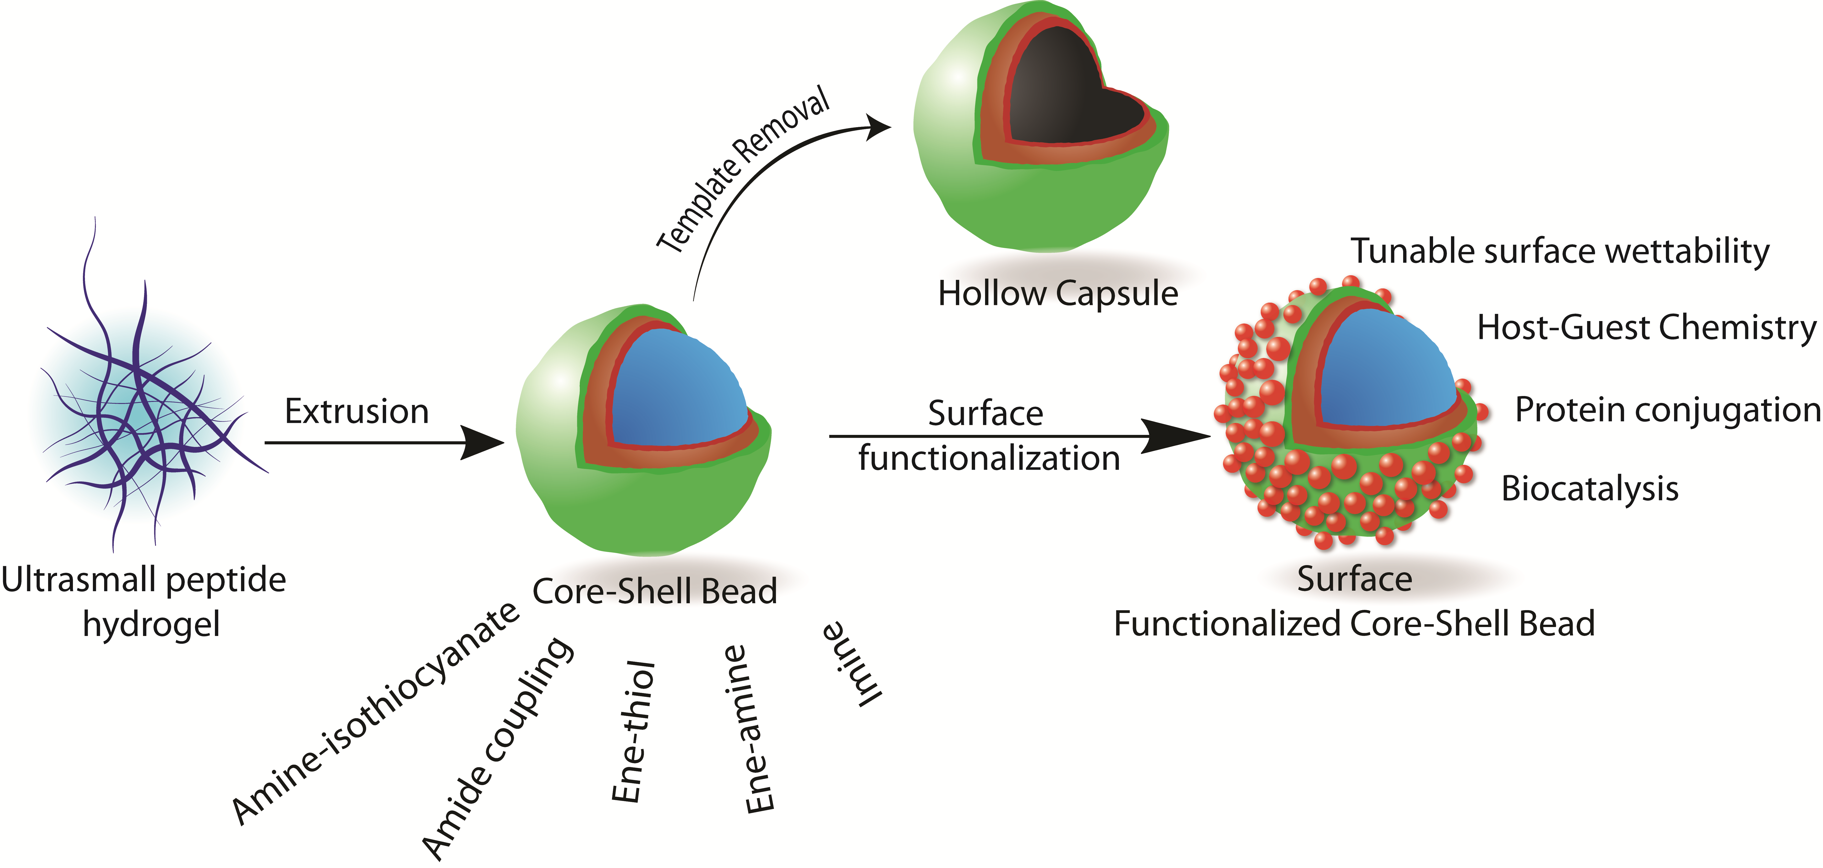

References:
1. Nilotpal Singha, Arpita Srivastava, Bapan Pramanik, Sahnawaz Ahmed, Payel Dowari, Sumit Chowdhuri, Basab Kanti Das, Ananya Debnath and Debapratim Das*, Chem. Sci., 2019, 10, 5920-5928
2. Nilotpal Singha, Basab Kanti Das, Bapan Pramanik, Saurav Das and Debapratim Das*, Chem. Sci., 2019, 10, 10035-10039

