Weak Coordination-Guided C4-H Alkylation of Indoles with
Cyclopropanols via Sequential C-H/C-C Bond Activation
Tripti Paul, Shubhajit Basak, and Tharmalingam Punniyamurthy*
Chemistry, IIT Guwahati, Guwahati, Assam – 781039, India
E-mail: tpunni@iitg.ac.in

The N-heterocyclic indole scaffold is one of the cardinal constituents of numerous natural products, bioactive molecules, functional materials.¹ Thus, site-selective C-H functionalization of indole core has become an important pursuit in organic synthesis.² In particular, design of efficient methodology for the selective editing of C4-H bond of indoles has gained considerable interest due to their conspicuous biological activity.³ A Rh-catalyzed weak chelation-assisted C4-alkylation of indoles has been accomplished using readily accessible cyclopropanols as an alkylating agent via the cascade C-H and C-C bond activation (Figure 1).⁴ The substrate scope, functional group tolerance, and late-stage mutation of drug molecules are the important practical features.

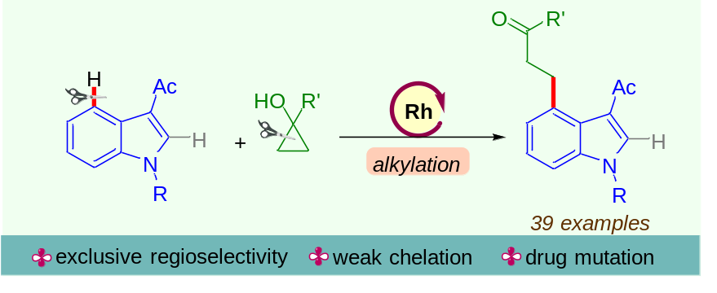

Figure 1. C4-H alkylation of indole via C-H/C-C bond activation

References
[1] R. D. Taylor, M. MacCoss, A. D. G. Lawson, J. Med. Chem. 2014, 57, 5845.
[2] R. Dalpozzo, Chem. Soc. Rev. 2015, 44, 742.
[3] H. Liu, Y. Jia, Nat. Prod. Rep. 2017, 34, 411.
[4] T. Paul, S. Basak, T. Punniyamurthy, Org. Lett. 2022, 24, 6000.

.

