Spectrum and Core Allocation in SDM-EON Multi Core
Fiber using First Random Fit

Vasundhara1 , Abhilash Mandloi2

1,2 Department of Electronics Engineering, SVNIT- Surat, India

E-mail: vasundhara.nit@gmail.com
asm@eced.svnit.ac.in

Abstract

Due to the increasing adoption of cloud services and the proliferation of connected devices, data traffic within data centres have been growing rapidly. This growth has resulted in the need for a networking infrastructure that can scale to handle the increasing volume of data traffic and being cost-effective. To address this challenge, various networking technologies, such as software defined networking (SDN) and high-speed Ethernet allow for dynamic allocation of resources and improved network performance. The use of space-division multiplexing (SDM) has been identified as a promising solution to address the capacity limitations of optical networks and enable cost-effective network capacity scaling. Multicore fiber (MCF) is considered the most feasible and efficient way to realize SDM networks. However, the issue of crosstalk (XT) in MCF needs to be addressed to ensure optimal transmission performance. In SDM-EON (Elastic optical network), the allocation of requests and routing constraints change frequently which leads to inefficient utilization of the available spectrum resources. This results in fragmentation of the spectrum, which means that there are empty slots scattered throughout the spectrum. Fragmentation is determined by how many empty slots are adjacent to each other. Based upon Fragmentation Coefficient (FC), spectrum is assigned using a First Random Fit to the distinct core-pair using distinct modulation formats.
Student Academic Board (SAB), Indian Institute of Technology Guwahati, Guwahati, Assam, India
Keywords: Routing and Spectrum Allocation (RSA), SDM, MCF, FC, CASR.
Research & Industrial Conclave 2023 "An amalgamation of Academia, Industry & Start-up”
"

CASR=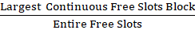
System Parameter | Value
Number of Cores © | 7
Spectrum Slots per Core | 320
Number of shortest paths (k) | 3
Power Coupling Coefficient | 4×10⁻⁴
BPSK Threshold | -64 dB
QPSK Threshold | -67 dB
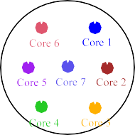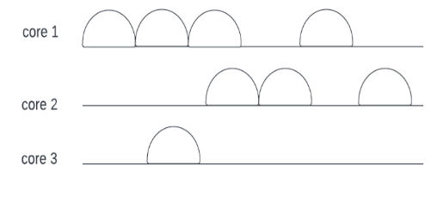
Figure 1. CASR in each Core
Table 1. System Parameters in Physical Layer Model
Algorithm (Heuristic Approach)
I. Find the k-shortest routes between the destination (D) and the source (S) for each new connection request NCR (S,D,SS) using Dijkstra Algorithm.
II. For each k^{th} route and c^{th} core pair, determine the fragmentation coefficient based on the CASR.
III. Choose the pair with the minimum value of min (k, c) after sorting every k-c pair in the list using .
IV. The route and core of min(k,c) are utilised to find the appropriate spectrum slice (SS) while satisfying the XT threshold limit.
V. By utilising BPSK and First Fit (FF), assign the spectrum slot to the core-pair with the highest .
VI. The core-pair with the lowest should get the SS through Random Fit (RF) and QPSK.
VII. Remove the (k,c) from the list in step 3 and then repeat steps 3 and 4 if SS is not available.
VIII. If the SS is available, return the route k and core c (first slice index and last slice index) of the chosen spectrum block.

References

1. Capucho, Joao HL, and Leandro C. Resendo. "ILP model and effective genetic algorithm for routing and spectrum allocation in elastic optical networks." In 2013 SBMO/IEEE MTT-S International Microwave & Optoelectronics Conference (IMOC), pp. 1-5. IEEE, 2013
2. H. Tode and Y. Hirota, “Routing, Spectrum and Core Assignment for Space Division Multiplexing Elastic Optical Networks,” Proc. of Networks 2014, thu.s11.4,
Sep. 2014 (Invited).
3. Zhao, Yongli, Liyazhou Hu, Ruijie Zhu, Xiaosong Yu, Xinbo Wang, and Jie Zhang. "Crosstalk-aware spectrum defragmentation based on spectrum compactness in space division multiplexing enabled elastic optical networks with multicore fiber." IEEE Access 6 (2018): 15346-15355
4. Behera, Sadananda, and Goutam Das. "Dynamic Routing and Spectrum Allocation in Elastic Optical Networks with Minimal Disruption." In 2020 NCC pp. 1-5.
IEEE.

