Development of highly efficient electrocatalyst derived from ZIF-67 for the synthesis of green ammonia

P.Mukherjee 1 , GM. Karim1 and UN. Maiti1

1 Department of Physics, IIT Guwahati, India

E-mail: priyammukherjee@iitg.ac.in

Abstract
Student Academic Board (SAB), Indian Institute of Technology Guwahati, Guwahati, Assam, India
Research & Industrial Conclave 2023 "An amalgamation of Academia, Industry & Start-up”
"

While a prosperous human population is considered as a great socio-economic resource of a country, it often parallelly demands an even greater challenge to realise; i.e proper nourishment of its people. To overcome this challenge, the production of sufficient amount of food is essential which cannot be possible without the production of enough fertilizers, mainly urea and hence its precursor ammonia.

Today, the industrial production of ammonia is mainly dominated by traditional Haber-Bosch process (N₂ + H₂ →NH₃). However, this process needs harsh reaction conditions (350 – 550C, 150-350 bar) which not only requires high energy but also needs complex equipment to induce reduction in inert-like N₂ gases. Moreover, the hydrogen needed in this process is mainly obtained from natural gases which involve the production of a large amount of CO₂ that greatly contributes to the overall CO₂ emissions reaching 300 million tons. Furthermore, the unprecedented amount of energy requirement for this process is as high as 2-3% of the world's energy. So, an alternative environment-friendly, cost, and energy-inexpensive process is in great need at the current time.

The electrochemical synthesis of ammonia from the nitrogenous species (N₂, NO₃⁻, NO₂⁻, etc.) is one of the green and promising alternatives of the traditional Haber-Bosch process. However, due to slow cleavage of N-N triple bond, low solubility of gaseous N₂ in aqueous solution, and the complex eight electron transfer process for NO₃⁻ reduction, the yield and the faradaic efficiency is still not enough for its industrial implementation. Hence, strategic development of the catalyst for high yield and faradaic efficiency is the current need of the hour. Here we developed a binder free, self-supported, low cost electrocatalyst with high surface area derived from the pyrolysis of Zeolitic imidazolate framework (ZIF-67) which is act as a promising electrocatalyst for the reduction of NO₃⁻ to ammonia with yield rate of 1036 g h⁻¹cm⁻² and faradaic efficiency of 96.2 % at -0.2 V Vs RHE.

Keywords: electrochemical synthesis of ammonia, ZIF-67.

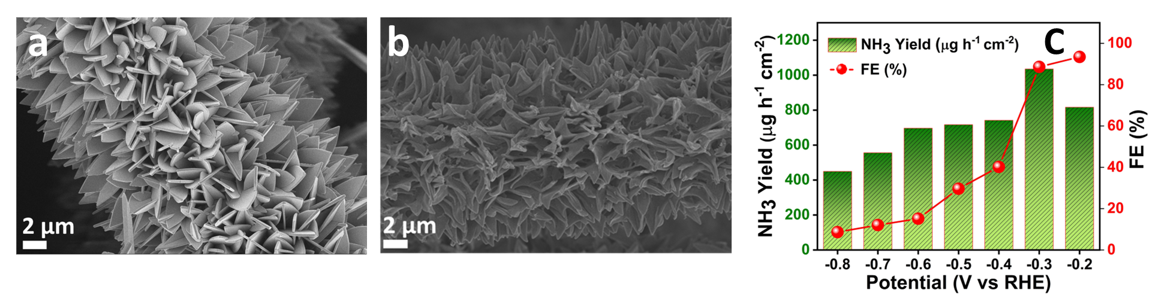
Figure 1: FESEM image of ZIF-67@CC (a) before pyrolysis (b) after pyrolysis (c) ammonia yield and faradaic efficiency of the prepared catalyst.

