Fabrication of n-MoS₂ /p-type crystalline-Si heterojunction solar cells
Anterdipan Singh¹* and Pratima Agarwal^{1,2}
¹Department of Physics, Indian Institute of Technology Guwahati, Assam 781039, India
²School of Energy Science and Engineering, Indian Institute of Technology Guwahati, Assam 781039, India
*pratima@iitg⋅ac⋅in
Abstract

For a practically functional solar cell, the cost-effectiveness and efficiency of the device is essential. This can be achieved by either enhancing the efficiency and lowering the fabrication cost of the device. Both can be achieved in n-type MoS₂/p-type crystalline-Si heterojunction device. Si has dominated the commercial photovoltaic market due to the high abundance of Si materials and acceptable power conversion efficiencies and mature Si semiconductor technologies. Molybdenum Disulfide (MoS₂) have attracted great interest because of its significant chemical and physical properties. MoS₂ exhibit excellent charge carrier transport properties, i.e., high mobility values. Experimentally, carrier doping levels of have been achieved in MoS₂ which makes it a potential low-cost and promising candidate for replacement of doped emitter layers in c-silicon solar cells. In addition, monolayer and bilayer of MoS₂ can be synthesized over a large area by the chemical vapor deposition (CVD) method without using any toxic gases. Motivated by the potential of the n-type MoS₂ /p-type crystalline-Si solar cell, thin films of MoS₂ were deposited on a Silicon substrate using Dual Zone CVD technique. The resulting device yielded an efficiency of 1.37 % with J_{sc} of 22.24mA/cm², FF=0.20 and V_{OC} = 0.3V. Further optimization of MoS₂ layer properties and back contact are going on for improving the efficiency of device.

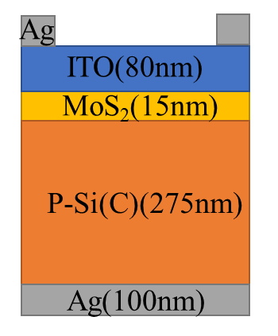
(a)
(b)
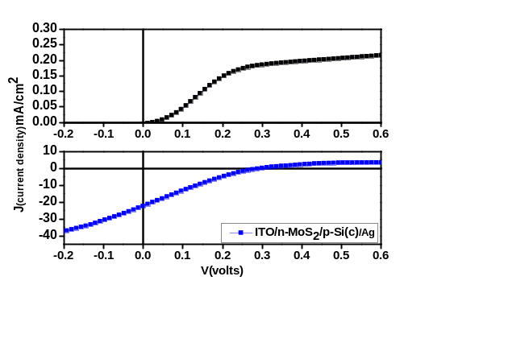
Dark
Light

Fig 1: The (a) schematic diagram of the fabricated device and its (b) corresponding J-V curve under dark and light conditions.

