Nutritional and functional potentials of Ajwain seed oil and its health benefits

Darshankumar A. Bhingaradiya¹, Subhajit Ray*²
^{1,2} Department of Food Engineering &Technology, Central Institute of Technology Kokrajhar, Kokrajhar, BTAD, Assam: 783370
E-mail: dbhingaradiya452@gmail.com

Abstract

Ajwain (Trachyspermum ammi L.) is a herb and spice plant from the Apiaceae family with diverse therapeutic and functional properties. Ajwain essential oil uses as an antimicrobial and flavouring agent. The objective of the study is to determine the chemical, nutritional, and phytochemical profiles of ajwain seed and the characterization of the bioactive components of extracted essential oil using Soxhlet solvent extraction technique. In the present investigation, the impact of different solvents and their combinations on extraction of different bioactive constituents was also analysed. Ajwain seed has shown to have higher amount of carbohydrate (55.38%), fat (10.08%), protein (15.73%) and also significant ash (7%) and crude fiber content (18.98%). Furthermore, it contains potential functional qualities, including total flavonoid content (2.0608 mg quercetin/gm), total phenolic content (126.021 mg GAE/100 gm), and antioxidant content of 36.36 g/ml. Ajwain seed contains major bioactive components e.g. Thymol, γ-terpinene, and p-cymene, which are strong germicides, antibacterial, antispasmodic, and fungicidal. The major bioactive component of ajwain seed essential oil is thymol, which has significantly influenced its therapeutic capabilities and capacity to treat a variety of illnesses such skin disorders, headaches, and nausea
Student Academic Board (SAB), Indian Institute of Technology Guwahati, Guwahati, Assam, India
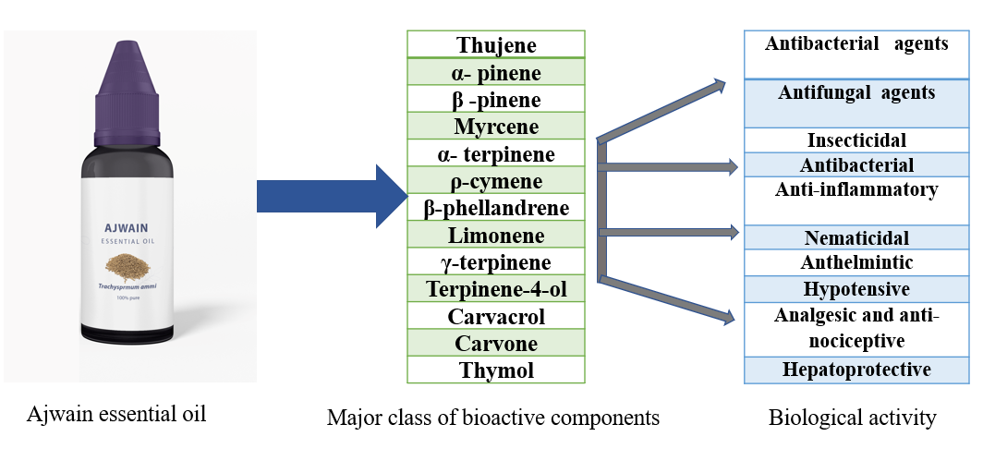
Figure 1. Bioactivity of Ajwain essential oil
Keywords: Ajwain seed oil, proximate composition, bioactive compounds, solvent extraction, health benefits

