Rutuja Kale¹, Dr. Saurabh Kumar¹, Mr. Arun D¹,
Mr. Mayur Krishna Das¹,
Dr. S. Kanagraj²

¹Department of Medical Devices, NIPER Guwahati, India
²Department of Mechanical Engineering, IIT Guwahati, India

E-mail: md22mt3028@niperguwahati.in

Abstract
Electroconvulsive therapy (ECT) is used to study anticonvulsive drugs in animal models. In ECT, a small amount of known electric current is passed through the test subject's brain, resulting in an intentional trigger for a brief period of time. Auricular electrodes are non-invasive electrodes, that help in inducing the required amount of current. These electrodes are generally provided along with the ECT machine thus making them company-specific and expensive. Thus, there is a need for the fabrication of universal, performance-effective, and cost-effective electrodes. Metals like platinum, iridium, gold, silver, and stainless steel are generally used for this purpose. Moreover, the impedance between animal skin and electrode surface has key importance in ECT. Metals have conductive properties; thus, they have less impedance compared to polymers and non-metals. Other parameters like corrosion, stiffness, shape of the electrode, and thermal resistance are taken into consideration while selecting a suitable material for electrode fabrication. The amount of current delivered to the test subject is estimated using an electric circuit consisting of an ECT machine, a resistor that mimics an animal, and an oscilloscope for visual inspection corresponding to a given current (see Fig.1). The ratio of square voltage to the applied resistance (power loss) is calculated. The efficiency of the delivery of current is inversely proportional to power loss.

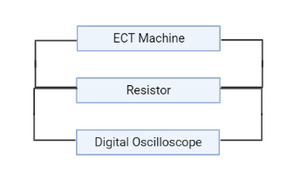

Fig.1 Circuit Diagram

Keywords: ECT, non-invasive electrode, stainless steel

References:

- Lunde, Mary E et al. “Electroconvulsive therapy in patients with epilepsy.”Epilepsy &amp; behavior : E&amp;B vol. 9,2 (2006): 355-9. doi:10.1016/j.yebeh.2006.06.013.
- Lykken, David T. &quot;Square‐wave analysis of skin impedance.&quot; Psychophysiology 7.2 (1970): 262-275.

