Smart Farming: “An Automated System for Optimal Water Irrigation and Soil Management in Agriculture"

A. Tanmay Saini1 , B. Vamika Singhal1

1 Department of Physics, Sanskriti The Gurukul, Guwahati
E-mail: tanmay.saini@sanskritithegurukul.in

Abstract

The farmers, who are the foundation of the Indian economy, were helped by this programme. The foundation of our project is automatic drip irrigation. A type of micro-irrigation system known as drip irrigation allows water to slowly trickle to plant roots buried below the soil's surface or above it, potentially conserving water and nutrients. The main benefit of drip irrigation is that it prevents water loss due to evaporation or seepage. However, if a farmer uses a regular drip irrigation system, he must remain close to his land at all times, which increases his workload and limits his mobility. What if there was a system that allowed the farmer to become more mobile?
Department of Physics, Sanskriti The Gurukul, Guwahati, India

Department of Physics, Sanskriti The Gurukul, Guwahati, India

Our project is made using Arduino UNO which is a microcontroller which serves as the project's brain. Then we have the GSM module, using the GSM library, which enables voice calls, SMS sending and receiving, and connectivity to the internet. In order to interact with the user, we also used the DFPlayer Mini. Relays which act as a switch for the pump. Then we have the water pumps and thin pipes to supply the water to the farm. To measure the outside temperature, humidity, and soil moisture level, a soil moisture sensor and a DHT11 sensor are used.

Our project has 3 functions, starting with a system in which the user can call a specific number and control the system by pressing numbers on the keypad. This system works both for a smartphone as well as for a keypad phone. After calling the system it receives the call only by the registered number and no other number to remove miscommunication. When the farmer presses the number 1 in the keypad the pump which is connected to a tank which only contains water gets switched on and when the user presses 2, the pump connected to the tank containing fertilizer mixed with water gets switched on. He can also press the number 3 to know which pump is currently on. A message notifying the user of the outside temperature, humidity, and soil moisture level is sent to him as soon as the call is hung up. The second phase is that if the soil moisture level is too low in the soil the system itself calls the user informing him about the situation so that he can take the required action. Lastly, this feature is exclusively made for users which have smartphones. We have a website for the farmers who have their farms not at a very vast distance from the city. The website makes it easier for customers to buy supplements and contact the farmers directly. This will enable us to cut out the middleman, which will benefit both the farmers and the consumers. The consumer will receive the fruits and veggies at a much-reduced price, while the farmer will still make a profit due to the system.

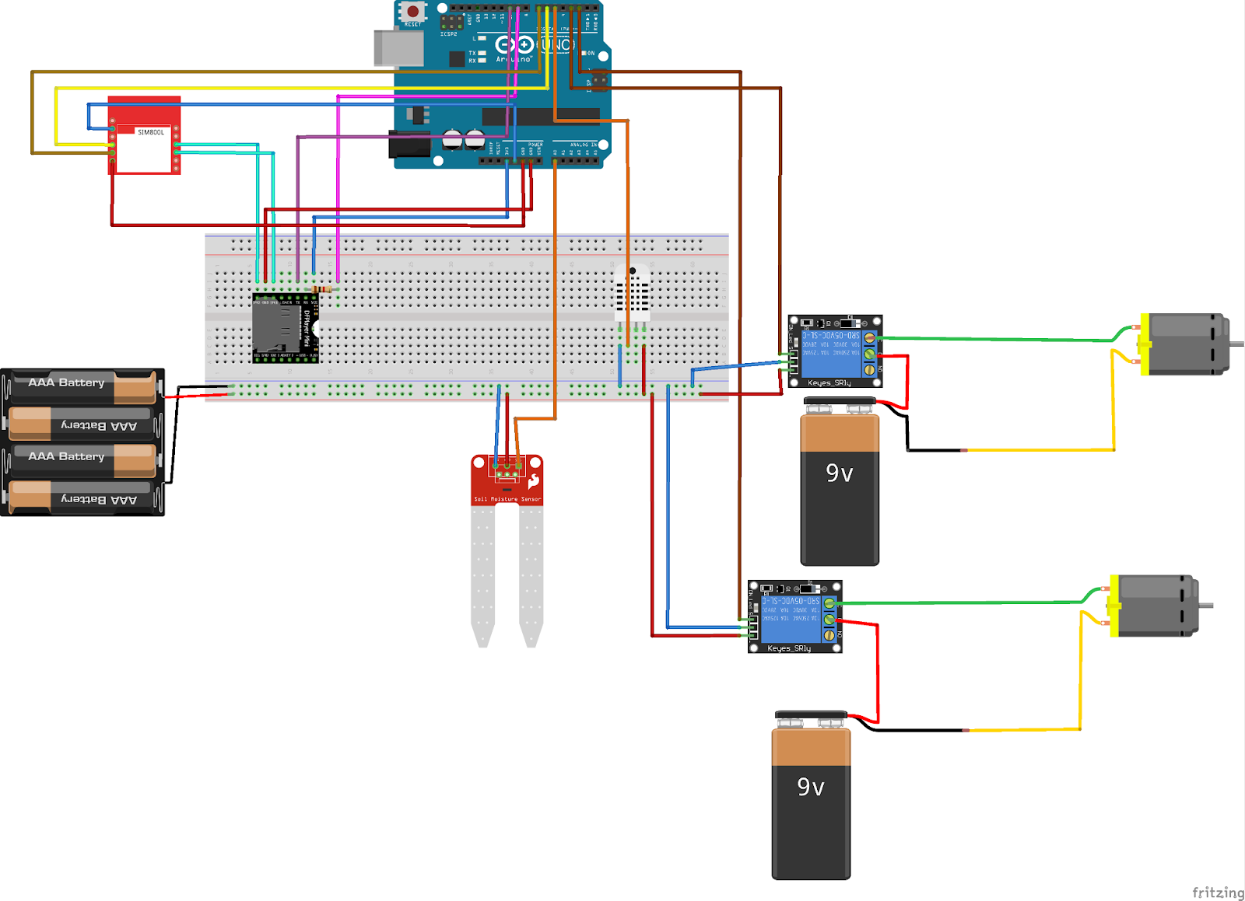
Figure 1: Circuit diagram of the Model

